|  |  |  |  |  |  |
| --- | --- | --- | --- | --- | --- |
|  |  | Image result for god all knowing |  | Related imageImage result for tick mark transparent backgroundImage result for god question mark |  |
| Related image |  | Image result for love hearts |  | Image result for big drum |  |
| Image result for number 1 dad shirt |  | Image result for infinity symbol |  | Related imageImage result for bible clip art |  |
| Image result for no god |  | Image result for universe planets |  | Related image |  |

|  |  |  |  |  |  |
| --- | --- | --- | --- | --- | --- |
|  |  | Image result for god all knowing |  | Related imageImage result for tick mark transparent backgroundImage result for god question mark |  |
| Related image |  | Image result for love hearts |  | Image result for big drum |  |
| Image result for number 1 dad shirt |  | Image result for infinity symbol |  | Related imageImage result for bible clip art |  |
| Image result for no god |  | Image result for universe planets |  | Related image |  |

|  |  |  |  |  |  |
| --- | --- | --- | --- | --- | --- |
|  |  | Image result for god all knowing |  | Related imageImage result for tick mark transparent backgroundImage result for god question mark |  |
| Related image |  | Image result for love hearts |  | Image result for big drum |  |
| Image result for number 1 dad shirt |  | Image result for infinity symbol |  | Related imageImage result for bible clip art |  |
| Image result for no god |  | Image result for universe planets |  | Related image |  |

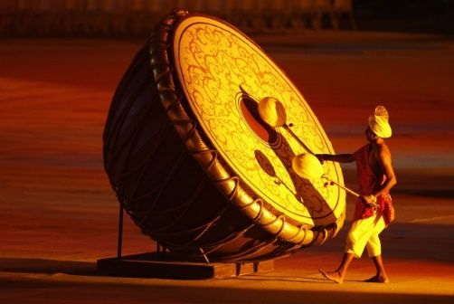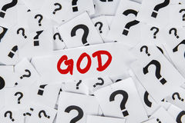

*Clues…*

Unsure if God exists.

Scientific idea about the creation of the universe.

Where the Christian Creation story can be found.

In the beginning God created this…

|  |  |  |  |  |  |
| --- | --- | --- | --- | --- | --- |
|  |  | Image result for god all knowing |  | Related imageImage result for tick mark transparent backgroundImage result for god question mark |  |
| Related image |  | Image result for love hearts |  | Image result for big drum |  |
| Image result for number 1 dad shirt |  | Image result for infinity symbol |  | Related imageImage result for bible clip art |  |
| Image result for no god |  | Image result for universe planets |  | Related image |  |

|  |  |  |  |  |  |
| --- | --- | --- | --- | --- | --- |
|  |  | Image result for god all knowing |  | Related imageImage result for tick mark transparent backgroundImage result for god question mark |  |
| Related image |  | Image result for love hearts |  | Image result for big drum |  |
| Image result for number 1 dad shirt |  | Image result for infinity symbol |  | Related imageImage result for bible clip art |  |
| Image result for no god |  | Image result for universe planets |  | Related image |  |



*Clues…*

Unsure if God exists.

Scientific idea about the creation of the universe.

Where the Christian Creation story can be found.

In the beginning God created this…

|  |  |  |  |  |  |
| --- | --- | --- | --- | --- | --- |
|  |  | Image result for god all knowing |  | Related imageImage result for tick mark transparent backgroundImage result for god question mark |  |
| Related image |  | Image result for love hearts |  | Image result for big drum |  |
| Image result for number 1 dad shirt |  | Image result for infinity symbol |  | Related imageImage result for bible clip art |  |
| Image result for no god |  | Image result for universe planets |  | Related image |  |



*Clues…*

Unsure if God exists.

Scientific idea about the creation of the universe.

Where the Christian Creation story can be found.

In the beginning God created this…