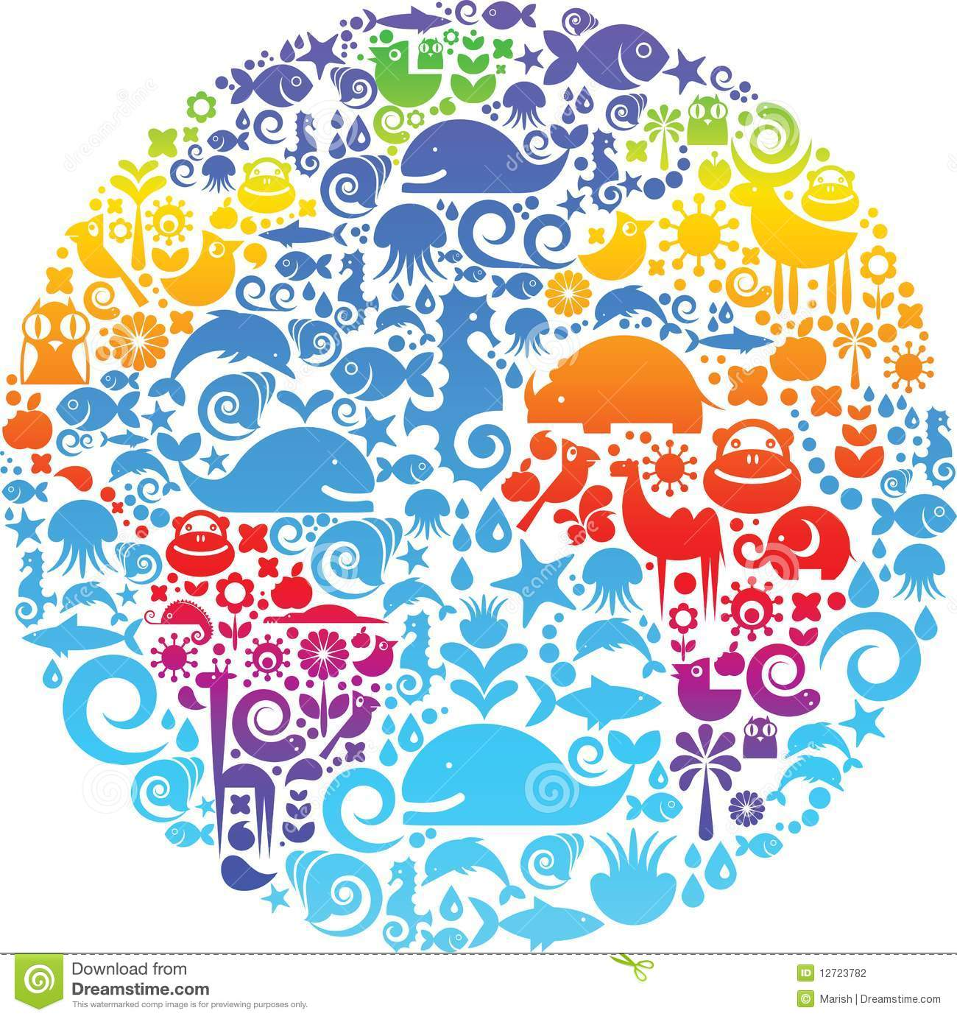

**F.R. Tennent**

Tennant’s modern version of the

Design Argument is called the

_________________ __________________.

He said that _________ designed the world so that human life would _______________. The universe _________________ at just the

correct rate to allow the development of ____________ such as ___________. These

____________ conditions could have

only been created by the actions of

_________, not by chance.

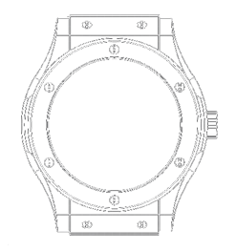

Paley argued that a

_____________was a very

______________ piece of machinery,

which had to be _______________ and

put together carefully. The ____________

is far more ______________than a watch, therefore the universe must be designed.

The only possible _______________for

something so complex must be,

_______therefore _______

must exist.

**William Paley**

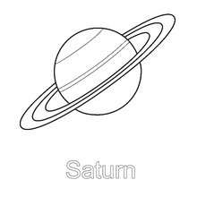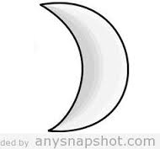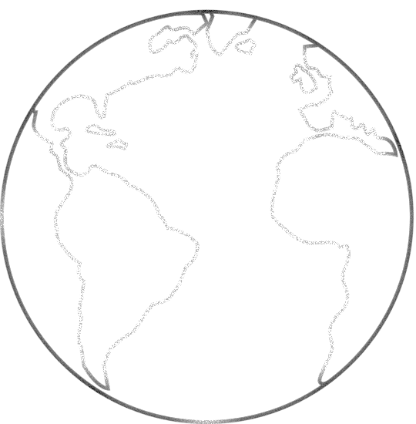

**St. Thomas Aquinas**

Aquinas said that the ______________

(the sun, _____________, stars, _____________ etc) could only be kept

in ___________ by an ___­­­­____________

being.



**Isaac Newton**

Newton said that because ____________

and apes have _______________ thumbs, unlike

any other _______________, it is an example of

________ ____________. He also claimed that our

___________ prints are evidence that _______

created us separately and _____________,

as no two thumb prints are the

_____________.