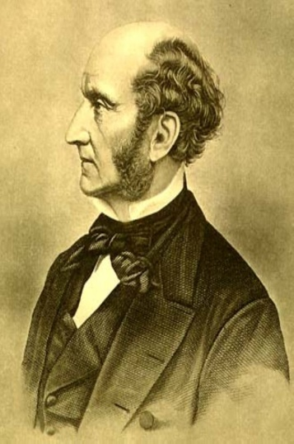
Mill and the Design Argument
John Stuart Mill was one of the most famous thinkers of the nineteenth century. He is well known for his theories of Ethics, Philosophy and Politics. He wrote an essay called On Nature. In it he challenged the Design Argument, pointing out that there are faults in the natural world such as earthquakes, volcanoes and diseases. A cat will play with a mouse for its own pleasure and the mouse will suffer a slow, lingering death after which the cat will not even bother to eat it. Many animals are ‘designed’ with sharp teeth and claws for the purpose of killing other animals. Carnivores like sharks cannot survive without killing others. Parasites like fleas live by sucking blood from mammals.
Mill argued that the most terrible crimes that people commit such as murder are just ordinary, everyday occurrences in nature. If there were a God or other designer then he must be cruel in order to design nature in a way that so many creatures suffer so much. Either God is evil or there is no designer at all and all of these things happen by chance with no overall guiding intelligent being.

Counter argument to Mill
Christians, Jews and Muslims argue that this suffering can be explained in terms of sin. In the scriptures, when God made the world everything was perfect but suffering and cruelty in nature came into the world because of human sin. For example, in Genesis chapter 3 God tells Adam that because he ate the forbidden fruit ‘cursed is the ground because of you’; it would produce thorns and thistles that would make Adam’s farming very hard as a punishment on him. This argument allows the possibility of a good designer in an imperfect universe.

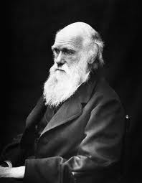
Darwin and the Design Argument
Charles Darwin is famous for his Theory of Evolution. He wrote a famous book called The Origin of Species in 1859 in which he argued that plants and animals (including humans) evolved or changed over a long period of time and adapted to the environment in which they lived. Those which were better suited to their surroundings were more likely to live long enough to reproduce than those less well suited. Less well adapted plants and animals would become extinct, in other words they would die out. This process is called natural selection. For example, finches (a type of bird) on one of the Galapagos Islands had slightly different beaks from the same type of finches on the neighbouring island. One type of beak was better for crushing seeds and the other type of beak was better for eating insects. The birds had adapted to their own island.
Darwin did not have the Design Argument in mind when he wrote his book but his ideas did cause a problem for the argument. If he was right then it was possible that plants and animals were not designed at all but that they evolved over millions of years by random accidental processes. This meant that the natural world could be explained without a designer (God). Richard Dawkins (a famous modern scientific atheist) argues that the process of evolution is like a ‘blind watchmaker’ that causes things to develop and change by accident without any plan or intention.
Counter argument to Darwin
Some people who do believe in God also believe in evolution. They believe that God planned the design of plants and animals long ago and that evolution is the process by which God made it all happen. This is called theistic evolution. In fact, even Darwin was open to the possibility that a God was behind the whole process.

