The Existence of God & Revelation
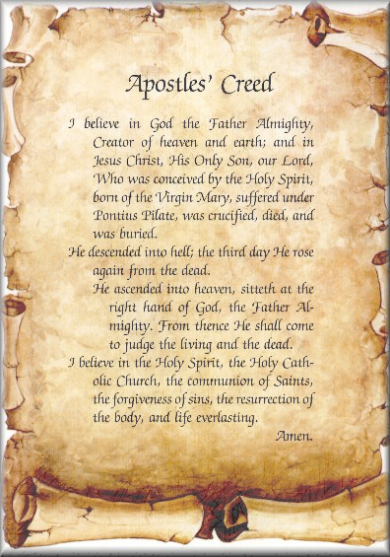
Christian beliefs about God.
The Apostle’s Creed

One of main Christian beliefs about God is that God is three in one – a Trinity. God is one, but has three forms, Father, Son and Holy Spirit.
I believe in God the Father Almighty Creator of Heaven and earth; and in Jesus Christ, His only Son, who was conceived of the Holy Spirit, born of the Virgin Mary…suffered, crucified, died and was buried. …on the third day he rose again from the dead. He ascended into Heaven, sits on the right hand of the Father …to judge the living and the dead… .

The Nature of God.

Christians also believe God is;

- Omnipotent
- Omniscient
- Omnibenevolent
- Immanent
- Transcendent
- Personal
- Impersonal
God
the Son
is Jesus. He
was crucified and
was resurrected. For
believers, following Jesus
means they can have their sins
forgiven and at death, be resurrected
and have eternal life in Heaven.

Buddhism and God.

Buddhists do not believe in a creator
God. They do not believe a god would
create a world so full of suffering.
Instead they believe that they can
only free themselves from
suffering by moving towards
enlightenment. They are
architects of their own
futures through their
own actions,
earning good and
bad karma
throughout
life.

When talking about God, immanent means He is active in the world, He can do this because of his omnipotence and his love
for all of His creations. Jesus is said to be an example of this immanence as He came to earth to show the way to attain heaven.
God is also described as ‘transcendent’. This means He is beyond this world and its limits.
God is not limited by time so He is eternal – He was never born and will never die.

God
the Father
so called
because of his
active interest in
humans. Responds to
humanity, acting in their best
interests. ‘Father’ also signifies
God as creator, the authority, and he is, omnipotent, omniscient and omnibenevolent.

The Holy Trinity

The
Holy Spirit
Is a guide and
support for
Christians. It appeared as
wind and fire to the disciples
after Jesus’ ascension to Heaven
to guide them to go out and teach his
gospel and convert people to Christianity.

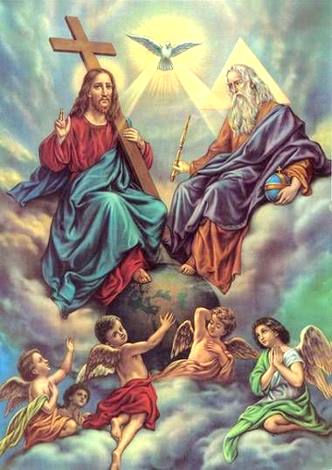

Key Words

Omnipotent – all powerful
Omniscient – all knowing
Omnibenevolent – all good/loving
Immanent – belief that God is at work in the world, for example performing miracles.
Transcendent – God is beyond space and time, not controlled or limited by either.
Impersonal – God is beyond human understanding, unknowable and mysterious.

God is… | Explanation
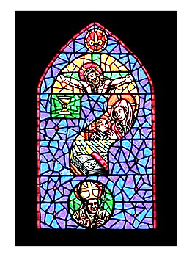

Christian Beliefs about the Nature of God

Omnipotent – all __________________. God has
____-_____________ power.

Omniscient – all _____________. God __________
and _____________ everything.

Omnibenevolent – God is all __________________
and all ___________. This suggests He __________
for all his creations.

Immanent – belief that God is at _________ in the
world, for example performing _______________.
___________ was an example of this.

Transcendent – God is beyond __________ and
________, not ________________ or ___________
by either.

Impersonal – God is beyond ______________
__________________. He is unknowable and
__________________________

Personal – the idea the _______ is a person that
_____________ can have a ___________________
with and can _____________________ with.

