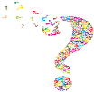
Peace & Conflict Revision Quiz
- What is the Buddhist First Precept?

- Note down two possible causes of war.

- Give an example of an organisation that helps victims of war. Note down three ways in which this organisation helps victims of war.

- What is a Just War? Note down 4 of the criteria.

- What is a Holy War? Give a definition and an example.

- Give an example of a Buddhist who has campaigned for peace. Give some examples of his actions.

- Give an example of a Christian group that has campaigned for peace. Note down some examples of their actions.

- Give an example of a Christian who has led peaceful campaigns against injustice. Note down some examples of his actions.
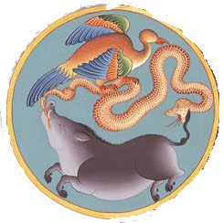

- What are the Buddhist Three Poisons?

- Explain reasons why two of the Three Poisons could lead to conflict.

- Note down two Christian teachings that suggest peace is preferable to war.

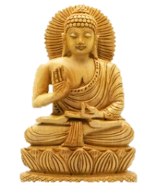
- Note down a Christian teaching that suggests war is acceptable in some circumstances.

- Note down a Buddhist teaching that suggests Buddhists should be pacifists.

- What is a riot? Give an example of a riot in the UK and a reason why this riot started.

- What is terrorism? Give a different Buddhist teaching to the one you noted down in Q13 that suggests Buddhists should never engage in terrorism.

- Give examples of two wars fought in the 21st Century. Give a reason why one of these wars could be said to be ‘just’, and a reason the same war might not be ‘just’.

- What is the Buddhist belief that means if you treat people badly bad things will happen to you?

- What are the Geneva Conventions? Give two examples of these conventions.

- Explain briefly what ‘Engaged Buddhism’ is.

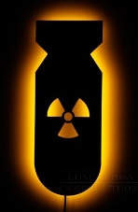
- What are WMDs? Give a reason why they do not meet the just war criteria.

- Where were the only atomic bombs to be used, dropped?

- Give examples of two other types of WMDs. Note down two of the main effects of each of these types of weapon.

- What is CCND? Note down three ways in which they campaign for their cause.

- Note down three different groups of people that are likely to become victims of wars.

- Note down two examples of how each of the groups you have mentioned in Q24 might be affected by war.
Peace & Conflict - Exam Questions.

1 Which one of the following is a largely acceptable reason for going to war?

A) Retaliation B) Greed C) Power D) Self-defence [1 mark]

2 Give two religious beliefs that show that violence is wrong. [2 marks]

3 Explain two contrasting beliefs in contemporary British society about whether religious believers
should fight in holy wars.

In your answer you should refer to the main religious tradition of Great Britain and one or
more other religious traditions. [4 marks]

4 Explain two reasons why religious beliefs should help victims of war. Refer to scripture or sacred
writings in your answer. [5 marks]

5 ‘The use of weapons of mass destruction is sometimes necessary.’

Evaluate this statement.

In your answer you:
• should give reasoned arguments in support of this statement
• should give reasoned arguments to support a different point of view
• should refer to religious arguments
• may refer to non-religious arguments.
• should reach a justified conclusion [12 marks] SPaG 5 Marks
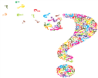
Peace & Conflict - Exam Questions (2).

1 Which one of the following is not an organisation that helps victims of war?

A) Red Cross B) United Nations C) CND D) Christian Aid [1 mark]

2 Give two ways in which religious believers could help victims of war. [2 marks]

3 Explain two contrasting beliefs in contemporary British society about whether countries should
possess weapons of mass destruction.

In your answer you should refer to the main religious tradition of Great Britain and one or
more other religious traditions. [4 marks]

4 Explain two religious beliefs about reconciliation. Refer to scripture or sacred writings in your
answer. [5 marks]

5 ‘Pacifism is the only way to end all conflict.’

Evaluate this statement.

In your answer you:
• should give reasoned arguments in support of this statement
• should give reasoned arguments to support a different point of view
• should refer to religious arguments
• may refer to non-religious arguments.
• should reach a justified conclusion [12 marks] SPaG 5 Marks

