bd06662_

**Useful Quotations – War & Peace**

*Fill in the missing words;*

1. ‘Love thy \_\_\_\_\_\_\_\_\_\_\_\_\_\_\_\_\_\_\_\_\_\_\_\_’. (Jesus)
2. ‘You \_\_\_\_\_\_\_\_\_ \_\_\_\_\_\_ kill’. (Bible – Ten Commandments)
3. ‘If there is \_\_\_\_\_\_\_\_\_\_\_ injury you are to \_\_\_\_\_\_\_\_ a life for a \_\_\_\_\_\_\_, eye for an \_\_\_\_\_\_\_. (Bible)
4. Everyone has a \_\_\_\_\_\_\_\_\_\_\_\_ to seek asylum. (UDHR)
5. ‘Avoid harming any \_\_\_\_\_\_\_\_\_\_\_\_\_\_\_\_\_\_ \_\_\_\_\_\_\_\_\_\_\_\_\_\_. (Buddhism)
6. ‘All who \_\_\_\_\_\_\_\_\_\_ by the \_\_\_\_\_\_\_\_\_\_\_\_\_\_, die by the \_\_\_\_\_\_\_\_\_\_\_\_\_\_’. (Bible – Jesus).
7. ‘Blessed are the \_\_\_\_\_\_\_\_\_\_\_\_\_\_\_\_\_\_\_.’ (Bible – Jesus)
8. ‘They will \_\_\_\_\_\_\_\_\_\_\_\_\_ their swords into \_\_\_\_\_\_\_\_\_\_\_\_\_\_\_\_\_\_\_\_\_ …nation will not take up \_\_\_\_\_\_\_\_\_\_\_\_\_ against \_\_\_\_\_\_\_\_\_\_\_\_\_.’
9. ‘If you don’t have a \_\_\_\_\_\_\_\_\_\_\_\_\_\_, sell your \_\_\_\_\_\_\_\_\_\_\_\_\_ and \_\_\_\_\_\_\_\_ one’. (Bible – Jesus)
10. ‘The light of \_\_\_\_\_\_\_ is in every single \_\_\_\_\_\_\_\_\_\_\_\_\_’.

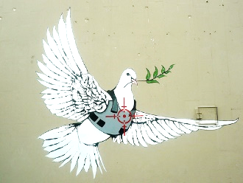 (Quakers)