Helping Victims of War
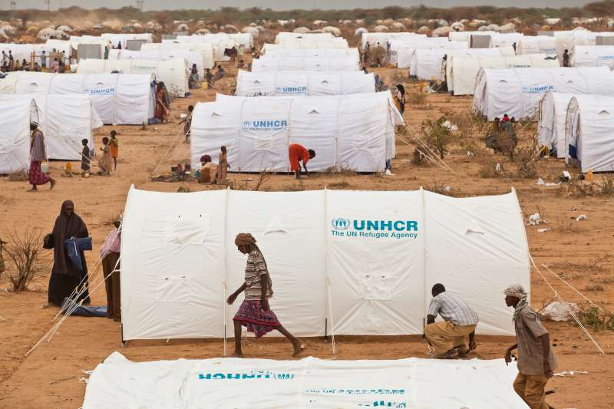
Victims of War.

Casualties are an unavoidable part of war. In addition to the harm that is caused to those directly involved in the fighting harm is also caused to their family and friends. Apart from the grief caused if a loved one dies in a war, there may be financial issues too, for example if the main wage earner dies, the family may struggle. Serious injury can also have emotional effects on the whole family.
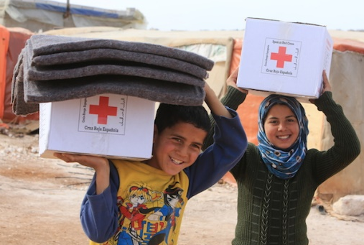
There are many organisations that offer help to victims of war. For example The Red Cross, UNICEF and UNHCR.

Christians would support these organisations due to the basic Christian belief to, ‘Love your neighbour’. Buddhists would support such charities due to their belief that all suffering should be stopped, whatever its origin.
Research…

Complete a table outlining what the Red Cross - http://www.redcross.org.uk/ and the UNHCR - http://www.unhcr.org/uk/ (United Nations High Commission for Refugees) to help victims of war.

Exam questions…

- Give two ways in which religious believers would help victims of war. (2 marks)

- Explain two reasons why religious believers should help victims of war. (5marks)

You should now be able to answer questions on all parts of the Peace & Conflict topic…

The meaning and significance of:

• peace
• justice
• forgiveness
• reconciliation.
• Violence, including violent protest.
• Terrorism.
• Reasons for war, including greed,
self-defence and retaliation.
• The just war theory, including the
criteria for a just war.
• Holy war.
• Pacifism.

Religion and belief in 21st century conflict:

• Religion and belief as a cause of war and violence
in the contemporary world.
• Nuclear weapons, including nuclear deterrence.
• The use of weapons of mass destruction.
• Religion and peace-making in the contemporary world
including the work of individuals influenced by religious
teaching.
• Religious responses to the victims of war including the
work of one present day religious organisation.

Review/Revise…

Review your notes and make sure they are complete and include work on each of the above topics. Note down one important thing about each bullet point.

Organisation | Where? | Who? | What? | Effects/Results
Red Cross
http://www.redcross.org.uk/
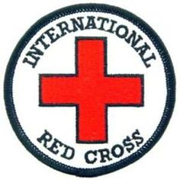

UNHCR
http://www.unhcr.org/uk/

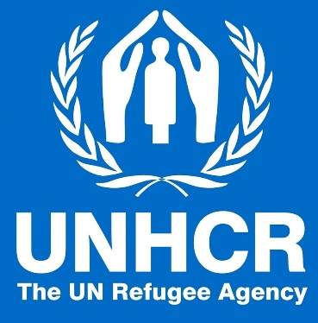

Helping Victims of War - Charities

