Religion, Peace & Conflict – WMDs
Nuclear Weapons.
Key Terms

Weapons of Mass Destruction:
Weapons that cause uncontrollable damage and large numbers of deaths.

Nuclear Weapons:
Weapons that work by a nuclear reaction, devastating huge areas and killing large numbers of people.

Chemical Weapons:
Weapons that use chemicals to poison, burn, paralyse or kill humans and destroy the environment.

Biological Weapons:
Weapons that release living organisms or infective material that can lead to disease or death.
Christians and Buddhists do not agree with the use of weapons of mass destruction. Many have joined protests against them. Nuclear or atomic bombs are capable of killing thousands of people at once. They kill indiscriminately meaning armed forces cannot be solely targeted and innocent civilians will be killed. Therefore these weapons violate the Geneva Conventions (rules for war) and, for Christians the use of these weapons would make a war ‘unjust’.
The only nuclear weapons that have been used have been the attacks on the Japanese cities of Nagasaki and Hiroshima in 1945. Nowadays nuclear weapons are far more powerful and are fired from many miles away so whoever releases the weapon does not directly see the immediate effects of the attack.
Hiroshima & Nagasaki.

The two atomic bombs were dropped with the aim of ending the war with Japan after WW2 had ended in Europe. After Germany had surrendered, the Allies demanded Japan did the same. However Japan ignored the order and carried on fighting.
The two bombs caused the deaths of at between 129,000 – 226,000 people. During the following months, many more people died from the effect of burns, radiation sickness, and other injuries, compounded by illness and malnutrition. In the following months several thousand people died of cancer. In both cities, most of the dead were civilians, even though Hiroshima had a sizable military garrison.

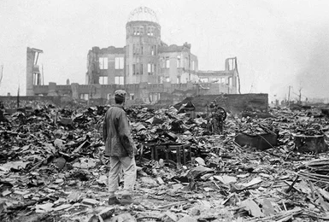

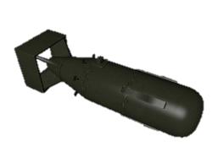
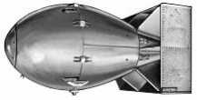
Things to do…

- Why would the use of a nuclear bomb go against the Just War criteria?
- Where were the only nuclear weapons to be used, dropped?
- Who were the main victims of the bombs? Approximately how many died?
- Why were these bombs dropped?

1-2-3…

Give one Buddhist teaching; two Christian teachings and three non-religious reasons for why the use of nuclear weapons is wrong.

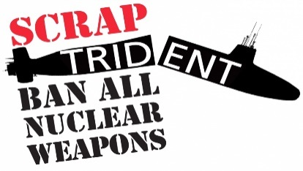

CND.

CND campaigns non-violently to achieve British nuclear disarmament – to get rid of the Trident nuclear weapons system and stop its replacement. But we recognise that Britain’s nuclear weapons are only a small part of the problem, so we also campaign for a global nuclear weapons ban, the prevention and cessation of wars in which nuclear weapons may be used and the encouragement of non-military solutions to conflict.

Christian CND.

Christian CND is a specialist section of the Campaign for Nuclear Disarmament with its own separate membership. CCND provides a focus for Christians who campaign against nuclear weapons and other weapons of mass destruction – and for peace, as a part of their Christian faith.
They have organised many conferences and meetings as well as acts of protest, and religious services at military bases and government sites. Being seen publicly is only one aspect of their work: they are also engaged in letter writing and educating for peace and disarmament. They work closely with all Christian justice and peace organisations, on nuclear issues as well as working alongside Campaign for Nuclear Disarmament.

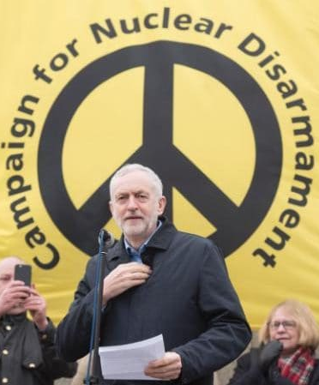
Chemical Weapons.
Chemical Weapons contain lethal chemical that can cause many deaths. These weapons were made illegal, worldwide in 1993. However they are believed to have thought to have been used in Iraq and Syria. Sarin is one chemical used in Syria. It is a nerve gas that affects the muscles and causes asphyxia.

Biological Weapons.
These weapons introduce harmful bacteria and diseases into the atmosphere. They can enter the food chain and water supply and cause illness and death on a massive scale. They are also illegal.

Note down …

- Note down three bullet points of information about CND, including their aims and how they try to achieve their aims.
- Note down three bullets point of information about CCND, including who they are, what they do and why they do it.
- Note down three bullet points of information about chemical weapons and three bullet points about biological weapons.
- Note down definitions of the key terms on this sheet.

