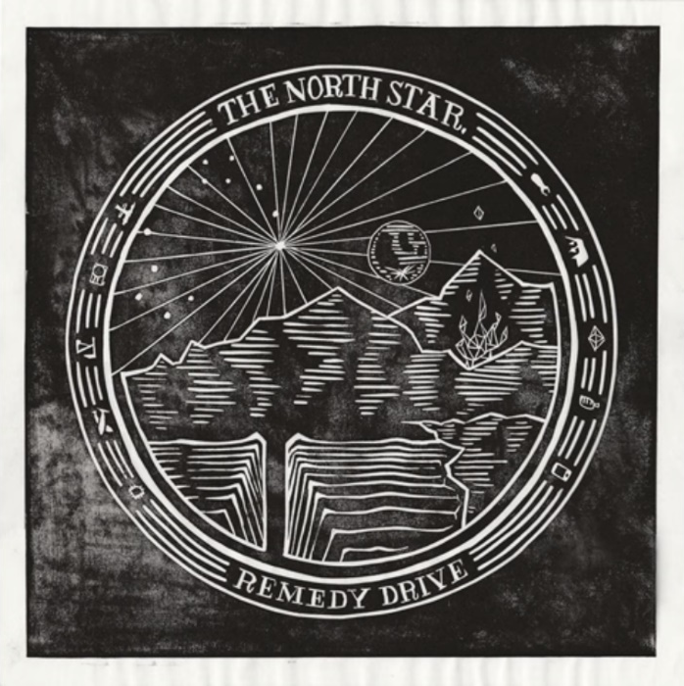
Warlike by Remedy Drive
“He has shown you, O man, what is good;
And what does the LORD require of you
But to do justice and to love mercy,
And to walk humbly with your God?”
Prophecy of Micah 6:8

Vocab (page 1)
clear cut – an area with all trees removed
demagogue – one who manipulates crowds with speeches
demi-god – half human, half god (Greek myth)
GMO – genetically modified organism
land mines – small bombs hidden under the soil that explode when stepped on
opioids – drugs similar to opium
racketeer – one who extracts money from others unfairly
strip mine – an open cast mine (for coal)
‘tickling ears’ – saying what people want to hear
titanium – a valuable metal
uranium – a metal used in nuclear bombs

https://www.youtube.com/watch?v=agMVILRQEeo
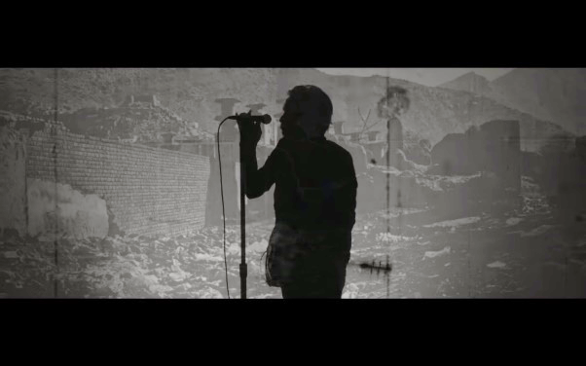
Keep your microchips out of my kid's skin
Keep your chemicals out of my oxygen
Keep your GMO out of my blood stream
Keep your oil fields and your war machine
Must we be the first and the strongest
Industrial military complex?
You can't take the prophets out of context
You can't love mercy if you love conquest
I'm not joking here
Something's broken here
I just hope it's clear
It's just smoke and mirrors
They're just stocking fears
They're just racketeers
It's a thin veneer
They're just tickling ears
Strong man said let's steal their oil and they cheered him on
Strong man said let's scorch the soil of the children
What's wrong, man, why you celebrate the talk of war crimes?
I don't belong, man, I'm not a fan of barrel bombs and land mines
Demi-gods like demagogues like war lords white collar frauds
In New York suits or in camouflage either way it's looks the same
It's a corruption it's a con job
Why are we so warlike?
Why are we so warlike?
Clear cut, land fill, oil spill, strip mine
They're draining out the essence of my soul through a pipe line
Turmoil like a flood growing toxic from the start
It's oil and not blood flowing through your dark heart
Where's the justice here?
They're just profiteers
Special interest has got their ears
But we need our
Opioids and our titanium
We've displaced the masses for cocaine and uranium
Building industry on the backs of the exiles and the enslaved
Textiles just like tobacco in the good old days
“In the same way as you judge others, you will be judged, … ‘Why do you look at the speck of sawdust in your brother’s eye and pay no attention to the plank in your own eye? … hypocrite, first take the plank out of your own eye, and then you will see clearly to remove the speck from your brother’s eye.”
Jesus in Matthew 7:2-5

Vocab (page 2)
apathy – not caring
blood diamond – a diamond sold to fund wars
coltan – a valuable mineral
hyper nationalism – extreme nationalism
schisms – divisions/breakaway groups
self-righteous – thinking you are morally better than everyone else (when you’re not)
Is this a blood diamond? I can't tell
I own blood minerals they're in my cell phone
How did we accumulate such wealth
What if the war criminal is myself?
Why are we so warlike?
Why are we so warlike?
Why are we so warlike?
Why are we so warlike?
The shrimp boats, the cocoa, the copper, the coffee, the coltan, the cotton
Why am I bringing it up again and again?
The tin and the timber the sugar cane; it's still the same
We're looking the other way today it feels like we've forgotten
Without the demand there'd be no need for the supply
There's blood on your hands, man and there's a plank in your eye
Questions
- What cause of war is mentioned here?
- List at least four effects of war here.
- Why can’t you ‘love mercy if you love conquest’?
Extension
- Of what is the writer accusing national leaders? (See verse beginning ‘Strong man’ p.1)
- Of what is the writer accusing consumers in the verse beginning ‘Without demand…’?
- What is meant by the line, ‘What if the war criminal is myself?’?

You don't look a thing like Jesus Christ to me
You look like self-righteous apathy
You look like entitlement and supremacy
Ye who tread on the weak to defend the wealthy
You talk so causally
Of endless battles, factions and schisms
Can't you see the casualties
Of your hyper nationalism?
Lyrics taken from <a href="https://www.elyrics.net/read/r/remedy-drive-lyrics/warlike-lyrics.html?ref=lyte">this page</a>

