The Mission
Glossary
cardinal - one of the very highest leaders in the Catholic church (one rank below Pope)
doctrine - a teaching or belief
Guarani - a tribe of jungle-dwelling people native to South America
Ignatius Loyola 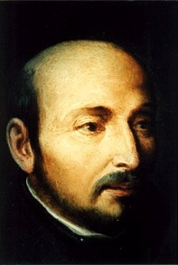 (1491-1556) Founder of the Jesuits. He was originally a Spanish knight but was seriously wounded in battle. He read a book on the life of Christ and decided to give up military life to become a spiritual ‘soldier of Christ’ instead.
Jesuits - missionary priests who belong to an order called the Society of Jesus (originally founded in 1534 by St Ignatius Loyola)
missionary - someone who is sent to a place to win people over to their religion
martyr - someone who dies for his or her beliefs
order - a religious organization, usually monks or nuns with rules and a command structure
penance - volunteering for punishment in order to make up for your sins
San - Spanish word for ‘Saint’ e.g. San Carlos = Saint Charles
Your Eminence - a phrase used when addressing a cardinal
Your Holiness - a phrase used when addressing the pope

Write who each character is and what happens to them in the story.
Unnamed Jesuit priest
Father John Fielding (Liam Neeson)
Father Gabriel (Jeremy Irons)

Guarani Chief (Asuncion Ontiveros)
Carlotta (Cherie Lunghi)
Felipe Mendoza (Aidan Quinn)

Roderigo Mendoza (Robert de Niro)
Don Cabeza, the Spanish governor (Chuck Low)
The political situation
Señor Hontar, Portuguese ambassador (Ronald Pickup)
Cardinal Altamirano (Ray McAnally)
San Carlos Mission

