Pacifism & Peacemaking Summary Sheet
(Pages 134-5 in the Buddhism textbooks and 136-7 in the Christianity textbooks)
This sheet is to summarise the beliefs of pacifists and the reasons for their beliefs.
According to the AQA specification you need to know the following things for the exam:
- ‘Pacifism
• Religion and peace-making in the contemporary world including the work of individuals influenced by religious teaching.’
Terminology
absolute pacifist - someone who believes that violence is always wrong in every situation
contingent pacifist - someone who believes in non-violence in certain situations where others would disagree
Engaged Buddhism - an organization that seeks to apply Buddha’s teaching to situations of war and social justice
pacifism - the belief that violence is wrong/refusal to fight
peacemaker - one who tries to bring an end to conflict

Buddhism
Buddha taught that his followers should ‘not harm a sentient being’ (The first of the Five Precepts). He taught that even if you were horribly attacked with a saw that you should still not give way to hatred but should have compassion on the attackers.
‘In times of war give rise in yourself to the mind of compassion, help living beings abandon the will to fight.’
Buddha
This means that Buddhists will not fight in any war or use personal violence against others. Some Buddhists are not very religious and will be soldiers in an army. Most Buddhist countries have armies but then, governments are often non-religious.

Christianity
Some Christians follow Just War Theory and believe that fighting in self-defence is reasonable.
Other Christians believe that violence is always wrong. These Christians look at what Jesus said in different places:
  - ‘He who draws the sword will surely perish by it.’
  - ‘Blessed are the peacemakers for they shall be called children of God.’
  - ‘I tell you, do not resist an evil person. If anyone slaps you on the right cheek, turn to them the other cheek also.’
  - ‘I tell you, love your enemies and pray for those who persecute you.’
  - Also, in the Ten Commandments God says ‘You shall not kill.’

Peacemakers
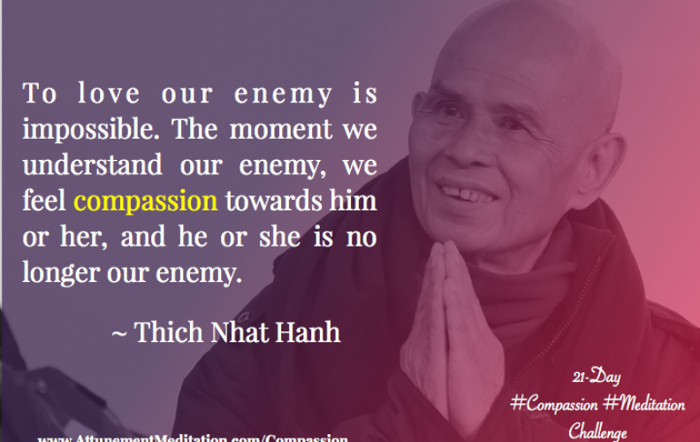
Thich Nhat Hanh is the founder of Engaged Buddhism. This is an organization to bring about social justice without harming others. During the Vietnam war he helped victims escape to other countries. In America he has also led peaceful protests for an end to war. He used to know Martin Luther King who spoke very highly of him.
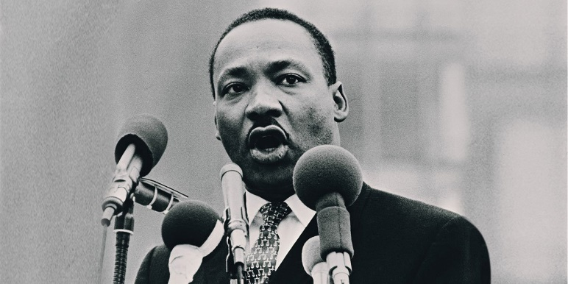
Martin Luther King was a contingent pacifist. He did not agree with America being in the Vietnam War. He was not opposed to all war but though that this one was wrong. He also campaigned for racial equality in the USA using only non-violent means. He was awarded the Nobel Peace Prize in 1964 for his commitment to racial justice through non-violent protest in spite of being on the receiving end of racist violence.

