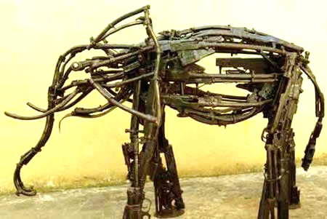

Christian Pacifists.

The Quakers (Religious Society of Friends) are a Christian denomination who are famous for their pacifist views. They think that violence nearly always creates more problems than it solves. They believe that, ***‘The light of God is in every single person’***, therefore believe in the sanctity of life. In 1916 the Quakers put out the following statement; ‘***War, in our view, involves the surrender of the Christian ideal and the denial of human brotherhood’.*** Quaker pacifism is not simply the refusal to fight: it includes working actively to bring about or preserve peace, by removing the causes of conflict. During war time Quakers work as medics, cooks and mechanics. In World Wars I & II some Quakers volunteered for the Friends’ Ambulance Unit.

Questions.

* What are the chairs the man is sat on made out of?
* This was a Christian Aid project in Mozambique. What do you think had happened there at the time of the project?
* Read Isaiah 2:4. What is the connection to the project?

They will beat their swords into ploughshares and their spears into pruning hooks.

Nation will not take up sword against nation, nor will they train for war anymore. *Isaiah 2:4*

What is Pacifism?

Pacifism is the belief that war and violence are wrong. A pacifist is someone that holds these beliefs. The majority of Buddhists are pacifists due to their belief in the First Precept - Avoid harming any sentient being.

Some Christians may also be pacifists due to Jesus’ teaching, ‘Blessed are the peacemakers’. However some Christians belief that if there is a good reason, war can be ‘Just’.

The civil war in Mozambique lasted for over 15 years and it started just two years after the war of independence which lasted 10 years. ‘Guns into Plowshares’, was Christian Aid’s response. Guns were handed in and replaced with tools that will help people earn a living, as well as reducing violence.

Pacifism & Pacifists

Buddhist Pacifists – Thich Nhat Hanh.

Thich Nhat Hanh is a Vietnamese Buddhist monk. He has been a peacemaker ever since he became a monk at the age of 16. He helped villagers during the bombing of the Vietnam War, and led protests against it. He is a pioneer of ‘***Engaged Buddhism***’ which argues that if Buddhists are to gain ‘inner peace’ they must work to put right injustices in society. However, being a Buddhist movement, this should always be done in a peaceful way. He also believes meditation is important for remaining calm in difficult situations. On one occasion he organised a rescue of hundreds of Vietnamese refugees, but the government stopped him and ordered him to leave the country. In this situation, meditation was the only option, or else violence could erupt.

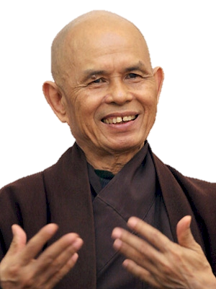

World War I & II

Quaker Peace

Who is he?

Engaged Buddhism

Vietnam War

Refugees

Quotation

Quotation

**Quakers**

Thich Naht Hanh



Exam Question

**1**

‘The best way to bring about world peace is for more individuals to

become pacifists’.

Evaluate this statement.

In your answer you:

* Should give detailed arguments in support of the statement
* Should give detailed arguments in support of a different view.
* Should refer to religious arguments
* May refer to non-religious arguments
* Should reach a justified conclusion.

I disagree with the statement because if people become pacifists, they will make themselves easy targets for their enemies. If someone attacks you and you don’t fight back, you are just going to die, or your whole country could be taken over. The bible teaches, ‘life for a life’. Also not enough people will ever become pacifists to make a difference. There will always be people that will want to start wars due to greed, wanting power and land.

Some people think different. Buddhists follow the First Precept so don’t believe in fighting. Quakers also do not believe in fighting because it kills people. In war time quakers were ambulance drivers. Some people in war become refugees and have to leave their homes and live in refugee camps which are sometimes run by christian charities like the red cross.

Overall I disagree with the statement because not everyone will ever become a pacifist and this is the only way it will work because people will always start wars for one reason or another.

bd06662_

|  |  |  |  |
| --- | --- | --- | --- |
| Level | **Level Descriptors** | Marks | /12 |
| 4 | ***A well-argued response***, reasoned consideration of different points of view. Logical chains of reasoning ***leading to judgement***(s) supported by knowledge and understanding of relevant evidence and information. | 10-12 |  |
| 3 | Reasoned consideration of ***different points of view***. Logical chains of reasoning that draw on knowledge and understanding of relevant evidence and information. | 7-9 |  |
| 2 | Reasoned consideration of a point of view. A ***logical chain of reasoning*** drawing on knowledge and understanding of ***relevant evidence*** and information. OR Recognition of ***different points of view***, each supported by relevant reasons / evidence. | 4-6 |  |
| 1 | Point of view with reason(s) stated in support. | 1-3 |  |



Exam Question

**2**

‘The best way to bring about world peace is for more individuals to

become pacifists’.

Evaluate this statement.

In your answer you:

* Should give detailed arguments in support of the statement
* Should give detailed arguments in support of a different view.
* Should refer to religious arguments
* May refer to non-religious arguments
* Should reach a justified conclusion.

I disagree with the statement because there will always be some people that want to start wars for reasons such as greed and power. Not enough people will ever become pacifists to make a difference to world peace, therefore in war time they are likely to be killed as they wouldn’t fight back to defeat an enemy that is intent on becoming a dictator.

In the Bible it says, ‘Life for a life’, this would suggest if someone attacks you, you have a right to defend yourself. Therefore if a country invades another one it would be ‘Just’ to fight back, therefore there will never be world peace.

Buddhists would agree with the statement because they follow the First Precept, which is to avoid harming any sentient being. In war time people are always harmed. The only way to stop this is for individuals to become pacifists. Buddhist scripture also says that ‘hatred is never overcome with hatred, hatred is overcome with love’. Buddhists therefore believe that hatred, that often leads to violence, can only end when we show compassion to everyone and we become pacifists.

Although some Christians believe fighting for ‘Just’ reasons is acceptable, some Christians are pacifists. For example the Quakers believe violence just leads to more problems. During the First world war they issued the statement - ‘War, in our view, involves the surrender of the Christian ideal and the denial of human brotherhood’. However, Quakers will help out during war time, even on the frontline as medics and ambulance drivers, but they will not carry weapons.

Overall, I would agree with the statement. It would be very difficult to get enough people to become pacifists to make a difference to world peace, but that doesn’t mean it is impossible. If more people are inspired by people like Thich Naht Hanh and his peaceful protests against violence (for example during the Vietnam War) there could be world peace.