Desmond Doss: A Pacifist’s Tale
Terminology
CO – conscientious objector – someone who objects to war because of their conscience about killing
court martial – a military trial
furlough – holiday
pacifism - the belief that all violence is wrong
Seventh Day Adventist – a type of Christianity that believes in Saturday as the day of rest and worship instead of Sunday
sabbath – a religious day of rest & worship
Section 8 discharge – when somebody is removed from the army for being insane
Religious teachings
‘Thou shalt not ____.’ (10 Commandments)
‘Turn the other c_____.’ (Jesus)
‘A n__ commandment I g___ unto you that you l____ one another as I have loved you.’ (Jesus)
‘Love your enemies and pray for those who persecute you.’ (Jesus)
Questions
- Desmond’s father is against war because…

- Captain Glover mocks Doss because …

- Sarge does not agree with Doss because…

- One argument against Desmond’s actions at the trial is…

One argument in his defence is …

- Desmond’s personal reason for not touching weapons is…

- Practised what teaching towards the Japanese?

- How many did Desmond Doss rescue at Hacksaw Ridge?

- What reward was he given?
Extension work:
- Explain two religious teachings on fighting in wars. [4 marks]
- Explain two contrasting beliefs about pacifism. In your answer you must refer to scripture.
Exam question
- ‘Pacifism cannot work in the real world.’ Do you agree? [12 marks]

Other famous pacifists
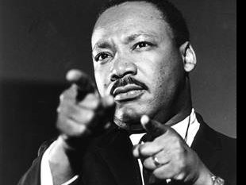
Martin Luther King campaigned non-violently against racist laws in the USA in the 1950s and 1960s.
Thich Nhat Hanh is a peace campaigner who has rescued refugees from different countries. His organization is called Engaged Buddhism.

