Religion, Peace & Conflict – Holy War
The Crusades.
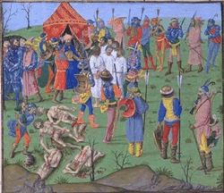The Crusades were a series of religiously sanctioned military campaigns waged by much of Christian Europe, particularly France and the Holy Roman Empire. Pope Urban II was the first Pope to initiate a Crusade. The specific crusades to restore Christian control of the Holy Land were fought over a period of nearly 200 years, between 1095 and 1291. Other campaigns in Spain and Eastern Europe continued into the 15th century. The Crusades were fought mainly against Muslims, although campaigns were also waged against political enemies of the popes. Crusaders took vows and were granted penance for past sins, often called an indulgence.
The Crusades originally had the aim of recapturing Jerusalem and the Holy Land from Muslim rule and were launched in response to a call from the Christian Empire in the East for help against the expansion of the Muslim Turks. The term is also used to describe subsequent campaigns conducted through to the 16th century against pagans, heretics, and peoples under the ban of excommunication.

The Troubles
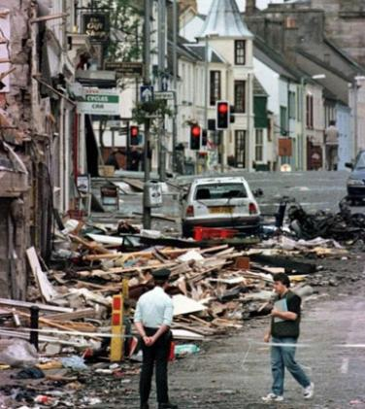There is a common perception of The Troubles in Northern Ireland as a religious conflict, as one side (Nationalists) was predominantly composed of Catholics and the other (Unionists) of Protestants. However, the more fundamental cause is the attachment of Northern Ireland to either the Republic of Ireland or the United Kingdom and while religion played a role as a cultural marker, the conflict was in fact ethnic or nationalistic rather than religious in nature. Since the native Irish were mostly Catholic and the later British-sponsored immigrants were mainly Protestant, the terms become shorthand for the two cultures, but it is inaccurate to describe the conflict as a religious one.
Things to do.

- Highlight words you do not understand. Use a dictionary to look the words then note them down in your books with definitions.
- Note down three bullets points of important information about the Crusades.
- Were the Crusades a Holy War? Explain using reasons and evidence for your answer.
- Note down three bullet points of important information about The Troubles.
- Can The Troubles be classed as a Holy war? Explain using reasons and evidence.

