D:\mhp\Common\MSShared\Clipart\std4prem\std4dir3\SO01900_.wmfD:\mhp\Common\MSShared\Clipart\std2prem\std2dir2\BD17651_.WMF

**Religion, Peace & Conflict – Just War**

The Just War Theory.

St. Thomas Aquinas first set out a distinct criteria for a Just War in the 13th century. It has been developed over many years by other Christian thinkers. The Just War criteria seeks to lay out the conditions under which fighting a war is justifiable.

* The war must have a just cause. This may include self-defence or defending an ally. It must not be for greed (e.g. gaining territory or resources) or in retaliation.
* The war must be declared by the government or lawful leader of the country. E.g. Neville Chamberlain declared war on Germany (WWII).
* The intentions of the war must be good, e.g. to defeat wrong doing and promote good. The good achieved by the war must outweigh the evils of war and what led to the war.
* Fighting must be a last resort. All other ways such as sanctions, diplomacy and peace talks must have been tried and failed before the war is declared.
* There must be a reasonable chance of success. It is unjust to ask people to fight in a war if it is probable that the war will be lost and they will be killed.
* The methods used to fight the war must be proportional, to achieve success. Excessive force (e.g. nuclear weapons) should not be used. This helps to keep civilian casualties to an absolute minimum.
* Internationally agreed conventions on the conduct of war must be followed. The Geneva Conventions, 1957, lays down the rules that must be obeyed in war.

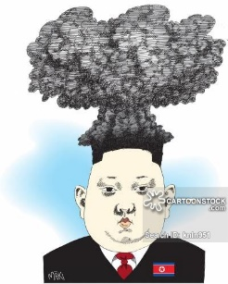



Note down...

1. Draw up a table to note down each of the Criteria with an explanation and at least one example.
2. Note down some of the rules of war – Geneva Conventions.

The Falklands War.

The Falklands and South Georgia are British territories off the coast of Argentina, South America. They have a population of just less than 3,000 people. For many year Argentina believed they should govern the Islands. In April 1982 Argentinian forces invaded the Islands, claiming them for themselves. Diplomatic pressure was put on Argentina to withdraw, but the British government sent a task force to reclaim the

Islands, although Mrs Thatcher (the Prime

Minster at the time) didn’t officially declare

a war. The Islands were regained in June 1982.

During the conflict almost a thousand

Argentinian and British service people were

killed. Three Falkland Islanders were also killed. The Islanders supported the war and the majority of Islanders still see themselves as

British citizens.

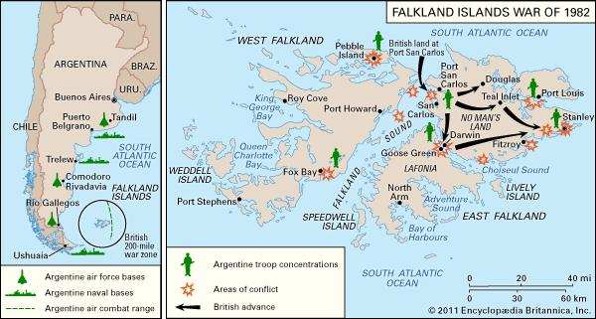



**Religion, Peace & Conflict – Just War**

|  |  |  |
| --- | --- | --- |
| Criteria | Explanation | Examples |
| The war must have a just cause. |  |  |
| The war must be lawfully declared. |  |  |
| The intentions of the war must be good. |  |  |
| Fighting must be a last resort. |  |  |
| There must be a reasonable chance of success. |  |  |
| The methods used to fight the war must be proportional. |  |  |
| Internationally agreed conventions on the conduct of war must be followed. |  |  |

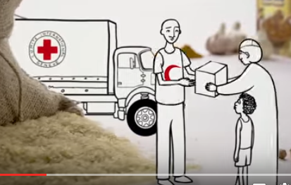

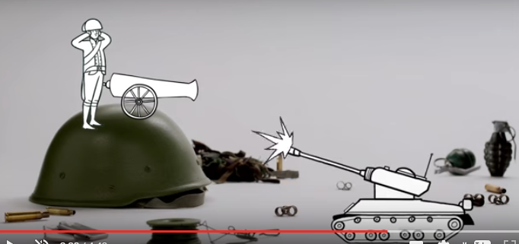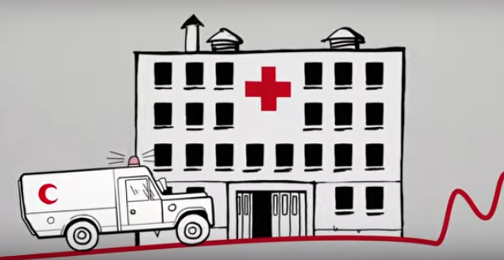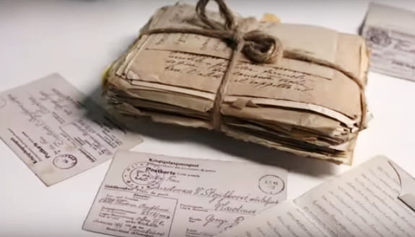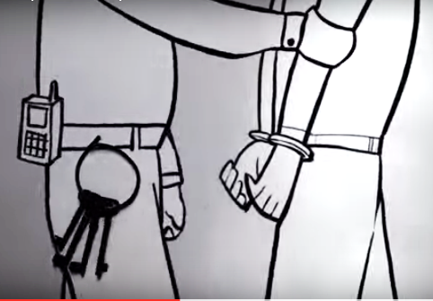

**The Geneva Conventions**

**(Rules of War)**

Re.

The F