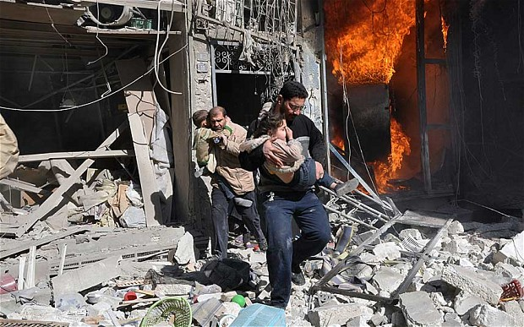

Where?

When?

What is happening? Why?

What Christians would think?

How might the situation be resolved and peace be maintained?

What Buddhists would think?

Who suffers?