D:\mhp\Common\MSShared\Clipart\std4prem\std4dir3\SO01900_.wmfD:\mhp\Common\MSShared\Clipart\std2prem\std2dir2\BD17651_.WMF

**Religion, Peace & Conflict – Protest, Violence & Terrorism**

Protest.

The right to protest is a right that all people should have. UK law allows people to demonstrate in public to get their point across. In the case of a march the police must be informed at least six days before the planned demonstration this is so that the police can apply to the court to stop a march that they consider could intimidate other or lead to violence.

2011 Riots.

Although the right to protest is protected in the UK, there is no right to violent protest. An unplanned protest that descends into violence is called a riot. A peaceful protest march after the police shooting of a Tottenham man was followed by riots, looting and criminal damage that spread to other cities in the UK. Afterwards it was local police, communities and faith groups that sought to repair the divisions between people caught up in the riots.

P

Although the right to protest is protected in the UK, there is no right to violent protest.

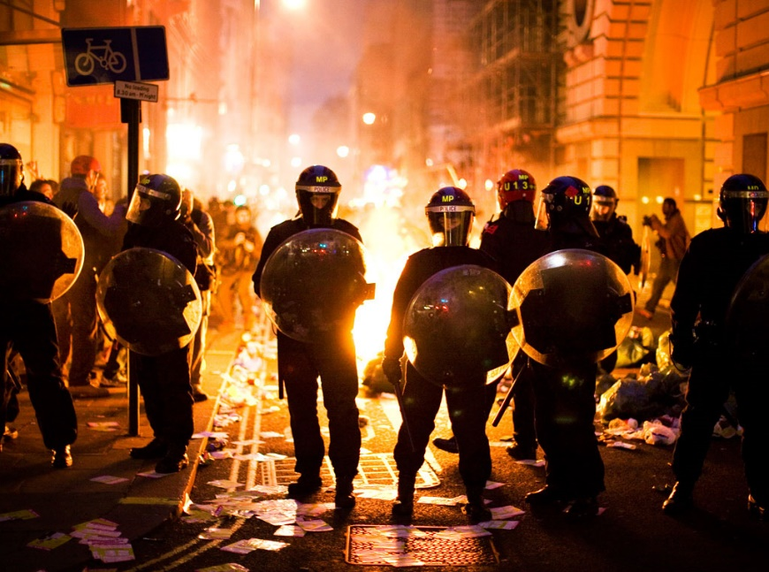

Religious beliefs.

No religion promotes violence in their teachings and generally agree that conflict should be avoided wherever possible. Buddhists are most likely to be pacifists due to following the 1st Precept – ‘Avoid harming any sentient being’.

Jesus said, ‘blessed are the peacemakers’, therefore peace is obviously preferable. However Christians also use the ‘Just War’ criteria, to justify going to war when necessary.

Peaceful Protest.

During segregation in the USA, peaceful protest was an important part of the Civil Rights movement led by Martin Luther King. He never resorted to violence in his fight for equal rights for black and white people. Even though he was assassinated in 1968, MLK gained worldwide respect for his peaceful methods and his message. The Civil Rights movement was successful; equal rights legislation was passed into US law.

Things to do.

1. Briefly explain the UK law on protest.
2. Would religious believers agree with what happened after the killing of Mark Duggan (Tottenham man killed by the police). Explain different points of view.
3. Note down the definitions for the key terms on your key terms sheet.

**Key Terms**

**Protest:** an expression of disapproval, often in a public group.

**Violence:** using actions that threaten or harm others.

**Terrorism:** the unlawful use of violence, usually against innocent civilians to achieve a political goal.





Terrorism.

One form of violent protest is terrorism. This is where an individual or a group who share the same beliefs, use terror to get their point across. Their violence is usually aimed at civilians and takes place in public places. Tactics of terrorists include suicide bombers, car bombs and gunmen shooting into crowds of people. Terrorists believe that causing fear will make people more aware of their cause, scare people and persuade governments to give way to their demands.

A terrorist may associate their cause with a religion. For example, in the USA fundamentalist Christians have attacked abortion clinics with bombs, bullets, acid and axes, killing doctors, nurses and supporters of legal abortions. Groups like ISIS have claimed responsibility for attacks in European cities including

killing a number of people in a Christmas market in Berlin. These examples are extreme and exceptional, they do not represent the beliefs of the vast majority of Christians or Muslims.

Things to do.

1. Explain an example of a religious believer who has used peaceful protest to achieve his aims.
2. Explain what terrorism is and give two examples of terrorist actions.
3. Why would Christians and Buddhists not agree with terrorism?

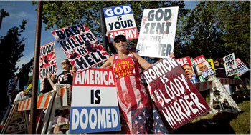

P

Although the right to protest is protected in the UK, there is no right to violent protest.

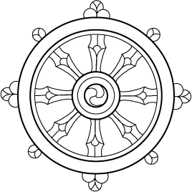

Christianity.

Jesus taught a message of love. The Quakers are a Christian group who are pacifists and will not take up arms against others. However some Christians accept that there are circumstances when it is necessary to use armed conflict and will fight in a Just war. No Christian denomination would support the use of nuclear weapons. The Bible teaches;

* ‘Those who live by the sword, die by the sword.’
* ‘Blessed are the peacemakers’.
* Love your enemies and pray for them’.

Most Christians only agree with war in certain circumstances, for example to defend against an invading force. The Crusades were fought to gain the Holy Land for Christianity and defend Christians.

Buddhism.

Buddhists follow teachings that promote peace and non-violence (ahimsa).

* The First Precept – To refrain from harming any sentient being.
* Hatred does not cease by hatred, hatred ceases by love. (Dhammapada)
* ‘Peace can exist if everyone respects all others’. Dalai Lama.

Buddhists believe their actions have consequences for their future rebirths (karma). They believe that all peaceful means to resolve conflict must be undertaken as war often leads to greater problems than it solves. War is often a result of the Three Poisons (Greed, hatred & ignorance).

The Dalai Lama was forced to leave Tibet when China invaded. He believes the only resolution can be a peaceful

one. He won the Nobel Peace Prize.

P

Although the right to protest is protected in the UK, there is no right to violent protest.