D:\mhp\Common\MSShared\Clipart\std4prem\std4dir3\SO01900_.wmfD:\mhp\Common\MSShared\Clipart\std2prem\std2dir2\BD17651_.WMF

**Religion, Peace & Conflict**

|  |  |  |  |
| --- | --- | --- | --- |
| Key Term | Explanation | Example(s) | Person/Organisation |
|  |  |  |  |
| Conflict  Image result for tank firing clipart |  |  |  |
| Image result for peace sign and dovePeace |  |  |  |
| Image result for justiceJustice |  |  |  |
| Image result for reconciliation handsReconciliation |  |  |  |
| Image result for forgiveness clipartForgiveness |  |  |  |

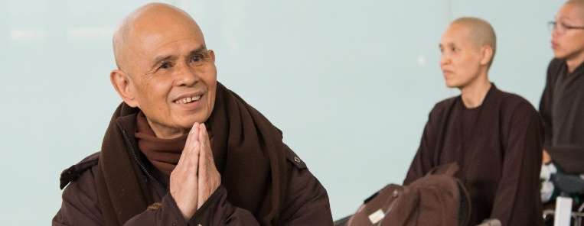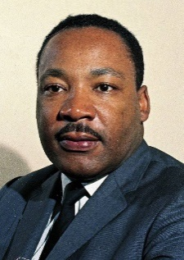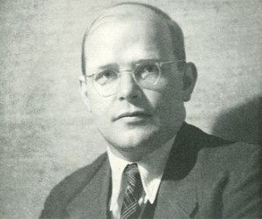D:\mhp\Common\MSShared\Clipart\std4prem\std4dir3\SO01900_.wmfD:\mhp\Common\MSShared\Clipart\std2prem\std2dir2\BD17651_.WMFD:\mhp\Common\MSShared\Clipart\std4prem\std4dir3\SO01900_.wmfD:\mhp\Common\MSShared\Clipart\std2prem\std2dir2\BD17651_.WMF

Reconciliation

For there to be lasting peace after a conflict the different sides need

to come together in a process of reconciliation. This process

attempts to resolve issues that led to conflict and bring about a

peace agreement.

Christian Arch-Bishop Desmond Tutu lead the

Truth and Reconciliation Commission after the abolition of Apartheid in South Africa. This process brought blacks and whites together to reconcile their differences after a long period of injustice and violence.

Justice

Justice is bringing about what is right and fair in situations that have been unjust. Many wars are fought to bring justice and to fight injustice.

Justice is often linked to equality because if people are not given the same opportunities this is seen as unfair. American Christian Pastor Martin Luther King fought injustice in the USA during the 1950s and 1960s during a time of Segregation of Blacks and Whites.

Peace

Peace is the absence of conflict. If we have peace, we can live in harmony and without fear. The Universal Declaration of Human Rights says everyone has a right to, ‘life, liberty and security of person’ (Article 3), without peace these are not possible.

Religious believers see peace as far more preferable than war. Jesus said, ‘Blessed are the Peacemakers’ (Matthew 5:9). The Quakers are a Christian group who are pacifists (believe war and violence are wrong). During war time the Quakers refused to take part in fighting, instead they worked as ambulance drivers and first-aiders.

Thich Nhat Hanh is a Vietnamese Buddhist Monk. He is a pioneer of

‘Engaged Buddhism’ which argues that, to achieve true inner peace,

Buddhists must to change the injustices in society. He combines

traditional Buddhist practice with non-violent protest. He protested

against the Vietnam War and helped Vietnamese refugees escape the

violence.

Conflict

Conflict is disagreement. There is conflict before war starts, armed conflict is the actual war. Groups such as the United Nations (UN) try to help countries and groups in conflict resolve issues before war breaks out and try to bring about peaceful solutions to end war. The civil war in Rwanda ended with a UN brokered peace agreement, however during the genocide that followed, the majority of UN forces left the country and did not help end the killing.

Religious believers often get involved in trying to prevent conflict. Dietrich Bonhoeffer was a Christian Pastor involved in a plot to kill Hitler. He did this in an attempt to end further bloodshed.

**Religion, Peace & Conflict**

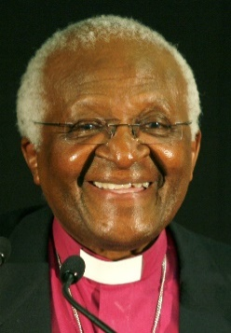

Forgiveness

To move forward after conflict forgiveness is important. Forgiveness is accepting an apology and putting the wrong-doing behind us.

Forgiveness is a central teaching is Christianity, Jesus answered Peter’s question; "Lord, how many times shall I forgive my brother when he sins against me? Up to seven times?" by saying; "I tell you, not seven times, but seventy-seven times. (*Matthew 18:21-22)*

A lot of work continues to be done in Rwanda by various organisations such as ‘Never Again Rwanda’, to bring perpetrators and victims together in the spirit of forgiveness and reconciliation.

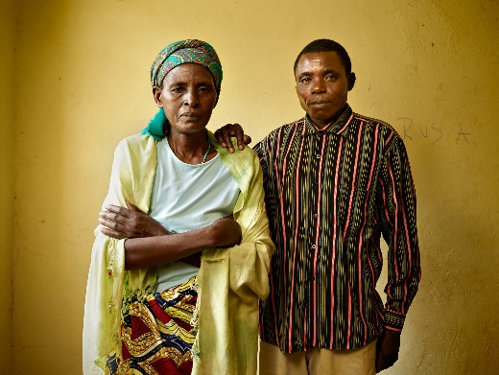

**Things to do…**

**Complete a table giving an explanation of the key terms, examples and people and/or organisations involved in each area.**

**The Religious bit…**

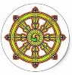

Buddhism

“These two are wise. Which two? The one who sees his/her transgression as a transgression, and the one who rightfully pardons another who has confessed his/her transgression. These two are wise.” *Buddha*

To understand everything is to forgive everything. *Buddha*

Christianity

‘Let everyone be subject to the governing authorities, for there is no authority except that which God has established. The authorities that exist have been established by God’. *Romans 13:1*

‘And they will hammer their swords into plowshares... Nation will not lift up sword against nation...’ *Isaiah 2:4*

‘When justice is done, it is a joy to the righteous but terror to evildoers’. *Proverbs 21:15*



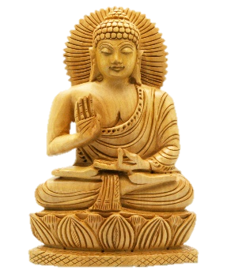







**Match the quotations…**

**In your exercise book note down each of the quotations and match them up to the key terms. Make sure you note down which religion each quotation comes from.**

**Also…**

**Make sure you have noted down the definitions for the key terms from this lesson on your key terms sheet.**

Buddhism

“These two are wise. Which two? The one who sees his/her transgression as a transgression, and the one who rightfully pardons another who has confessed his/her transgression. These two are wise.” *Buddha*

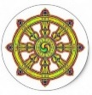

Buddhism

To understand everything is to forgive everything. *Buddha*



Christianity

‘Let everyone be subject to the governing authorities, for there is no authority except that which God has established. The authorities that exist have been established by God’. *Romans 13:1*





Christianity

‘And they will hammer their swords into plowshares... Nation will not lift up sword against nation...’ *Isaiah 2:4*

Christianity

‘When justice is done, it is a joy to the righteous but terror to evildoers’. *Proverbs 21:15*



Buddhism

“These two are wise. Which two? The one who sees his/her transgression as a transgression, and the one who rightfully pardons another who has confessed his/her transgression. These two are wise.” *Buddha*



Buddhism

To understand everything is to forgive everything. *Buddha*



Christianity

‘Let everyone be subject to the governing authorities, for there is no authority except that which God has established. The authorities that exist have been established by God’. *Romans 13:1*





Christianity

‘And they will hammer their swords into plowshares... Nation will not lift up sword against nation...’ *Isaiah 2:4*



Christianity

‘When justice is done, it is a joy to the righteous but terror to evildoers’. *Proverbs 21:15*

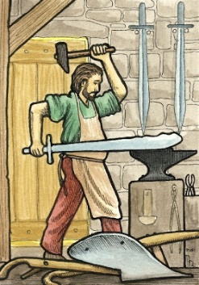

**Forgiveness**

**Conflict**

**Justice**

**Peace**

**Reconciliation**

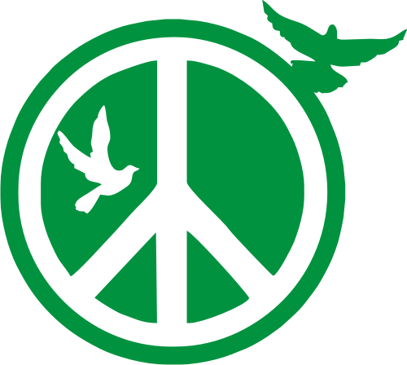



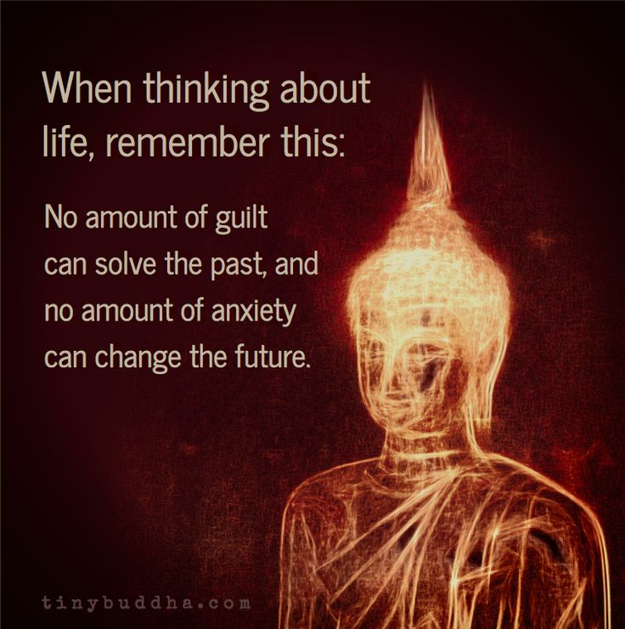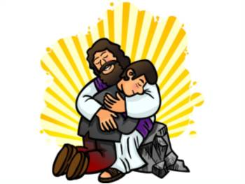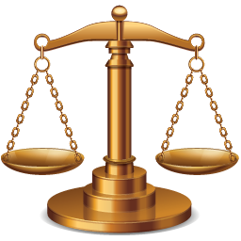

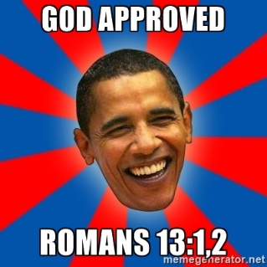



**Forgiveness**

**Conflict**

**Justice**

**Peace**

**Reconciliation**









Use key words below to answer the following;

1. The government in Neverneverland is victimising the Always people. The Always people are angry. What do the two groups try to do?
2. Peace talks have failed. What happens next?
3. War has led to a lot of people being killed, war crimes have been committed and there has been a lot of destruction to the country. After a year of fighting the Always people defeat the government. What happens next?
4. Neverneverland is now at peace and the country is to be renamed Neveralwaysland. How did this happen?

Agreement Conflict Justice Forgiveness Reconciliation

Use key words below to answer the following;

1. The government in Neverneverland is victimising the Always people. The Always people are angry. What do the two groups try to do?
2. Peace talks have failed. What happens next?
3. War has led to a lot of people being killed, war crimes have been committed and there has been a lot of destruction to the country. After a year of fighting the Always people defeat the government. What happens next?
4. Neverneverland is now at peace and the country is to be renamed Neveralwaysland. How did this

Agreement Conflict Justice Forgiveness Reconciliation