Hotel Rwanda
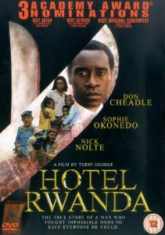
Basics

- Where is the film set?
- When did the events happen?
- Which groups were involved?
- Why was it a genocide?

Other Questions.

- What kind of war happened in Rwanda just before the genocide?
- What did the United Nations do about this war?
- Why did the genocide start?
- How did Paul Rusesabagina manage to save a large group of people?
- Which charity (other than the UN) helped people in Rwanda? How did they help?

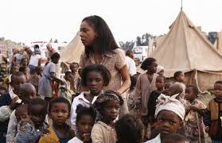
The United Nations

- How did the UN General try to help the people in the hotel?
- How did the UN fail some the people of Rwanda?
- Note down some ways in which the UN helped refugees in Rwanda.

Recap

Thinking about what you have seen in the film you have watched and your own knowledge, note down answers to the following;

- Give some of the causes of war.
- Note down some of the groups of people that are affected by war.
- Note down some of the effects of war.
Exam style questions;

- Explain what religious people might do to help victims of war.
- Name two recent conflicts.
- ‘Religious believers should not take any part in a war’.
Give reasons for and against this statement. Try to include religious beliefs and teachings in your answer.

