^{Christianity and Wealth}

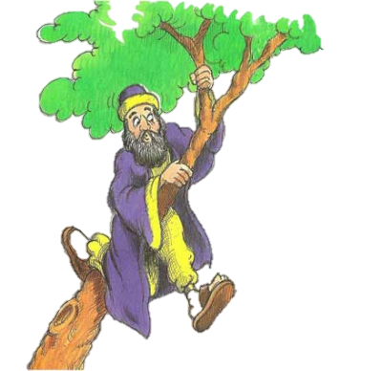
Zacchaeus the Tax Collector Luke 19:1-10

19 Jesus entered Jericho and was passing through. ² A man was there by the name of Zacchaeus; he was a chief tax collector and was wealthy.³ He wanted to see who Jesus was, but because he was short he could not see over the crowd. ⁴ So he ran ahead and climbed a figtree to see him, since Jesus was coming that way.
⁵ When Jesus reached the spot, he looked up and said to him, “Zacchaeus, come down immediately. I must stay at your house today.”⁶ So he came down at once and welcomed him gladly.
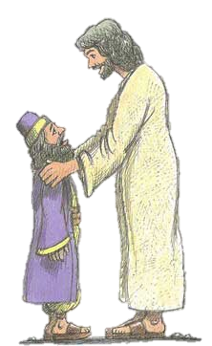
⁷ All the people saw this and began to mutter, “He has gone to be the guest of a sinner.”
⁸ But Zacchaeus stood up and said to the Lord, “Look, Lord! Here and now I give half of my possessions to the poor, and if I have cheated anybody out of anything, I will pay back four times the amount.”
⁹ Jesus said to him, “Today salvation has come to this house, because this man, too, is a son of Abraham. ¹⁰ For the Son of Man came to seek and to save the lost.”
Things to do...

Complete a flow diagram outlining the main points of the story.

What does the story teach Christians about how they should deal with money?

Poverty.

Christians believe that everyone is in need in some way. Even the very rich can still be spiritually poor. Poverty can be more than not having enough money. Spiritual poverty can be experienced though lack of loving relationships, loneliness, illness worry or unhappiness. Jesus saw in Zacchaeus the wealthy tax collector the poverty of his life. He was just as much in need as other people Jesus visited.

How should Christians use their money?

Money can be used wisely, for example donating to charities to help the poor
and needy. Right from the start of Christianity followers of Jesus sold their
surplus property and possessions and gave the money to the poor.

Things to do...

- What do you think wealthy Christians should do with their money? Include a reference to Bible teachings.

- Note down some of examples of Christian charities.

Jesus and the Tax Collector (Luke 19: 1-10).

Where does Jesus go?

Who lives there and what does he do?
Why did the man climb a tree?

Why did the crowd not like the man?
What did Jesus say to the man?
What do you think this story says about how Christians should deal with money?

Why was the crowd angry?
What was the man’s reaction?

What did the man say he would now do?

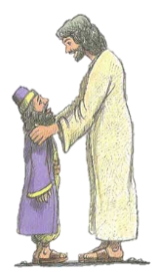
What does this story teach Christians about how they should deal with money?
What do you think this story says about how Christians should deal with money?

^{Buddhism and Wealth}
The Middle Way

Buddha left a very wealthy life for a much poorer one because he felt that wealth lead to craving and selfishness which cannot result in happiness. Monks and nuns give up money and most possessions. However Buddha recognised that people need the basics and some comforts in life, so he taught the Middle Way between wealth and poverty. The second precept states that money should be earned and used honestly.

Five Precepts
Refrain from harming any sentient being
Refrain from taking what is not given
Refrain from sexual misconduct
Refrain from wrong speech
Refrain from intoxicants which cloud the mind.

Karma.

Buddhists believe in compassion (loving kindness), excess wealth should be shared with the poor, this will help them earn good karma.

Things to do...

- What do you think wealthy Buddhists should do with their money? Explain reasons for your answer and include reference to Buddhist teachings.

- Note down some ways in which Buddhists could gain money whilst keeping to the second precept. Note down some examples of inappropriate (but legal) ways Buddhists could gain money.

- Note down some examples of how wealth could be used (a) in a good way and (b) in a bad way.

Exam Questions

- Give two causes of poverty. (2 marks)

- Give two ways in which people become wealthy. (2 marks)

- Explain two religious beliefs about the correct use of money.
Refer to Christianity and Buddhism in your answer. (5 marks)

Help for Q3.

Christians believe money should be used to… (explain using a religious teaching)

Buddhists follow the (+ appropriate religious teaching…) this means that they should … (explain…). An example of this would be …. this will also help them gain …

Additional help for Q3.
Christians believe money should be used _________ ___________ people. Jesus taught ‘_________ _____ _________________’, so if a Christian can afford it they should _____________ to a _____________.
Buddhists follow the second ______________ which suggests they should use ___________ to _________ others. An example of this would be to give excess ____________ to the _________. This will also help them gain good ____________.
Additional help for Q3.
Christians believe money should be used _________ ___________ people. Jesus taught ‘_________ _____ _________________’, so if a Christian can afford it they should _____________ to a _____________.
Buddhists follow the second ______________ which suggests they should use ___________ to _________ others. An example of this would be to give excess ____________ to the _________. This will also help them gain good ____________.

