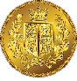

My thoughts on the value of wealth

My thoughts on the value of wealth

Possibilities of having wealth

Evidence of wealth

Evidence of wealth

Possibilities of having wealth

Three new things I have learnt

Three new things I have learnt