bd06662_

**Social Justice - Starter**

*Answer the following questions whilst the other members of the class are taking part in the quiz;*

1. What do you notice about who your teacher was asking easy questions to?
2. What rewards were given to these girls?
3. What do you notice about the girls who were asked questions that were very difficult?
4. What are the reactions of the girls who were asked the very difficult questions, seeing the others getting rewards?
5. What do you think is actually happening here?

bd06662_

**Social Justice - Starter**

*Answer the following questions whilst the other members of the class are taking part in the quiz;*

1. What do you notice about who your teacher was asking easy questions to?
2. What rewards were given to these girls?
3. What do you notice about the girls who were asked questions that were very difficult?
4. What are the reactions of the girls who were asked the very difficult questions, seeing the others getting rewards?
5. What do you think is actually happening here?

Quiz questions (for teacher);

1. Who were the main targets of the Holocaust?
2. Give an example of a ‘Right’ everyone is entitled to.
3. What did William Wilberforce help to bring to an end in 1833?
4. What is the name of the Tibetan man we found out about last lesson who was sent to prison for flying the Tibetan flag? (Lhamo Kyab)
5. Give any one of the Ten Commandments.
6. What is the second of the Ten Commandments? (Do not worship idols)
7. What is the name of the Christian book where the Ten Commandments can be found?
8. What is the name of the book where Buddhists can find the Eightfold Path? (Dhammapada)
9. What is the name of the man who gave the ‘I have a dream’ speech?
10. What was the date of this speech? (August 28th 1963)
11. If you were prevented from going to school which ‘Right’ would be being taken away from you?
12. Who was ultimately responsible for the Holocaust?

Instructions – a group of six students – two students (who are resilient and not easily upset) must have something in common that the other three do not have (e.g. blond hair, glasses etc).

The two ‘different’ students should be asked the very difficult (red) questions (with the aim of not being able to answer them) and the easy questions given to the other girls. When they get the question correct give them lots of praise and a sweet. If they cannot answer a question, give them lots of clues so they can’t fail to get the question right. Do not do the same for the ‘different’ girls – but try to appear slightly annoyed when they can’t answer the questions.

The idea is to get the girls to see the injustice of the game.

After the discussion about the game make sure the ‘different’ students get the same sweets as the others.

bd06662_

Social Justice

*What is ‘social justice’?*

Social justice is defined as "... promoting a just society by challenging injustice and valuing diversity." It exists when all people are treated equally, are able to access their human rights, and there is a fair allocation of community resources.

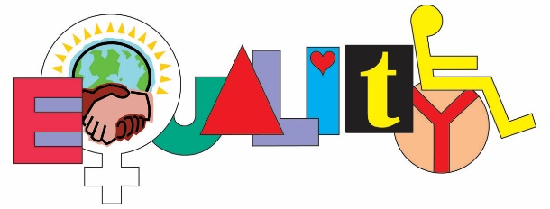Where there is social justice, people are not discriminated against, their welfare and well-being are not restricted or prejudiced on the basis of gender, sexuality, religion, political affiliations, age, race, belief, disability, location, social class, or any other characteristic of background or group membership.

Social justice is generally the ideas of equality equal opportunity in society and responsibility to treat other people in a moral way.

Things to do.

1. List or complete a mind map of things happening in the community that you consider wrong, unjust, unfair, and unkind.
2. Choose one of these injustices and explain at least two reasons why it is morally wrong.
3. Choose an issue from your mind map or list and give suggestions for what someone could do to improve the situation.

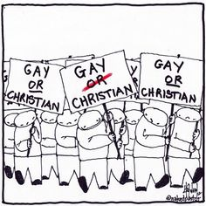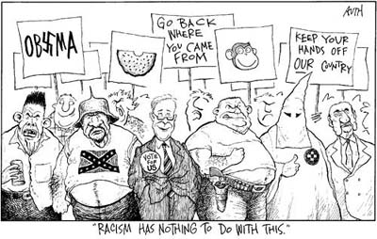

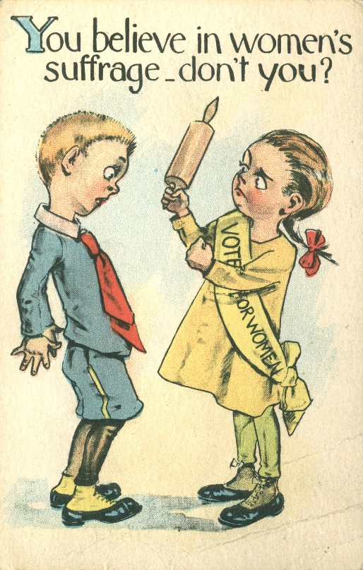

The Political Cartoons show prejudice about specific groups. For each one explain…

(a) which group the focus of the prejudice is;

(b) what the cartoons suggest about that group;

(c) why these images are morally wrong,

(d) the detrimental effects they may have on both the group and society as a whole.

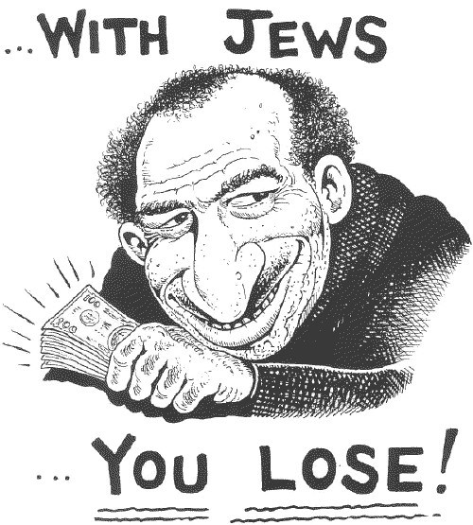



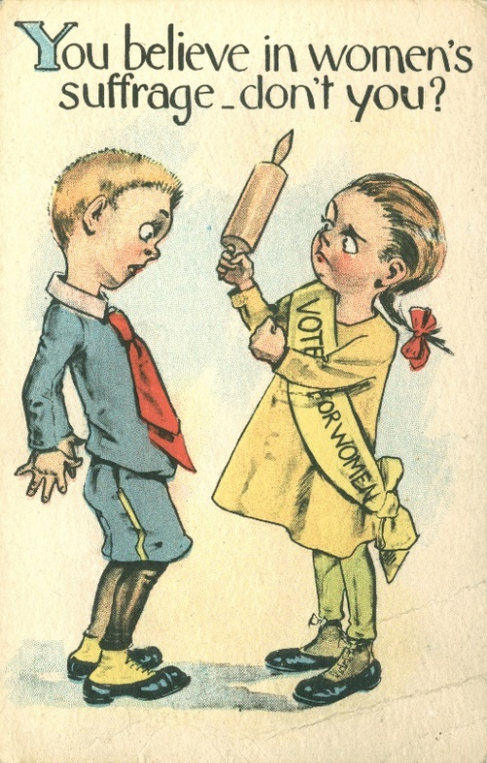

The Political Cartoons show prejudice about specific groups. For each one explain…

(a) which group the focus of the prejudice is;

(b) what the cartoons suggest about that group;

(c) why these images are morally wrong,

(d) the detrimental effects they may have on both the group and society as a whole.





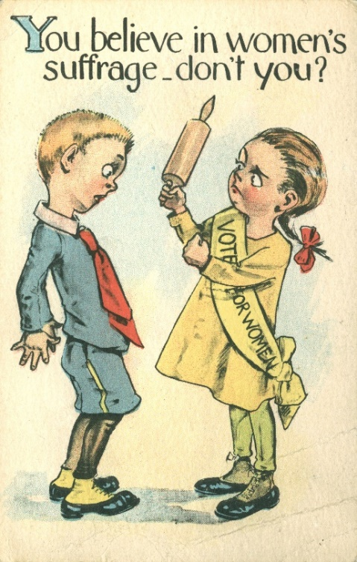

The Political Cartoons show prejudice about specific groups. For each one explain…

(a) which group the focus of the prejudice is;

(b) what the cartoons suggest about that group;

(c) why these images are morally wrong,

(d) the detrimental effects they may have on both the group and society as a whole.