Jesus & Prejudice
discrimination – treating people differently because of their race, etc. (This is an action.)
prejudice – pre-judging someone because of their race, gender, religion, etc. (This is an attitude.)
Story | What happens? | The issue is prejudice against ... | How does Jesus/Peter respond? | Extension:  Give an example of how this story might apply to human rights today.
Woman caught in adultery

Jesus and Matthew
Woman at the well

Jesus and the leper
Peter and Cornelius

Martin Luther King’s Mountaintop Speech
In the Bible, Moses led the people of Israel out of slavery in Egypt through the desert and up to the Promised Land. Moses did not go into the land because he died just before they went in. Right at the end though, God took him to the top of Mount Nebo, just outside, from which Moses saw the whole of the Promised Land, moments before he died. The people mourned his death and then entered the land.
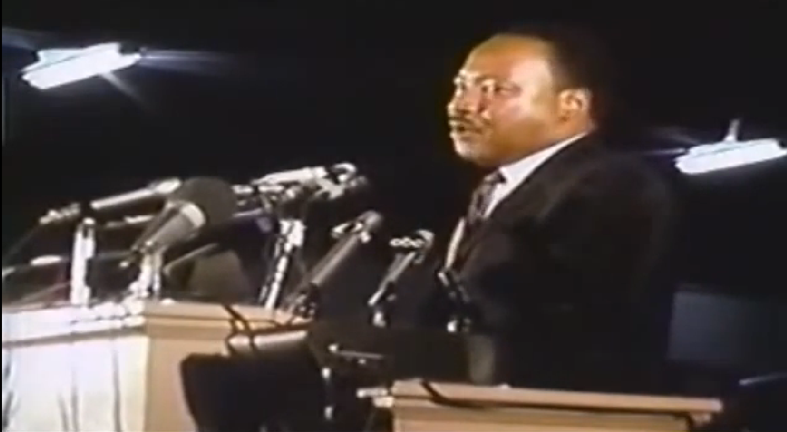
The famous MLK speech you are about to hear was made on 3rd April 1968 in Memphis, Tennessee. Two sanitation workers in that city had been crushed to death in an accident and the other workers were angry about poor safety and low wages so they went on strike. Most of the workers were black men and they felt they were not valued as human beings because of their race. MLK made this speech to support the workers in their campaign.
- Complete the following quotation: ‘Either we go up together or we go down together. Let us develop a kind of ________________ ___________________.’
- Jesus said that the Samaritan was the good man, a great man because he developed the capacity to be concerned about ________ ________________.
- The priest and the Levite asked, ‘If I stop to help this man what will __________ ___ ___?’
- What is the ‘question tonight’ that the audience should ask about the sanitation workers?
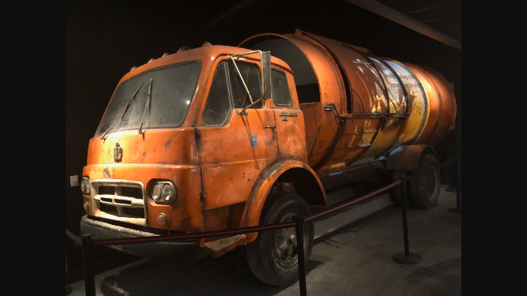

- What happened to MLK in New York?

- What would have killed him if he had done it?
- Give at least two things that MLK would have missed if he had died. (He lists about six.)

- What does he mean, ‘We as a people will get to the Promised Land,’?
‘All of you who were baptized into Christ have clothed yourselves with Christ. There is neither Jew nor Greek, there is neither slave nor free man, there is neither male nor female; for you are all one in Christ Jesus and if you belong to Christ, then you are Abraham’s offspring, heirs according to promise.’ Paul in Galatians 3:27-29.

- List some human rights involved with this situation.

