1.2.1 Demand

Starter
- If this drink was £5 a can would you buy it?
- If this drink was 10p a can would you buy more of it?

Write your definition of demand here:
________________________________________________________________________________________________________________________________________________________________________________________________________________________________________________________________________________________________________________________________________
Price determines levels of demand
________________________________________________________________________________________________________________________________________________________________________________________________________________________________________________________________________________________________________________________________________

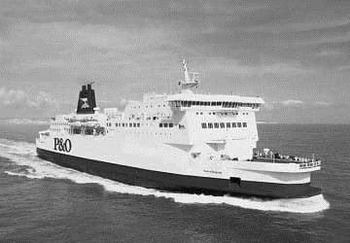
- Price of substitutes
__________________________________________________________________________________________________________________________________________________________________________________________________________________________________________________________________________________________________________________________________________________________________________________________________________________________

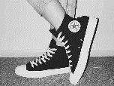
- Alternative brands
__________________________________________________________________________________________________________________________________________________________________________________________________________________________________________________________________________________________________________________________________________________________________________________________________________________________
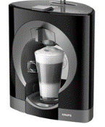
- Price of compliments
__________________________________________________________________________________________________________________________________________________________________________________________________________________________________________________________________________________________________________________________________________________________________________________________________________________________

- Changes in consumer income
__________________________________________________________________________________________________________________________________________________________________________________________________________________________________________________________________________________________________________________________________________________________________________________________________________________________

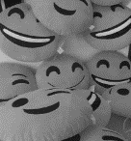
- Trends in fashion and tastes
__________________________________________________________________________________________________________________________________________________________________________________________________________________________________________________________________________________________________________________________________________________________________________________________________________________________

- Marketing, advertising and branding
__________________________________________________________________________________________________________________________________________________________________________________________________________________________________________________________________________________________________________________________________________________________________________________________________________________________
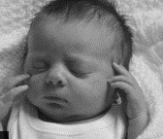
- Population structure / demographics
__________________________________________________________________________________________________________________________________________________________________________________________________________________________________________________________________________________________________________________________________________________________________________________________________________________________
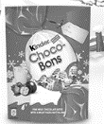
- Time of year
__________________________________________________________________________________________________________________________________________________________________________________________________________________________________________________________________________________________________________________________________________________________________________________________________________________________
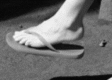
- Weather and climate
__________________________________________________________________________________________________________________________________________________________________________________________________________________________________________________________________________________________________________________________________________________________________________________________________________________________

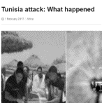
- External shocks
__________________________________________________________________________________________________________________________________________________________________________________________________________________________________________________________________________________________________________________________________________________________________________________________________________________________

