Interest rates
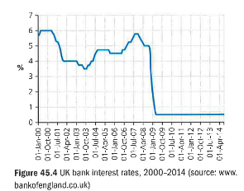
The interest rate is the price charged by a bank per year for lending money or for providing credit. Individual banks decide for themselves about the rate they will charge on their credit cards or for the overdrafts, they provide. But they are usually influenced by the interest rate that the central bank charges high street banks for borrowing money: the bank rate. In Britain, this is set each month by a committee of the Bank of England. As shown in Figure 45.4, the standard rate of interest in the UK has generally been around 4 -5 per cent. In March 2009, though, the rate was cut to its lowest point in the Bank of England's history - 0.5 per cent. And it remained there as a way of helping to revive an economy hit very hard by the 2009 recession.

The Bank of England committee is asked to set interest rates at a level that should ensure UK prices rise by around 2 per cent per year. If the committee members decide that the economy is growing so strongly that prices may rise faster than 2 per cent, it will increase interest rates.

Then people will feel worried about borrowing more (because of the higher repayment cost) and may cut their spending. This should help to discourage firms from increasing their prices.

For firms, the level of interest rates is very important because:
• it affects consumer demand, especially for goods bought on credit, such as houses and cars; the higher the rate of interest, the lower the sales that can be expected
• the interest charges affect the total operating costs (that is, the higher the interest rate, the higher the costs of running an overdraft, and therefore the lower the profit)
• the higher the rate of interest, the less attractive it is for a firm to invest money into the future of the business (because of the opportunity cost - the high interest rates available for keeping money safely in the bank); therefore, there is a risk of falling demand for items such as lorries, computers and factory machinery. If interest rates fall, the opposite effects occur, to the benefit of both companies and the economy as a whole.

