2.4.2 Capacity Utilisation

Starter
- If you ran a factory and the maximum “Nibnobs” you could make in a day was 200, would you make:
- A) 200 Nibnobs a day
- B) 185 Nibnobs a day
- C) 210 Nibnobs a day
Explain your answer

________________________________________________________________________________________________________________________________________________________________________________________________________________________________________________________________________________________________________________________________________

Write a definition of capacity utilisation here:
________________________________________________________________________________________________________________________________________________________________________________________________________________________________________________________________________________________________________________________________________

Capacity utilisation explained
- In any business there are decisions to be made about how best to ____________________________ resources

- An operations manager will need to make daily decisions about how best to turn inputs such as ________________________, labour and _________________________ into outputs

- Capacity utilisation is how best to use those _______________________ for the benefit of the business

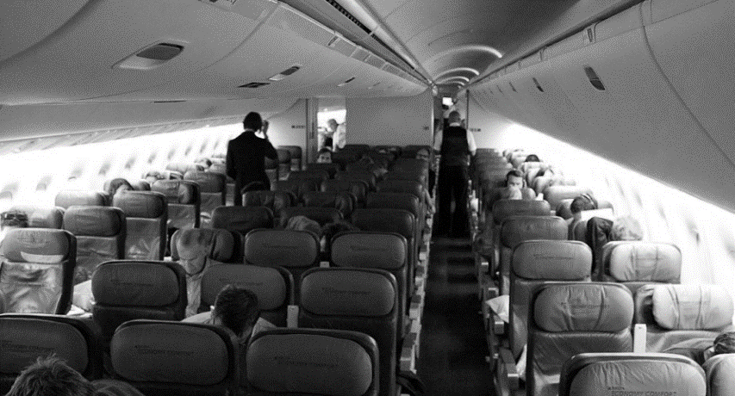

Capacity utilisation explained continued
- If a business cannot increase its ______________________, it is at full capacity

- For example, a 295 seat plane if it is full then it is ______________________ at full capacity

- If the plane is half full then it is running at 50% __________________________

- One way to improve capacity is to reduce the cost of less popular ______________________ times “off-peak” travel

Capacity utilisation explained continued
- Capacity utilisation is important as it has a bearing on ______________________ cost per unit and therefore EOS (Economies of scale)

- In high capacity utilisation the _____________________ costs are spread over more units of production

- In low capacity utilisation the fixed costs can be ______________ high to stay in business or keep ________________________ that product

Ways to improve capacity utilisation
__________________________________________________________________________________________________________________________________________________________________________________________________________________________________________________________________________________________________________________________________________________________________________________________________________________________
More ways to improve capacity utilisation

__________________________________________________________________________________________________________________________________________________________________________________________________________________________________________________________________________________________________________________________________________________________________________________________________________________________

Improving capacity utilisation
__________________________________________________________________________________________________________________________________________________________________________________________________________________________________________________________________________________________________________________________________________________________________________________________________________________________

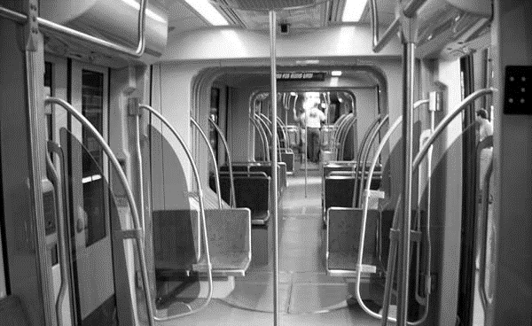
Name 5 ways that this train company can improve their capacity utilisation
1
2
3
4
5

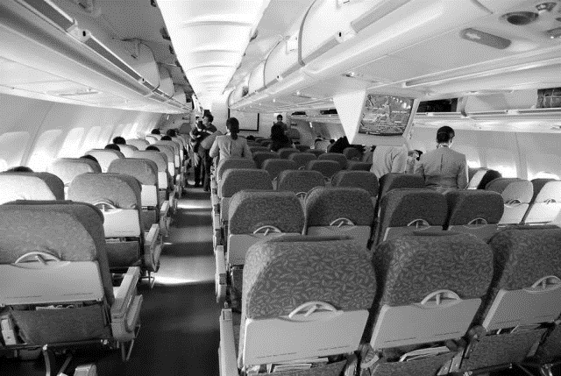
Name 5 actions this airline should take to reduce this cost
1
2
3
4
5

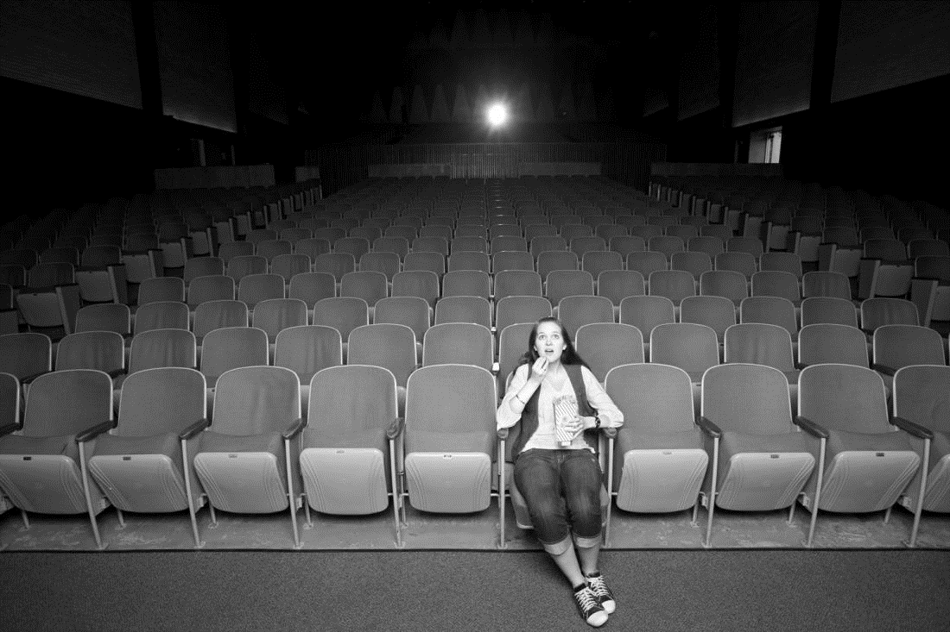

Name 5 ways this cinema company could spread their fixed costs
1
2
3
4
5

Name 5 ways this restaurant could make better use of their resources

1
2
3
4
5

Write the capacity utilisation formula here:

Example calculation:

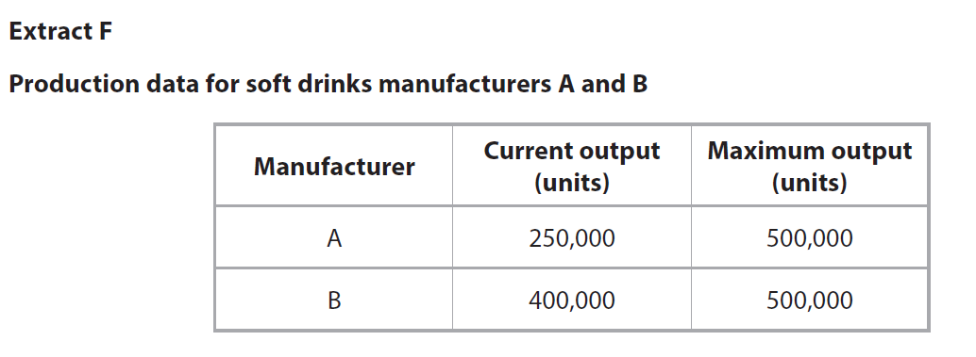

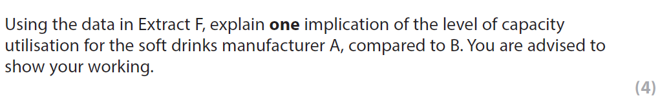

Why would running at 80% be OK?
________________________________________________________________________________________________________________________________________________________________________________________________________________________________________________________________________________________________________________________________________
Capacity
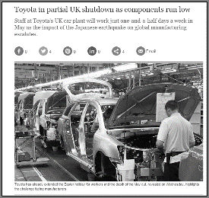
________________________________________________________________________________________________________________________________________________________________________________________________________________________________________________________________________________________________________________________________________
Implications of under-utilisation
________________________________________________________________________________________________________________________________________________________________________________________________________________________________________________________________________________________________________________________________________
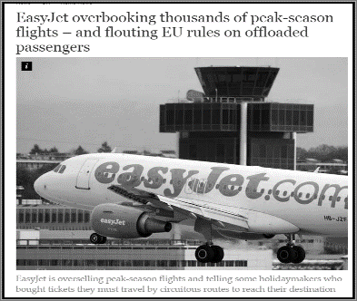
Implications of over-utilisation
________________________________________________________________________________________________________________________________________________________________________________________________________________________________________________________________________________________________________________________________________

