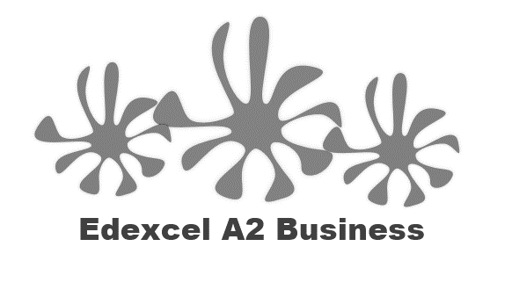
4.4.1 The impact of MNCs

Starter statement – do you agree or disagree?

MNCs are good for the developing nations that they trade or manufacture in

Yes I agree | No I disagree

Write a definition of the term MNC here:

________________________________________________________________________________________________________________________________________________________________________________________________________________________________________________________________________________________________________________________________________

Positive effects of MNCs

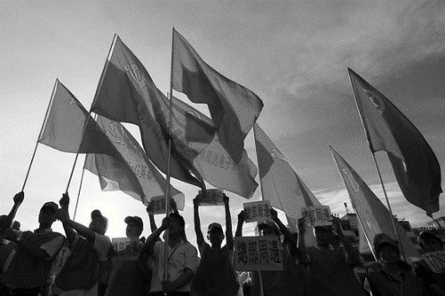
Positive impacts

Creates employment

Increases skills base

Increased standard of living

Raises country’s profile

Improves balance of payments

Improves infrastructure

Negative effects of MNCs

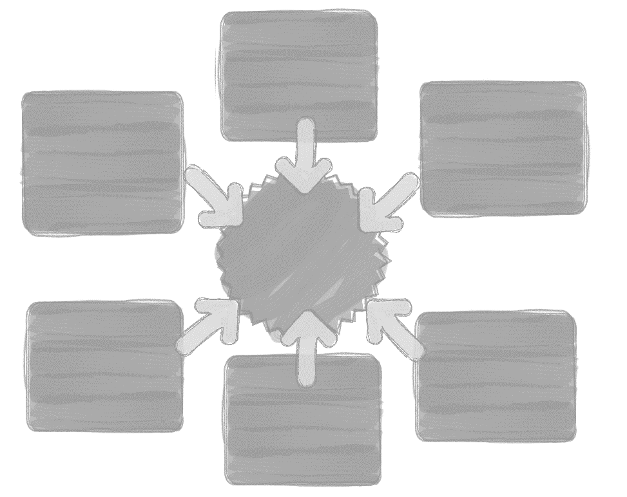

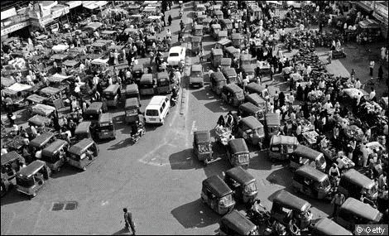
Negative impacts

Profit leakage
Low paid jobs
Pull out quickly
Poor safety record
Increases urbanisation
Widens poverty gap

Impact on the local community / environment

________________________________________________________________________________________________________________________________________________________________________________________________________________________________________________________________________________________________________________________________________

________________________________________________________________________________________________________________________________________________________________________________________________________________________________________________________________________________________________________________________________________

Impact on the local community / environment

_______________________________________________________________________________________________________________________________________________________________________________________________________________________________________________________________________________________________________________________________________

_______________________________________________________________________________________________________________________________________________________________________________________________________________________________________________________________________________________________________________________________________

Impact of MNCs on national economy
MNCs and FDI flows

MNCs and the balance of payments
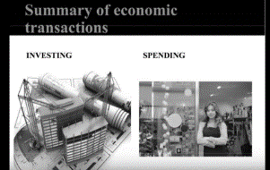
MNCs and technology and skills transfer

MNCs and technology and skills transfer
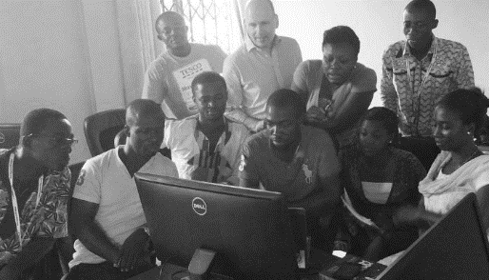

MNCs and impact on consumers
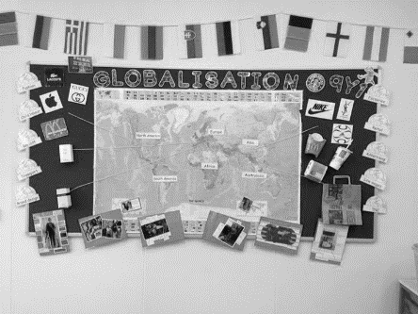

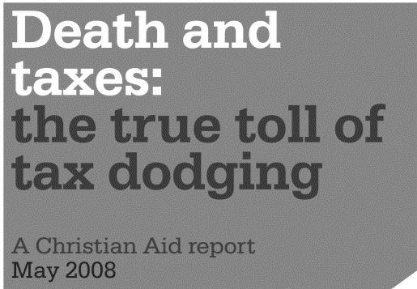

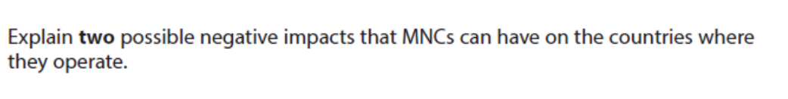
[6] No case study with this question

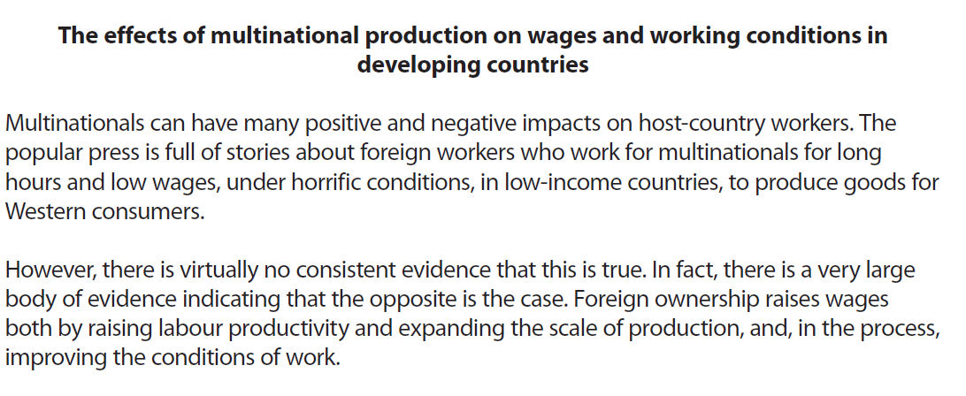

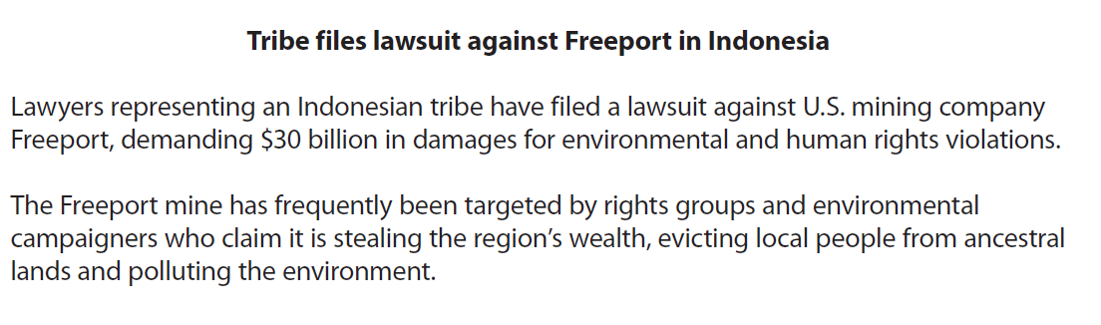

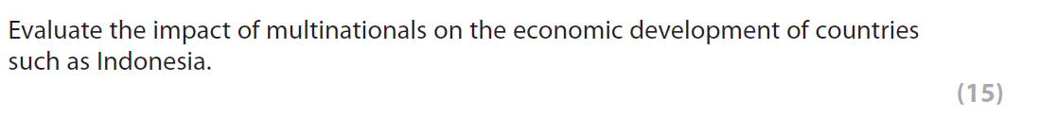

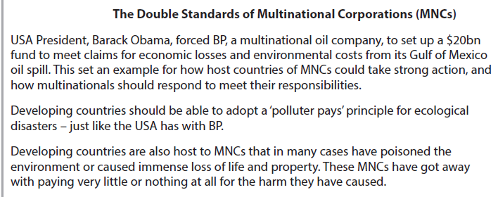

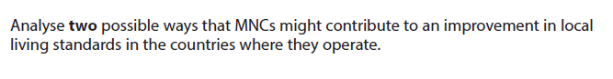
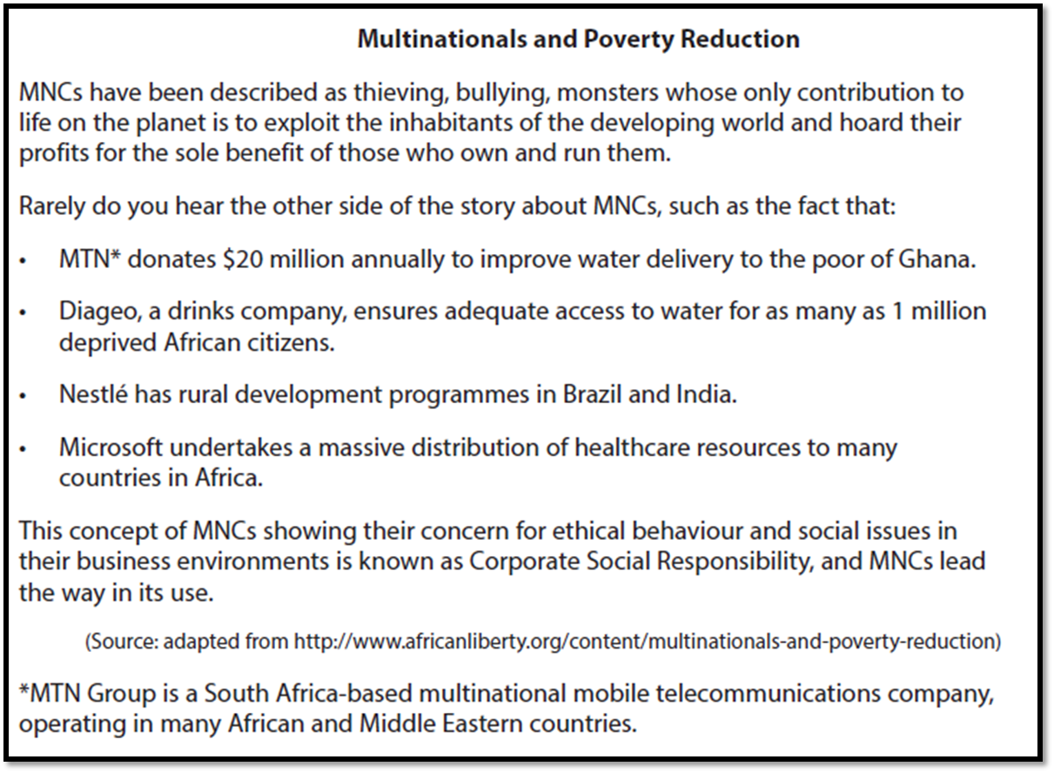

[8]

