1.3.2 Branding and Promotion - #7 Sales promotions
BOGOF
- BOGOF stands for buy one get one free
- In a BOGOF sales promotion a business offers one item free when another one is bought
- Used to encourage customers to go into the shop or buy the item
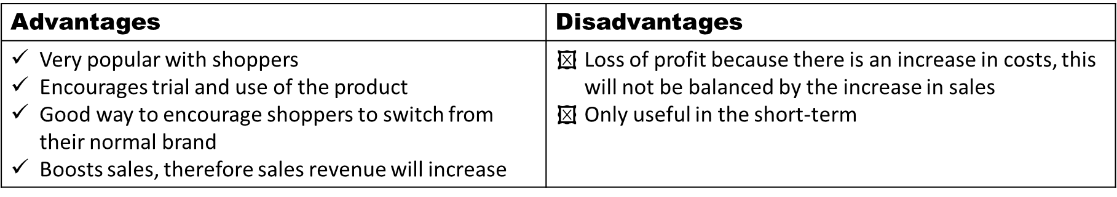
Price discounts
- Price discounts means that the normal RRP (recommended retail price) of the product or service has been reduced
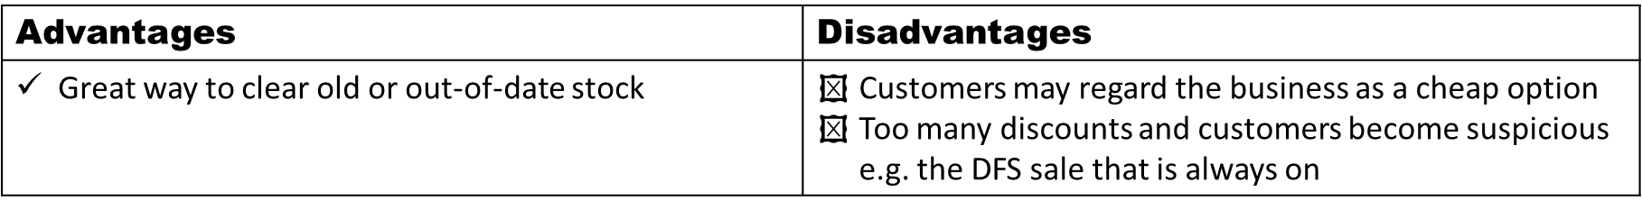
Money off coupons
- Coupons can be used to capture new customers – to add an incentive
- Coupons can also be used with existing customers to encourage an impulse spend
- Companies like BZZ agent give out coupons in return for reviews

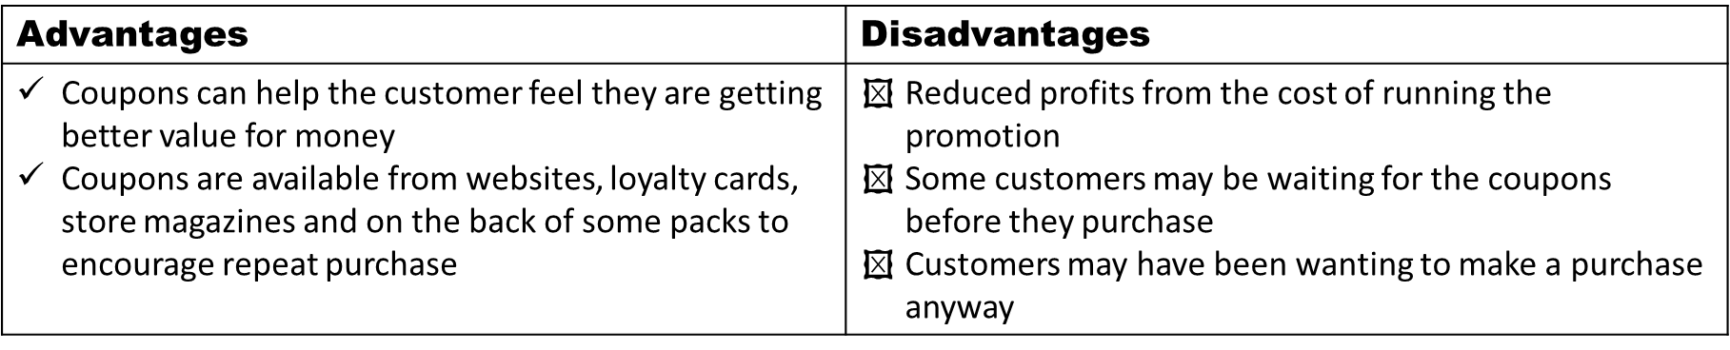
Samples / giveaways
- This is where a business may send out or give customers free samples in order to persuade them to try the product for the first time
- Giveaways may occur on the front of a magazine e.g. match attax cards on a football magazine

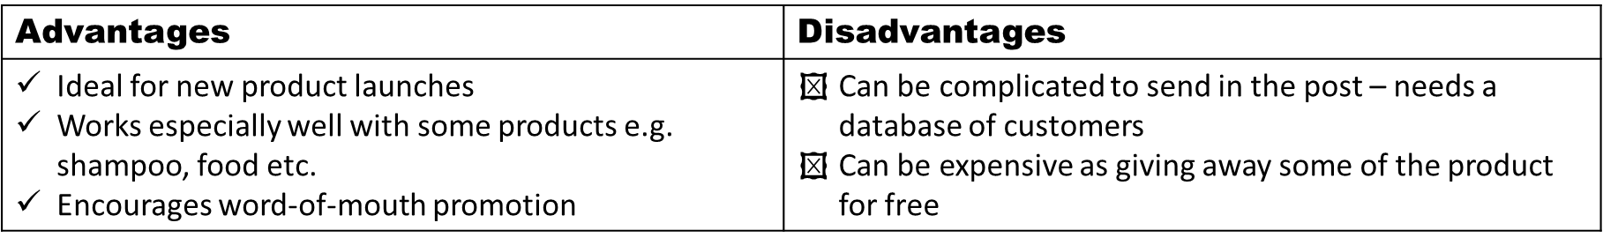
Special events
- Special events are activities that the business does to encourage consumers to try the product
- Events can be; shows, fetes, fairs, or an event at the business e.g. a special tasting evening at a restaurant
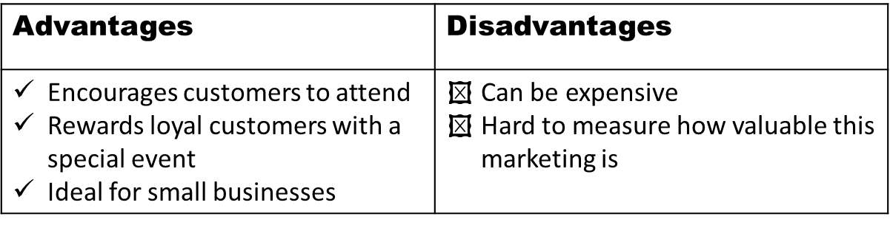
Point of sale
- Point of sale display is usually a cardboard display stand located close to the till within a shop
- This is to draw customer attention and trigger an “impulse” purchase

