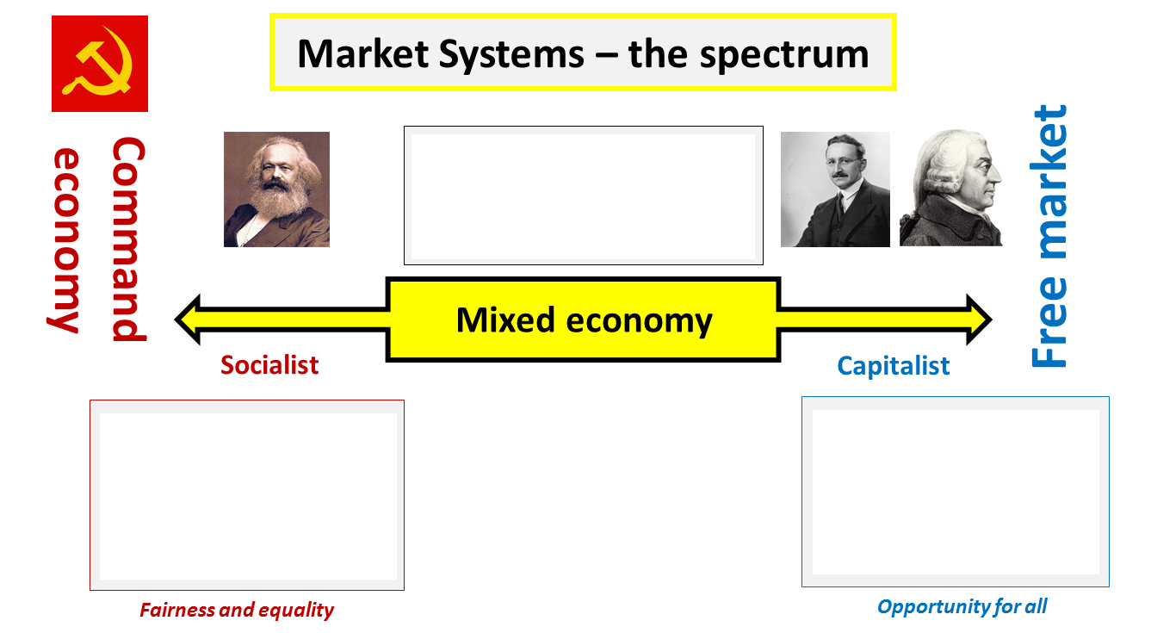

The UK: Socialist or Capitalist? Scale Activity
Consider the market for the following goods/services in the UK. Where would you place them on the scale below?
Remember, free-market economies are entirely free of any government invention and command economies are entirely planned by the state.
Be prepared to justify your answer!
Cars
Emergency Services
Streetlamps
Waste Disposal
Railways
Alcohol

Education
Food
Housing
Banking
Healthcare
Furniture

COMMAND ECONOMY
(Socialist)
MARKET ECONOMY
(Capitalist)

