2.5.3 The Competitive Environment

Starter
- How often do you shop at independent shops? _____________________
- Do you stick to chain stores? ___________________________
- Can you recommend a good independent shop? ___________________
- What do the independents offer the shopper? ________________________

Write a definition of competition here:

________________________________________________________________________________________________________________________________________________________________________________________________________________________________________________________________________________________________________________________________________

#1 nature of business ownership

________________________________________________________________________________________________________________________________________________________________________________________________________________________________________________________________________________________________________________________________________
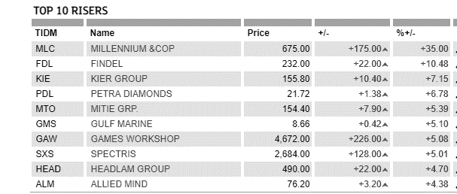

#2 nature of product or services provided

________________________________________________________________________________________________________________________________________________________________________________________________________________________________________________________________________________________________________________________________________
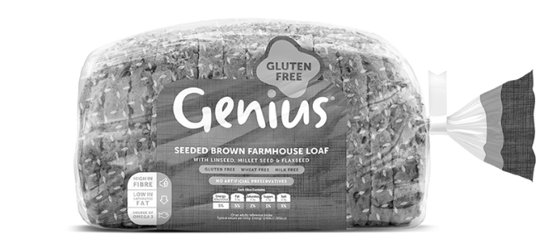
#3 nature of the product range
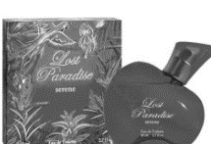
________________________________________________________________________________________________________________________________________________________________________________________________________________________________________________________________________________________________________________________________________
#4 pricing strategies used

________________________________________________________________________________________________________________________________________________________________________________________________________________________________________________________________________________________________________________________________________

#5 marketing methods used
________________________________________________________________________________________________________________________________________________________________________________________________________________________________________________________________________________________________________________________________________
Independent vs Chain store: Tony and Guy
________________________________________________________________________________________________________________________________________________________________________________________________________________________________________________________________________________________________________________________________________
How do independent hairdressers compete?

________________________________________________________________________________________________________________________________________________________________________________________________________________________________________________________________________________________________________________________________________
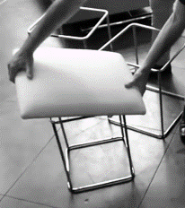
The impact on business of being in a competitive market

______________________________________________________________________________________________________________________________________________________________________________________________________________________________________________________________________________________________________________________________________

