Q1.The diagram below shows a cross-section of a plant root. The transport tissues are labelled.
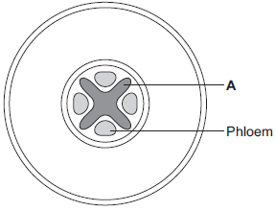

(a) (i) What is tissue A?
Draw a ring around the correct answer.
cuticle epidermis xylem
(1)

(ii) Name two substances transported by tissue A.
1 .............................................................................................................
2 .............................................................................................................
(2)

(b) Phloem is involved in a process called translocation.
(i) What is translocation?
...............................................................................................................
...............................................................................................................
...............................................................................................................
(1)

(ii) Explain why translocation is important to plants.
...............................................................................................................
...............................................................................................................
...............................................................................................................
...............................................................................................................
(2)

(c) Plants must use active transport to move some substances from the soil into root hair cells.
(i) Active transport needs energy.
Which part of the cell releases most of this energy?
Tick (✓) one box.
mitochondria
nucleus
ribosome

(1)

(ii) Explain why active transport is necessary in root hair cells.
...............................................................................................................
...............................................................................................................
...............................................................................................................
...............................................................................................................
...............................................................................................................
...............................................................................................................
(2)
(Total 9 marks)

Q2.The image below shows some cells in the lining of the stomach.
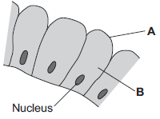

(a) (i) Use words from the box to name structures A and B.

 | cell membrane | chloroplast | cytoplasm | vacuole

A ..........................................................................
B ..........................................................................
(2)

(ii) What is the function of the nucleus?
Tick () one box.

To control the activities of the cell
To control movement of substances into and out of the cell
To release energy in respiration

(1)

(b) Draw one line from each part of the human body to its correct scientific name.

 | Part of human body |  | Scientific name
 |  |  | An organ
 | Layer of cells lining the stomach
 |  |  | An organism
 | Stomach
 |  |  | An organ system
Mouth, stomach, intestines,
liver and pancreas
 |  |  | A tissue

(3)
(Total 6 marks)

M1.(a) (i) xylem
1

(ii) water
1

minerals / ions / named example(s)
ignore nutrients
1

(b) (i) movement of (dissolved) sugar
allow additional substances, eg amino acids / correct named sugar (allow sucrose / glucose)
allow nutrients / substances / food molecules if sufficiently qualified
ignore food alone
1

(ii) sugars are made in the leaves
1

so they need to be moved to other parts of the plant for respiration / growth / storage
1

(c) (i) mitochondria
1

(ii) for movement of minerals / ions
Do not accept ‘water’
1

against their concentration gradient
1
[9]

M2.(a) (i) A = (cell) membrane
1

B = cytoplasm
do not accept cytoplast
1

(ii) To control the activities of the cell
1

(b)
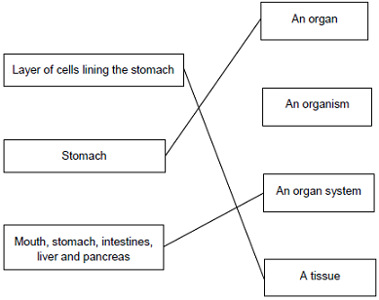
extra lines cancel
3
[6]

