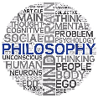
A Level Philosophy - Influences of developments in religious belief.

6.1 Views about life after death across a range of religious traditions

a) Immortality of the soul: soul as non-physical and spiritual and continuing to exist after death of body.

b) Rebirth: belief there is no unchanging soul and importance of karma.

c) Reincarnation: transmigration of souls and importance of karma.

d) Replica theory: notion that one can die in one body and continue to live in a different body while being the same person, including after death.
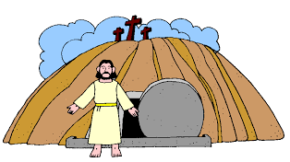
e) Resurrection: belief that God will restore the dead in bodily form to eternal life.

With reference to the ideas of J Hick.

6.2 Points for discussion about life after death

a) Relationship between mind and body, including variations of dualism and monism.

b) Life after death linked to moral reasoning, near death experiences, debates related to role of evidence, religious language.

With reference to the ideas of Plato and Aristotle.

6.3 Religion and science debates and their significance for philosophy of religion

a) Methodologies with emphasis on observation, hypothesis and experiment, identifying connections and differences vis a vis religious belief and processes; miracles.

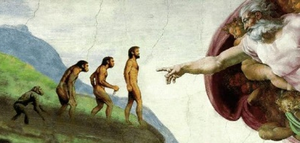
b) Creation themes and scientific cosmologies: Big Bang, steady state theories, intelligent design and irreducible complexity, creationism, cosmological constant, evolution, Gaia hypothesis.

With reference to the ideas of C Darwin and R Dawkins.
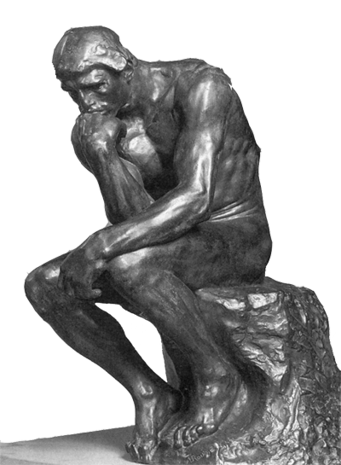

In this unit we will study the topics in relation to Christianity, Buddhism and
Hinduism as well as atheism. We also consider philosophical ideas dating back to the Ancient Greeks and investigate developments in those beliefs and ideas right up to modern times. Comparisons are made between religious/Biblical ideas and scientific theories and evaluate how scientific developments have affected religious beliefs.

