2.2.3 Break-even

Starter – try your calculation here:

Write the definition of break-even here:
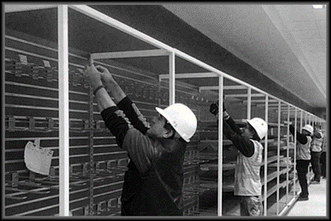
________________________________________________________________________________________________________________________________________________________________________________________________________________________________________________________________________________________________________________________________________
Break-even explained

________________________________________________________________________________________________________________________________________________________________________________________________________________________________________________________________________________________________________________________________________

Break-even

Write a definition of contribution here:
________________________________________________________________________________________________________________________________________________________________________________________________________________________________________________________________________________________________________________________________________

Contribution formula write that here:

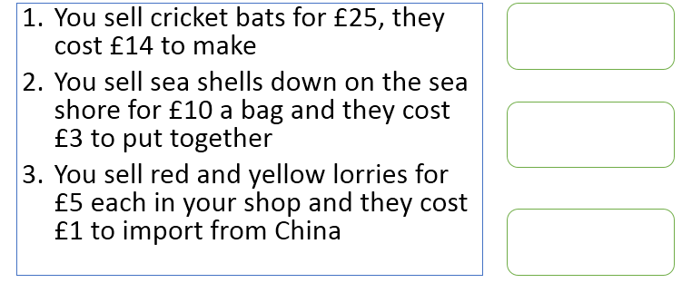

Write the break-even formula here:

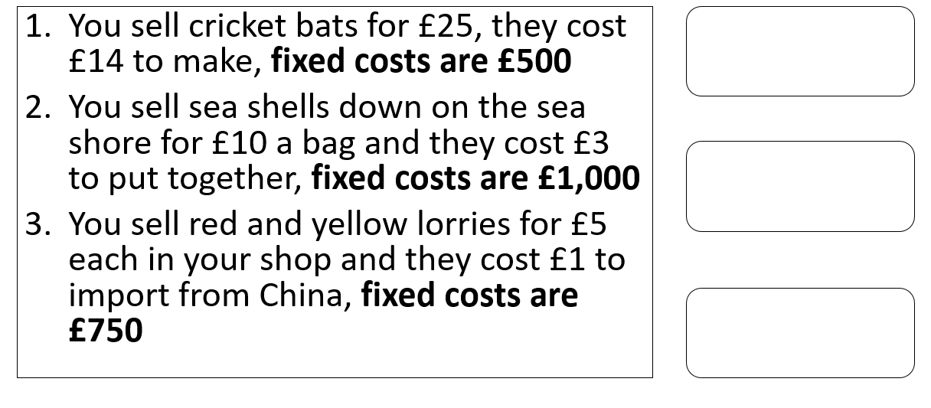

Break-even calculation example:
- Lucy sets up a business to print panda t-shirts. The fixed costs are £3000. The variable costs per t-shirt (the t-shirt, ink, wages) are £5. Each printed t-shirt sells for £25.

Calculate how many t-shirts Lucy needs to sell to break-even

Interpretation of break-even charts
Number of sales (units) | Total revenue (£)  (sales x £180) | Fixed costs (£) | Variable costs (£)  (sales x £120) | Total Costs (£)  Variable costs Plus Fixed costs
50 | 9000 | 12000 | 6000 | 18000
100 |  | 12000
150 |  | 12000
200
250
300

Draw your break-even graph here:

Step 8: Interpret your break-even chart

A
B
C
D

Margin of safety
What does margin of safety show?

________________________________________________________________________________________________________________________________________________________________________________________________________________________________________________________________________________________________________________________________________

Margin of safety formula, write that here:

Margin of safety

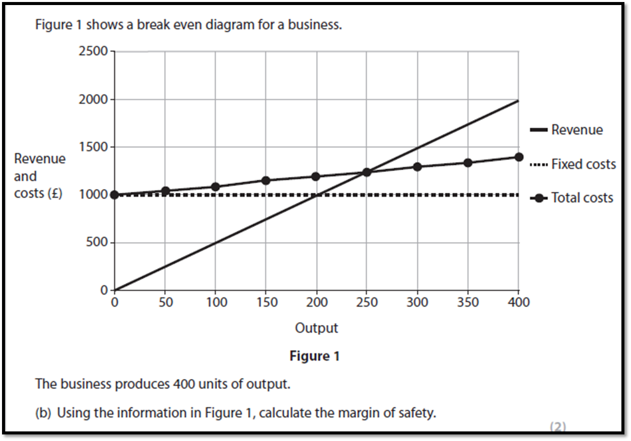
________________________________________________________________________________________________________________________________________________________________________________________________________________________________________________________________________________________________________________________________________

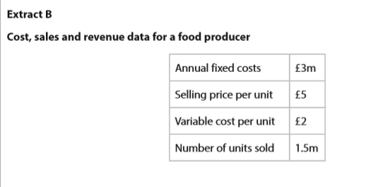

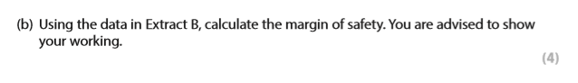
Add the margin of safety information to the break-even diagram

Uses of break-even analysis

Limitations of break-even analysis

