Quantitative sales forecasting
Sales forecasting is a crucial part of business planning.
The sales forecast forms the basis for most other common parts of business planning:
• Human resource plan: how many people we need linked with expected output
• Production / capacity plans
• Cash flow forecasts
• Profit forecasts and budgets
• Part of regular competitor analysis and helps to focus market research
Key Factors Affecting the Accuracy and Reliability of Sales Forecasts
Sales forecasting requires a subjective judgement about an uncertain future. So it is inevitable that actual sales will differ from those forecasts. Key factors that create this variability include:
• Consumer trends
- Demand in many markets changes as consumer tastes & fashions change
- Affects both overall market demand & the market shares of existing competitors
• Economic variables
- Demand often sensitive to changes in variables such as exchange rates, interest rates, taxation etc.
- Overall strength of the economy (GDP growth) also important
• Competitor actions
- Hard to predict, but often significant reason why sales forecasts prove over-optimistic
Circumstances Where Sales Forecasts Are Likely to be Inaccurate
The situations where actual sales are most likely to be significantly different from the sales forecast include:
• Business is new – a start-up (notoriously difficult to forecast sales)
• Market subject to significant disruption from technological change
• Demand is highly sensitive to changes in price and income (elasticity)
• Product is a fashion item
• Significant changes in market share (e.g. new market entrants)
• Management have demonstrated poor sales forecasting ability in the past!

There are three main methods used to provide a quantitative sales forecast:

- moving averages
- extrapolation
- correlation
Moving averages
A useful way to show trends is by using a moving average. This is helpful in two main circumstances:

- where there are strong seasonal influences on sales, such as in the ice cream parlour example
- When sales are erratic for no obvious reason; wild ups and downs may make it hard to see the underlying situation.

Month | Monthly sales | Centred - 3 months total | Centred - 3 months average
January | £ 48,000
February | £ 57,000 |  | £ 52,000
March | £ 51,000 | £156,000 | £ 49,000
April | £ 39,000 | £147,000 | £ 47,700
May | £ 53,000 | £143,000 | £ 46,300
June | £ 47,000 | £139,000 | £ 45,300
July | £ 36,000 | £136,000 | £ 44,700
August | £ 51,000 | £134,000

To find the moving average of the data:
• The first step is to calculate a moving total, in this case a three-month total - in other words, the January to March figures are totalled, then the February to April figures, and so on.
• The third column shows the centred average (that is, the January to March total of 156,000 is divided by 3 to make 52,000); this monthly average sales figure for January to March is centred to February, because that is the 'average' of January to March.

Note how well the three-month moving average clarifies the data, revealing the (very poor) underlying trend.

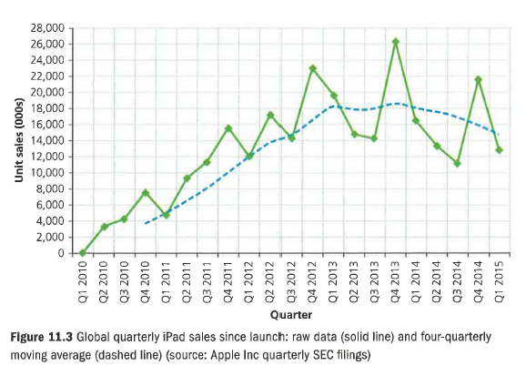

Forecasting sales using extrapolation
The simplest way of predicting the future is to assume that it will be just like the past. For the immediate future this may be realistic. If demand for your product has been rising over the past few months, it is fair to assume it will continue in the foreseeable future. The process of predicting based on what has happened before is known as extrapolation. Extrapolation can often be done by drawing a line by eye to extend the trend on a graph (see Figure 11.4).
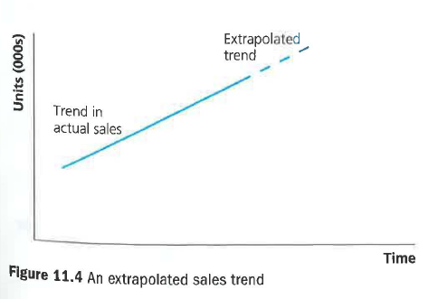
Here a very steady upward trend over a long period may continue and be predicted to continue. However, such stability and predictability are rare. The values of data plotted over time, called time-series analysis, vary because of genuinely random factors.

As with every business technique, there is also a need for judgement. Look at Figure 11.5. Based upon the longer-term trend, you might believe that the recent downturn is temporary (perhaps due to bad weather). Or it may be that you believe that the recent figures have established the likely trend for the future. It is never wise to simply use a calculator, a computer or graph paper without thinking carefully about what makes the most sense.
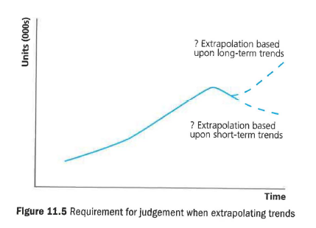

Scatter graphs (correlation)
Businesses are always keen to learn about the effect on sales of marketing strategies such as TV advertising, sales promotion or direct mailshots. Often researchers will compare sales volume and advertising expenditure. A good way to do this is on a graph. In Figure 11.6 there is clearly a strong relationship, or correlation, between the two. The correlation is positive: as one increases so does the other. It is important to realise that each point correlating the two variables represents one observation covering a period of time, e.g. spring 2016: advertising spending £30,000; sales 800 units.

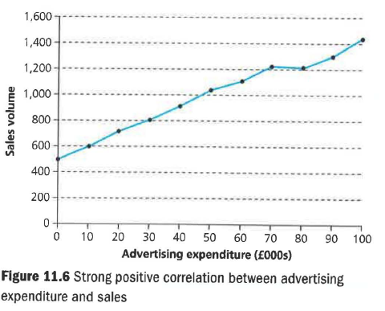

In Figure 11.7, however, there is not so much linkage, as the diagram is little more than a collection of randomly dispersed points. In this case there is low correlation between advertising and sales, suggesting that the firm should stop wasting its money until it has found a way to make its advertising work more effectively.

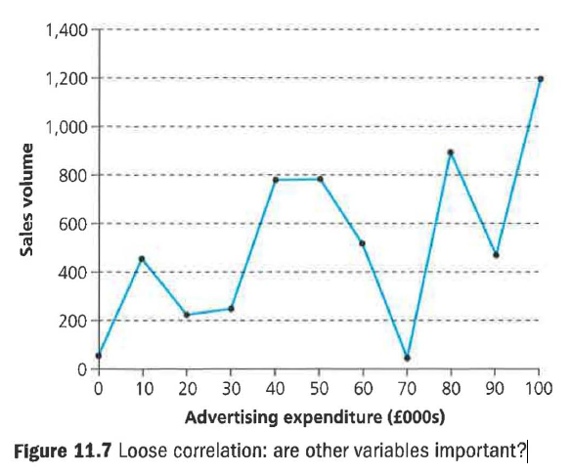

What the researcher is looking for is cause and effect, such as evidence that the advertising has caused the increase in sales. Correlation by itself does not indicate cause and effect. The sun rising in the morning may be strongly correlated with the delivery time of newspapers, but it does not cause them to be delivered. Strong correlation is evidence that cause and effect may be present.

A useful technique for interpreting scatter graphs is to look for the line of best fit. This shows whether the correlation is positive or negative. In addition, the degree of variation from the line of best fit gives a clear idea of the strength or the weakness of the correlation. In Figure 11.8 you can see that the more stores opened by the John Lewis Partnership (including Waitrose), the lower the bonus received by staff.

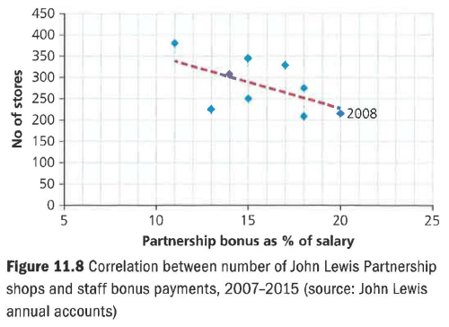

Correlation

In Britain, the Met Office offers businesses a weather-forecasting service, charging a fee for predicting the sales of products ranging from lemonade to cat food. It uses correlation analysis to predict how demand will vary according to the time of year and the prevailing weather. It has found that lemonade sales rise in the summer, but tail away if the weather is very hot (presumably consumers switch to non-fizzy drinks or to ice lollies). More surprisingly, cat food is weather-affected. Rainy days boost demand (the cats don't go out), while, if it's hot, cats eat less.

The website www.metoffice.gov.uk recently featured a producer of hot ready meals that used the Met Office's correlation software to find out that it lost £70,000 of sales for every 1 degree of temperature increase above 20°C.

Limitations of quantitative sales forecasting techniques
Both extrapolation and correlation can only help to forecast if the future proves to be like the past. Certain future factors are certain, such as Christmas being in December. But many others are uncertain because of factors such as:

• New entrants into the market
• A sudden wave of viral, social media support for or criticism of - your products or the celebrity who promotes your products• population changes
• Changes in weather conditions
• Legal changes (for example, limiting particular forms of promotion or new taxes, perhaps on high-sugar drinks)
• internal factors such as changes in the sales force, changes in the amount of spending on promotion or the way that the money is being spent, or the launch of a new product.

In most cases the actual sales forecast will not be absolutely accurate. However, this does not make forecasting a waste of time; as long as it can provide an estimate that is approximately correct, it will have helped the firm to plan its staffing, funding and production. Better to plan and be approximately right than not plan at all and be unprepared. However, it is always important to review your sales forecasts and compare this with what actually happened; this can help the firm to improve its forecasting techniques and provide better estimates in the future.

Revision questions

1 What is a sales forecast? (2)

2 Explain how you can show the trend in a series of data. (4)

3 Explain how two of the following Heinz managers could be helped by two weeks' warning that sales are forecast to rise by 15 per cent:
a) the operations manager
b) the marketing manager, Heinz Baked Beans
c) the personnel manager
d) the chief accountant (8)

4 What do you understand by the term 'extrapolation'? Explain how it's used to make a sales forecast. (6)

5 Explain how Coca-Cola may be helped by checking for correlations between the following factors:

a) Sales and the daily temperature
b) Staff absence levels and the leadership style of individual supervisors. (6)

6 Explain why it is risky to assume cause and effect when looking at factors that are correlated. (4)

