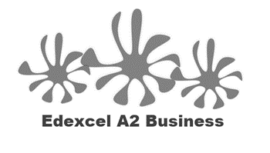
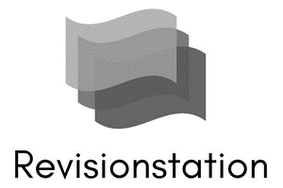
1.4.3 Organisational Design

Starter
Do you know someone who is terrible at communicating? Without naming them can you tick the ways that they fail to communicate effectively:
- Interrupts
- Talks about themselves too much
- Over dramatize everything
- Lies
- Talks too fast
- Doesn’t discuss important issues
- Constantly criticises
- Too sarcastic
- Always negative
- Rambling

Write your definition of organisational design here:

____________________________________________________________________________________________________________________________________________________________________

Hierarchy
- A hierarchy is a system in a business where employees are ___________________________ due to their status and authority
- Traditionally those at the ______________________ of the hierarchy are more ____________________________ than those at the bottom
- Employees during their career will seek to move up the hierarchy to improve their ___________________________ and working ________________

Chain of command
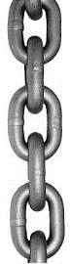
- The chain of command in a business is the flow of ___________________, power and _____________ through the organisation
- Those at the top have more ___________ and authority
- They can ___________________ tasks to those __________________ to them in the hierarchy (below them)
- ______________________ and status reports flow up the chain, _______________________ flow down the chain. Both need to be handled at the ____________________ level possible

Span of control

- This is a __________________
- An employee that works as a Head of Department in a school may have 6 teachers working for them. Their _____________________ of control is therefore _____________
- This is the number of subordinates that they can ____________________ to

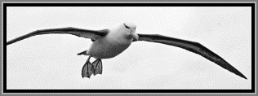
Span of control - the number

- Where there are _____________ spans of control there will be a __________________ hierarchy and jobs will be very _________________________________.
- A _______________________ span of control will mean a _______________ hierarchy and employees will be given more responsibility and larger roles

Decentralisation
_______________________________________________________________________________________________________________________________________________________________________________________________________________________________________________________________________________________________________________________________________
Centralisation
________________________________________________________________________________________________________________________________________________________________________________________________________________________________________________________________________________________________________________________________________

Centralisation – draw and label the diagram

Decentralisation – draw and label the diagram

Types of structure
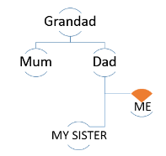
Draw your family organisational chart here:

________________________________________________________________________________________________________________________________________________________________________________________________________________________________________________________________________________________________________________________________________

What does an organisational chart show?

1
2
3
4
5
6

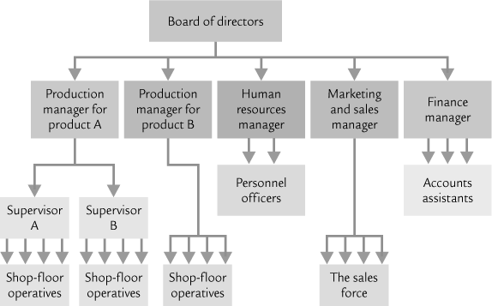
Tall hierarchical structure

________________________________________________________________________________________________________________________________________________________________________________________________________________________________________________________________________________________________________________________________________
Advantages | Disadvantages

Flat hierarchical structure

________________________________________________________________________________________________________________________________________________________________________________________________________________________________________________________________________________________________________________________________________
Advantages | Disadvantages

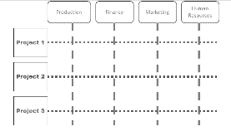
Matrix hierarchical structure

________________________________________________________________________________________________________________________________________________________________________________________________________________________________________________________________________________________________________________________________________
Advantages | Disadvantages

Impact of different organisational structures on business efficiency and motivation
 | Efficiency | Motivation
Matrix
Tall
Flat

