Price Elasticity of Supply - NOTES
Just like PED (where there is a variation in the responsiveness of demand, to a given change in price) the responsiveness of supply varies to a given change in price. This can also be measured and is called price elasticity of supply (PES).
PES measures the responsiveness of supply to a change in price:
% change in Quantity Supplied
% change in price
The PES coefficient will always be positive, this is due to the positive relationship between supply and price – the numerator and denominator in your calculation (see formula above) will always be the same in terms of positive or negative.
- When price goes up (positive), then supply increases (positive)
- When price goes down (negative), then supply decreases (negative)

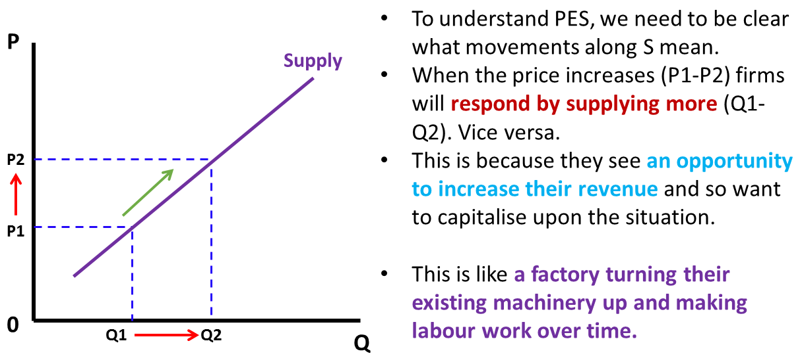

As with PED, different elasticities are given different names. When the PES is:
- Zero – perfectly inelastic – as there is no response in quantity supplied to a change in price.
- Less than 1 – inelastic – there is a proportionately smaller change in quantity supplied, to a given change in price.
- Infinite – perfectly elastic – producers are prepared to supply any amount at a given price.
- Greater than one – elastic - there is a proportionately larger change in quantity supplied, to a given change in price.

Factors influencing the price elasticity of supply
- Time – short-run and long-run: The shorter the time period, the more difficult it is for firms to respond to price changes. So in the short term, supply is likely to be more price inelastic than in the long-term. This short-term/long-term argument is linked to many of the arguments below. Economic definitions of SR/LR are:
  - Short-run: defined in Economics as the period of time when at least one factor of supply (land, labour and capital) is fixed and the rest are variable/changeable in terms of quantity/quality.
  - Long-run: defined in Economics as the period of time when all factors of supply (land, labour and capital) are variable/changeable in terms of quantity/quality.
- Production time: For example, if there is a crop failure of a product like wheat, it will take until next year to increase supply again, regardless of the price of wheat in the short-term. This also applies to products which are more complicated to produce, therefore a product which is easy to produce and does not take very long would be elastic, whereas a complex product would take longer to produce and so would be inelastic.
- Spare capacity: If the firm has spare capacity, in terms of production capabilities, then they are more able to increase supply in response to an increase in price. The more spare capacity there is, the less constraint this places on increasing supply in respond to price rises. For example, if a firm has a factory that can produce 1,000 products when operating at 100% capacity, but is only currently producing 500 products, then if the price went up the firm could respond quickly – so the PES would be elastic. However, if another factory was producing at 90% capacity, then they could only respond slightly to a change in price – therefore PES would be inelastic.
- Ability to hold stock: With some products, it is easy and relatively straightforward to hold stocks to keep and supply to the market when required. With other products, it is impossible or very difficult to hold stocks. For example, large stocks of wheat are can be held and released in response to an increase in prices, so the PES of wheat in this case would be elastic. However, some perishable items are difficult to stock for extended periods of time and so many food items would be PES inelastic – indeed large stocks of ice cream is expensive to store, as it requires freezers to stop the product from melting and so PES for these kinds of goods would be in inelastic. Large items such as planes and ships not only take a long time to manufacture (see above factor) but they are also very difficult to store and hold large stocks of, just trying to stockpile a 75m long Boeing 747 is going to be both expensive (in terms of paying for storage) and impractical – making them PES inelastic. Smaller items can be stacked on top of each other and kept in large warehouses, so would be PES elastic.
- Are the factors of production readily available: Often products require lots of land, labour and capital to produce them; the availability of these factors of supply will alter the PES of the product. For example, bread requires farmers (labour), flour (land) and tractors (capital) to produce it. If there is a shortage or difficult obtaining any of these, then this will mean that the PES of bread becomes inelastic as it is more difficult for supply to respond when price changes. If there is a lack of skilled farm labour, then it is difficult to produce the flour that the bread requires and this would be the same for a lack of tractors.
- Factor Immobility: It would also be the case if any of the factors of production (land, labour, capital) were indeed available, but not easily accessible to the firm – for example, if the flour was 1,000 miles away, or in an area with poor transport links, this makes the supply of bread less responsive to price changes, as a the bread producer would have difficulties getting the flour quickly to make the bread. Similarly if skilled farm labour lived 1,000 miles away from the bread producer, the producer would have difficulty hiring the necessary labour to produce the bread – hence why many firms like to locate themselves near universities. Or if house prices were much higher near the firm’s location and so labour would find it difficult to relocate (for example, from Wales to London). Any situation where the factors of production are unable to be utilised where they are required in an economy is known as factor immobility.
- Ability to switch production: If producers are easily able to switch their production from one process (good A) to another (good B), then the PES for good B is likely to be elastic – as producers can quickly respond and switch to the production of good B following a price rise. For example, if producers wanted to switch from producing cars to producing vans, then this could be easily achieved as the production processes are similar and so in this example of the PES of vans would be elastic. However, if producers wanted to switch from carrots to producing vans, then in this scenario the PES for vans would be inelastic – as it is difficult to change supply in response to a change in price. The production processes are just too dissimilar and there would be a delay in switching from carrots to vans.

Why is high PES desirable for a firm?
It is desirable for a firm to be highly responsive to changes in price and other market conditions. This is because a high PES makes the firm more competitive than its rivals and it allows the firm to generate more revenue and profits. If the ability of firms to change supply in response to a price change is low, then the price mechanism has difficulty operating and there are delays in equilibrium between price and quantity being established. This delayed response to a change in the market is a criticism of free-market economics.

