Inflation

Inflation measures the percentage annual rise in the average price level. For consumers, inflation increases the cost of living. The rate of inflation is measured monthly, but presented as a year-on-year figure. Therefore, September 2014 inflation of 1.2 per cent meant that the prices of the average household's shopping basket were 1.2 per cent higher than in September 2013.

Does this matter? Traditionally, it mattered most to those with cash savings, such as pensioners. Steady inflation erodes the spending power of money and therefore makes each £1,000 of cash savings worth less. In the period between 2009 and 2015, it mattered because the weakness of the labour market meant that earnings were hardly rising at all, year on year. Therefore, every 1 per cent of inflation meant a 1 per cent reduction in the value of employees' earnings. In turn, that meant squeezed living standards.

The most widely quoted index for measuring inflation is the Consumer Prices Index (CPI). This data series is produced by the government's statistical office each month. It selects 700 items that we buy most often, then measures changes in the price charged for this shopping basket in thousands of different stores and locations. The data is then converted into an index to make it easier to understand and use by students, journalists and others.

An index means converting a series of data into figures that all relate to a base period where the data = 100. This allows users of the data to see at a glance the percentage changes and trends. In Table 45.1, column A shows the total price of buying the shopping basket. Column B converts that data into an index. This starts by saying 'let £402 = 100', then all the other figures in column A are related to that base figure of 100. For example, the figure for 2014 is £514.15/£402 X 100 = 127.9. Column C then calculates the percentage change each year based on the data in column A (or column B - it should give the same figure).
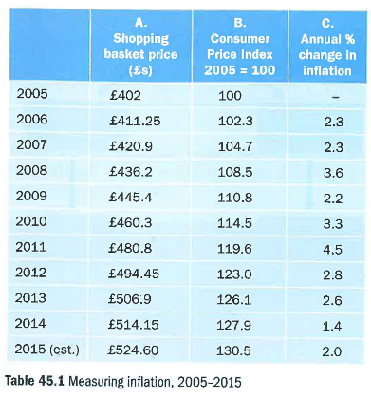

The advantage of index numbers is that you can see quickly that, for example, inflation amounted to 27.9 per cent between 2005 and 2014. Therefore, index numbers help you understand trends rather more easily. Their other huge benefit is that they enable direct comparisons to be made between different data series. In the case of inflation, the interesting recent comparison would be with earnings.
This data is shown in Table 45.2 and Figure 45.3. It shows average earnings outstripping prices in 2006 and 2007, but then being dragged back until - from 2011 – they were well behind the rise in prices.

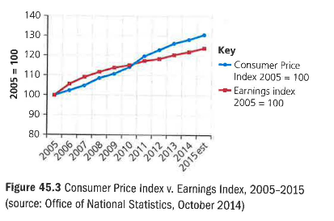
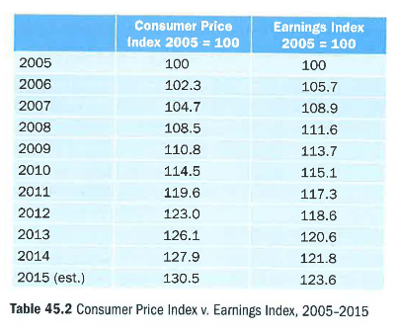

Effects of inflation on businesses

1 Firms with large loans benefit from inflation because inflation erodes the real value of the money owed. So when they have to repay the loan, it does not feel as painful because of the fall in the value of money. As an extreme example, a house in south London has just been sold for £1.2 million. When bought, 20 years ago, its price was £80,000. It was bought with a £50,000 mortgage.

Repaying a £50,000 mortgage seems a lot easier now that the sale has provided £1.2 million of cash.

2 But inflation can damage profitability, especially for firms that have fixed-price contracts that take a long time to complete. For example, a local building company might agree a £5 million price for an extension to a local private school, which is expected to take three years to finish. If inflation is higher than expected, profit could be wiped out by the unexpectedly high cost increases created by the unexpectedly high rates of inflation.

3 If costs in Britain are rising faster than prices elsewhere, UK companies will find that they are losing their ability to compete effectively with foreign firms. Renault has launched a new small car for India priced at £2,200. That would hardly pay the labour costs if the car was produced in Britain.

