The effect of economic uncertainty on the business environment

In late 2013, investment bankers Goldman Sachs made their forecast for oil prices for the coming year. They expected a price rise to $105, with $115 a distinct possibility. In fact, by December 2014, the world oil price was below $60 a barrel. Some very highly paid bankers got it all wrong. This, in turn, would mean that airlines would have paid too much for their fuel, and that suppliers of sustainable energy such as wind power would now be under severe economic pressure.

This gives an idea of what economic uncertainty looks like. If it is extremely difficult to forecast the level of supply and demand in the oil business (and therefore the price), how much harder is it to forecast the level of demand throughout an economy? It verges on the impossible. Therefore, every business has to make its plans for the coming year with little certainty about the overall state of the economy, and even less certainty about certain economic variables that are especially prone to big ups and downs. These include:

• the value of the pound; in the ten years from 2005 to 2014, the value of the pound against the euro fluctuated between £1 = €1.02 and £1 = €1.52; that variation of 50 per cent adds huge uncertainty to the plans of UK exporters • the rate of economic growth; in that same ten-year period, UK annual growth varied between +3.2 per cent and -5.0 per cent

• the value of oil; between 2005 and 2014, the world oil price varied between $41 and $133 once again, making planning extremely difficult.

The lesson businesses need to take from the uncertain economic environment is to always be prepared for changing times around the corner. In good times, make sure your cash balances are being built up sufficiently to cope with a sudden worsening of your position. And in bad times, keep alert to the opportunities that may soon be about to open up.

Five whys and a how
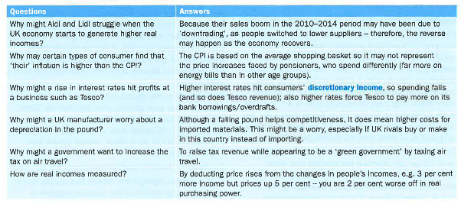

45.9 Economic influences - evaluation
When companies publish their annual results, commentators groan if the boss blames disappointing results on external factors such as the weather or the weakness of the economy. Business journalists admire chief executives who achieve their targets no matter what. Yet that may not be realistic. If you are running Coca-Cola, you have huge control over your pricing and therefore can probably find a way to boost profits to meet analysts' expectations. Not long ago, people assumed that Tesco was in a similar position. The squeeze on household spending, the rise of Aldi and Lidl and a series of strategy mistakes by Tesco make it look very different now.

In truth, it is always the case that firms are vulnerable to external factors. Even monopolies (when a single firm dominates a market) are subject to changing consumer habits, as Microsoft and even Apple have found in recent years. If things seem to be going wonderfully well - and every commentator thinks your business is bulletproof – it is probably time to worry. The one-time boss of monopolist microchip supplier Intel, Andy Grove, once said that 'only the paranoid survive'. That remains grimly true.

