Chief economist of Bank of England admits errors in Brexit forecasting
Andrew Haldane says his profession must adapt to regain the trust of the public, claiming narrow models ignored ‘irrational behaviour’
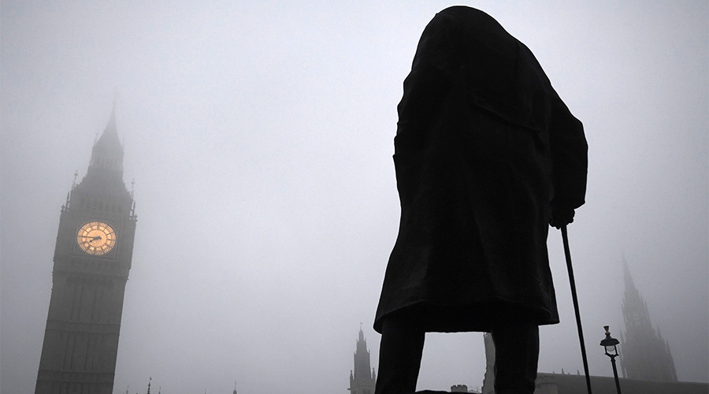
Thursday 5 January 2017
The Bank of England’s chief economist has admitted his profession is in crisis having failed to foresee the 2008 financial crash and having misjudged the impact of the Brexit vote.
Andrew Haldane, said it was “a fair cop” referring to a series of forecasting errors before and after the financial crash which had brought the profession’s reputation into question.
Blaming the failure of economic models to cope with “irrational behaviour” in the modern era, the economist said the profession needed to adapt to regain the trust of the public and politicians.
Haldane described the collapse of Lehman Brothers as the economics profession’s “Michael Fish moment” (a reference to when the BBC weather forecaster predicted in 1987 that the UK would avoid a hurricane that went on to devastate large parts of southern England). Haldane said meteorological forecasting had improved markedly following that embarrassing mistake and that the economics profession could follow in its footsteps.
The Bank of England has come under intense criticism for predicting a dramatic slowdown in the UK’s fortunes in the event of a vote for Brexit only for the economy to bounce back strongly and remain one of the best performing in the developed world.
Haldane is known to be concerned about mounting criticism of experts and the potential for the Bank of England’s forecasts to be dismissed by politicians if errors persist.
Former Tory ministers, including the former foreign secretary William Hague and the former justice secretary Michael Gove, last year attacked the Bank of England governor, Mark Carney, for predicting a dramatic slowdown in growth if the country voted to leave the EU.
Prominent Brexit campaigners have also besieged the central bank. Before the vote, the foreign secretary, Boris Johnson accused the bank of risking undermining economic confidence by issuing warnings about the potential effects of a vote for Brexit. During her conference speech following the vote, on 6 October, the prime minister, Theresa May, criticised the bank’s reaction to the vote after it cut interest rates further to 0.25% and boosted its package of stimulus measures by £60bn to £435bn.
Gove said last week that when he said experts needed to be challenged, he meant economists in particular.
Gove said: “Sometimes we’re invited to take experts as though they were prophets, as though their words were carved in tablets of stone and that we had to simply meekly bow down before them and accept their verdict.
“I think the right response in a democracy, to assertions made by experts, is to say ‘show us the evidence, show us the facts’. And then, if experts or indeed anyone in the debate can make a strong case, draw on evidence and let us think again – then of course they deserve respect.”
Flanders, who now works for JP Morgan, agreed that economists had a long record of being wrong on direct forecasts while expressing concerns about the consequences of expertise being dismissed out of hand. “I think we’ve seen over the last few years economists and indeed the elite, the technocrats, can be wrong in some pretty big areas,” she said. “They were wrong in their assumptions about certain financial instruments and developments, which helped contribute to the financial crisis.”
Official figures have shown the economy was outstripped only by the US among the large economies last year after growth in the third quarter was upgraded to 0.6%.
Forecasts by the Treasury, the International Monetary Fund and the Paris-based OECD, all pointed to a recession after the vote, based on assumptions of steeply declining consumer spending and business investment.
Haldane said: “It’s a fair cop to say the profession is to some degree in crisis. It’s not the first time it has happened. It happened back in the 1930s and [during] the Great Depression. But out of that something good spread. It brought us [John Maynard] Keynes and the birth of modern macro-economics. Out of this crisis, there could be a rebirth of economics. I’m not someone who would say that all that’s been done in the past is terrible. It’s just that the models we had were rather narrow and fragile. The problem came when the world was tipped upside down and those models were ill-equipped to making sense of behaviours that were deeply irrational.”
He blamed the profession’s reliance on models that were built for an age when consumers and businesses, and especially banks, “behaved rationally”. Since 2008, consumers have maintained their spending when the classic economic models would have expected them to be more circumspect.
Haldane, who is regularly cited as a dove on the bank’s interest rate-setting committee, has argued that the economy remains weak and that rates should stay low to boost growth.
Answering critics of the bank’s gloomy November forecast for the economy, he admitted that the bank did not anticipate the resilience of consumer spending after Britain voted to leave the EU. But he said that he thought the bank was wrong about timing not about the fundamentals, and that the Bank of England still expected Brexit to harm growth.
He blamed decades of education policies – that had left numeracy levels in England only just above Albania – for holding back improvements in productivity. He said the lack of numeracy skills was stark in comparison with other countries, which placed more emphasis on workers having more than a basic level of maths.
Haldane said: “I’ll give an example of where Britain is punching well below its weight and that’s in core numeracy skills. There are 17 million people who have levels of numeracy that are no better than those expected of primary age children. In a recent OECD study that looked at numeracy as it applies to financial literacy, the UK came 17th, just above Albania, on questions of financial literacy.”
He added that the UK’s lack of numeracy skills across more than half the working population was a key reason for its lack of productivity growth since the financial crisis.
Highlight or write down answers to the following questions:
What are the main criticisms of economists?

What is the current state of the UK economy?

https://www.theguardian.com/business/2017/jan/05/chief-economist-of-bank-of-england-admits-errors?CMP=share_btn_tw

