1.4.4 Motivation in theory and practice

Starter
- Would you clean a car for free?

- How much money would a business need to pay you to clean a car?

- What if money didn’t matter to you, how would a business get you to clean a car?

Write a definition of motivation here:
________________________________________________________________________________________________________________________________________________________________________________________________________________________________________________________________________________________________________________________________________
The importance of employee motivation to a business
________________________________________________________________________________________________________________________________________________________________________________________________________________________________________________________________________________________________________________________________________
The importance of employee motivation

________________________________________________________________________________________________________________________________________________________________________________________________________________________________________________________________________________________________________________________________________

Motivation theories

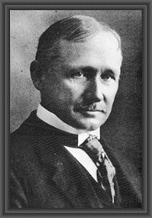
#1 Taylor – Scientific Management

____________________________________________________________________________________________________________________________________________________________________________________________________________________________________________________________________________________________________________________________________________________________________________________________________________________________________________________________________________________________________________
Notes from the video:

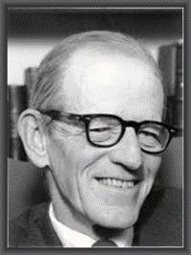
#2 Mayo – human relations theory

____________________________________________________________________________________________________________________________________________________________________________________________________________________________________________________________________________________________________________________________________________________________________________________________________________________________________________________________________________________________________________
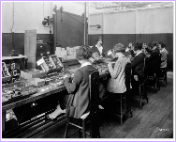
#2 Mayo: Ladies of the relay assembly room that Elton Mayo studied

________________________________________________________________________________________________________________________________________________________________________________________________________________________________________________________________________________________________________________________________________
Notes from the video:

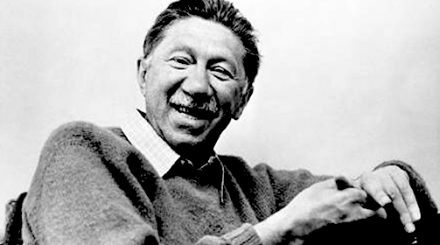
#3 Taylor – Scientific Management

____________________________________________________________________________________________________________________________________________________________________________________________________________________________________________________________________________________________________________________________________________________________________________________________________________________________________________________________________________________________________________
Notes from the video:

Draw and label your Maslow’s Hierarchy of needs diagram

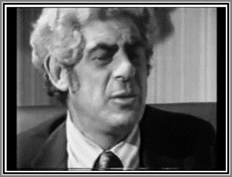
No 4 Herzberg (Two factory theory)

- Frederick Hertzberg worked in the 1960s, his theories are still studied today.
- He interviewed ____________________________ and ____________________________ to find out what motivated them
- His theory was that employees have motivating factors; interesting work, recognition and personal _______________________________, responsibility and scope to __________________________
- He also found that there were _____________________ factors which if not met would dissatisfy the employees, but if they were met did not motivate them any more than they were already. These were; good working _____________________________, pay, relationships with other employees
Draw the Herzberg diagram here:

Financial incentives to improve employee performance
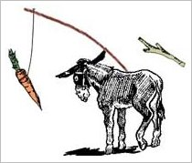
The carrot and the stick theory

________________________________________________________________________________________________________________________________________________________________________________________________________________________________________________________________________________________________________________________________________
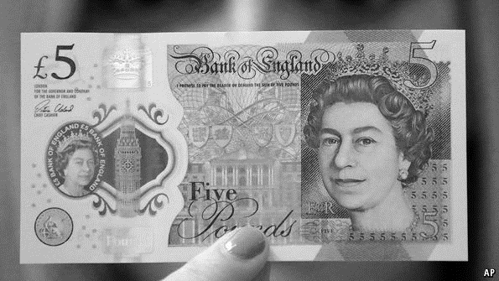
What if I give you £5?

________________________________________________________________________________________________________________________________________________________________________________________________________________________________________________________________________________________________________________________________________
What about if I shout at you will you work harder?

________________________________________________________________________________________________________________________________________________________________________________________________________________________________________________________________________________________________________________________________________
Financial motivation methods

1 |  | Advantages | Disadvantages
2

3 |  | Advantages | Disadvantages
4
5 |  | Advantages | Disadvantages

Non-financial techniques to improve employee performance

1 |  | Advantages | Disadvantages
2

3 |  | Advantages | Disadvantages
4
5 |  | Advantages | Disadvantages
6
7 |  | Advantages | Disadvantages
8

Motivation quiz

Financial motivators | Non-financial motivators

