4.2.5 Global competitiveness

Write a definition of exchange rates here:

________________________________________________________________________________________________________________________________________________________________________________________________________________________________________________________________________________________________________________________________________
£1 to the US Dollar |  | £ to the Japanese Yen
£1 to the Euro |  | £ to the Russian Ruble

SPICED – revision
Write the opposite to Spiced in here

S
P
I
C
E
D

Appreciation and exports

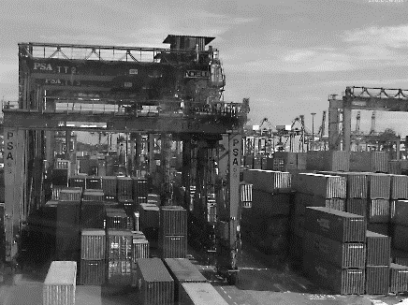

Appreciation and imports

Depreciation and exports

Depreciation and imports

Competitive advantage
Write a definition of competitive advantage here:

________________________________________________________________________________________________________________________________________________________________________________________________________________________________________________________________________________________________________________________________________
#1 Low cost leadership
________________________________________________________________________________________________________________________________________________________________________________________________________________________________________________________________________________________________________________________________________
#2 Differentiation

_______________________________________________________________________________________________________________________________________________________________________________________________________________________________________________________________________________________________________________________________________

What strategy – low cost / differentiation?

Skill shortages
Skill shortages and their impact on international competitiveness

_______________________________________________________________________________________________________________________________________________________________________________________________________________________________________________________________________________________________________________________________________

Skills shortages and competitive advantage

_______________________________________________________________________________________________________________________________________________________________________________________________________________________________________________________________________________________________________________________________________

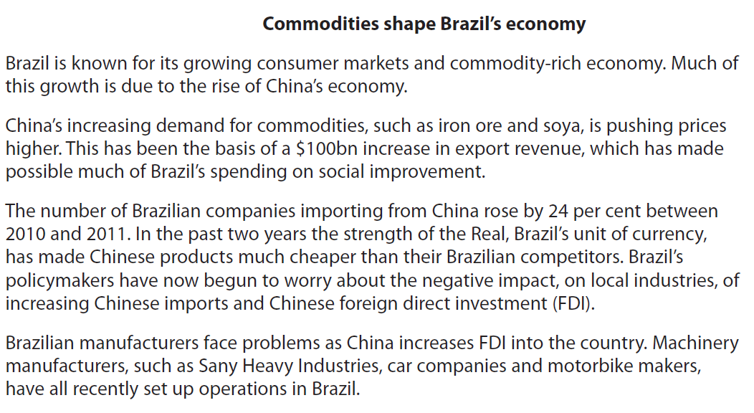

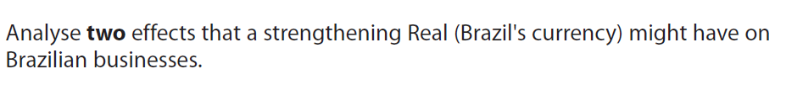

[8]

