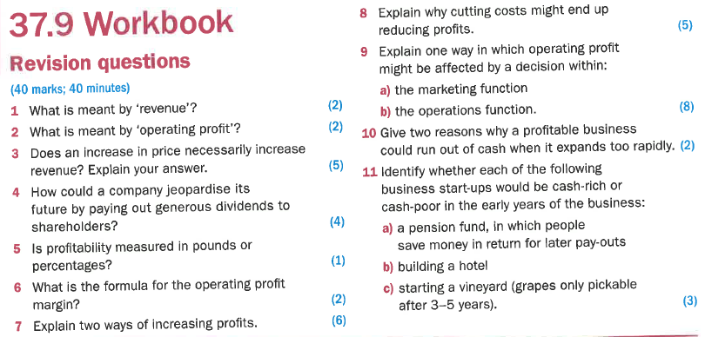

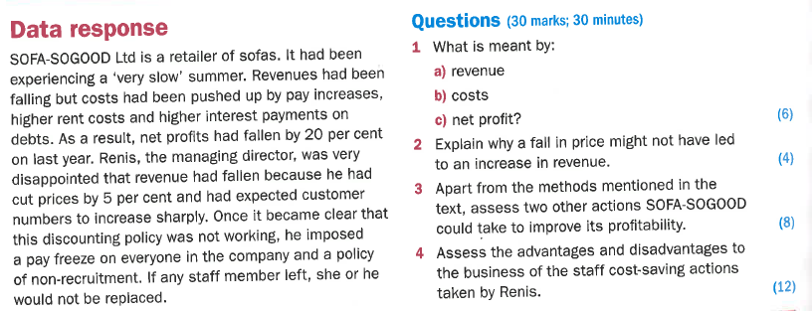
Profit and loss account

- The profit and loss account shows:
a) How a business has traded for a specific period
b) The assets and liabilities of a business at a specific point in time
c) How cash has come into the business and what it has been spent on
d) The amount of money made by selling surplus assets

- Which of the following is the correct calculation of gross profit?
a) Sales less operating costs
b) Sales less depreciation
c) Sales less cost of sales
d) Cash receipts less expenses

- A business achieves total sales of £250,000 and has a "cost of sales" of £110,000.
Overheads are £50,000. What is the gross profit of the business?
a) £250,000
b) £140,000
c) £90,000
d) £60,000

- A business makes a gross margin of 22% on sales of £450,000. What was the "cost of
sales" of the business?
a) £351,000
b) £99,000
c) £200,000
d) Not possible to calculate from the information given

- Which of the following actions would not improve the gross profit of a business?
a) Change to cheaper raw materials suppliers
b) Offer fewer discounts to customers
c) Increase selling prices of products
d) Reduce advertising expenditure

- A business makes a gross profit margin of 37.5% on its sales of £15.0 million in 2004.
What was the cost of sales in the year?
a) £5.625 million
b) £9.375 million
c) £5.735 million
d) £15.0 million

- Which of the following would improve the gross profit margin of a manufacturing
business?
a) Raw material suppliers to the business increase their prices
b) The marketing department offers higher customer discounts to encourage sales
c) New production methods reduce the factory reject rate
d) Office overheads are reduced following redundancies in the accounts and admin departments
- Which factor below would increase the operating profit margin of a business?
a) An increase in trade creditors
b) An increase in overheads
c) An increase in fixed asset spending
d) An increase in gross profit margin

- Which of the following would be separately shown as an “exceptional item” in the profit
and loss account?
a) An increase in the cost of raw materials
b) A pay rise for the sales and marketing team
c) The closure of a significant business unit
d) An increase in the depreciation charge

- Retained profit is calculated as:
a) Sales less cost of sales
b) Gross profit less overheads
c) Profit after tax less dividends
d) Operating profit plus dividends

- A limited company must pay out a dividend to shareholders if it makes a profit: true or
false?
a) True
b) False

Profit and loss account
Answers:
- (a)
- (c)
- (b)
- (a)
- (d)
- (b)
- (c)
- (d)
- (c)
- (c)
- (b)

