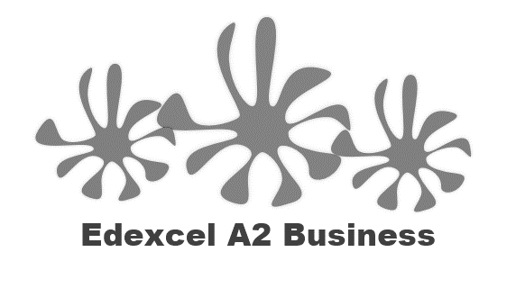

Starter - What do these 10 companies have in common:
- Nestlé
- Monsanto
- Amazon
- Shell
- Tesco
- Barclays
- Exxon
- Wal-Mart (ASDA)
- Coca Cola
- Primark

Write the definition of ethics here:
________________________________________________________________________________________________________________________________________________________________________________________________________________________________________________________________________________________________________________________________________

Ethical decisions
- Businesses want to appear to be doing “the right thing” but this is not always possible if they wish to make a _____________________
- Often there is a ____________________ between ethics and profitability (compromise)
- A prime example of a pharmaceutical company’s exploitation of medicinal availability is GSK created a ________________________ of HIV/AIDS medications in South Africa that resulted in drug availability to only 10% of the people who _________________ it.
Ethics vs profitability – Deepwater Horizon
- 2010 BP oil rig Deepwater Horizon caught ________
- 11 men lost their lives
- Obama said it was “the worst ___________________ disaster ever”
- Millions of gallons of ____________ spilt into the Gulf of Mexico
- All due to __________________________ by BP, failure to invest in training and health and safety
- Worst affected – _____________________ and residents of the Gulf
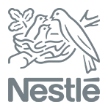
Nestle –profit before ethics
- Nestlé has been voted the ___________________ ethical company of the last 25 years by readers of Ethical Consumer.
- The ________________ food company 'won' with 15% of the vote, finishing just above Monsanto (14%) and the UK's number one tax avoider Amazon (12%).
- Nestlé is currently subject to the longest ever running consumer boycott. For over 20 years ________________________________ has called a boycott of the company for its irresponsible marketing of baby milk formula, which infringes the International Code of Marketing of Breast-milk
Ethics vs profitability – VW
_______________________________________________________________________________________________________________________________________________________________________________________________________________________________________________________________________________________________________________________________________
Video notes here:

Ethics vs profitability – Monsanto
_______________________________________________________________________________________________________________________________________________________________________________________________________________________________________________________________________________________________________________________________________
Video notes here:

Pay and rewards
Executive pay vs employee pay
_______________________________________________________________________________________________________________________________________________________________________________________________________________________________________________________________________________________________________________________________________

Bankers bonuses
_______________________________________________________________________________________________________________________________________________________________________________________________________________________________________________________________________________________________________________________________________
Sponsorship
_______________________________________________________________________________________________________________________________________________________________________________________________________________________________________________________________________________________________________________________________________
Corporate social responsibility (CSR)
CSR defined
_______________________________________________________________________________________________________________________________________________________________________________________________________________________________________________________________________________________________________________________________________

CSR and us
_______________________________________________________________________________________________________________________________________________________________________________________________________________________________________________________________________________________________________________________________________
CSR approach
_______________________________________________________________________________________________________________________________________________________________________________________________________________________________________________________________________________________________________________________________________

Corporate social responsibility:

Advantages of a CSR approach:
Happy customers
Happy staff
Happy investors
New products new markets
Good PR
Happy community
Happy suppliers
Cost reductions

Disadvantages of a CSR approach:
Fad?
Motive?
Cost?
Care?

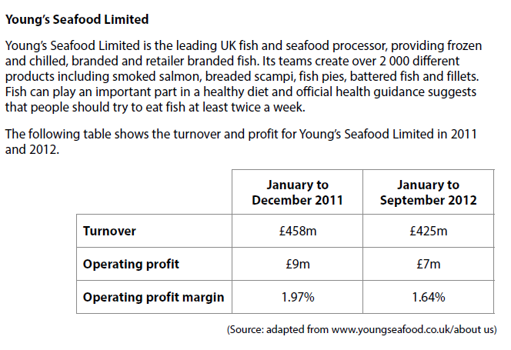

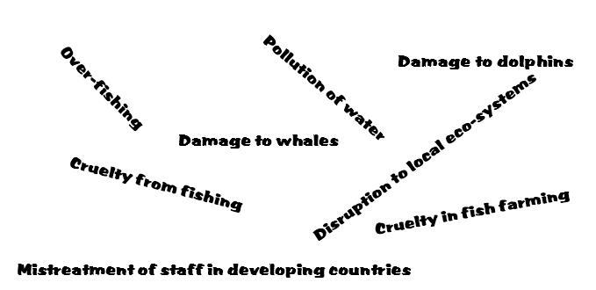
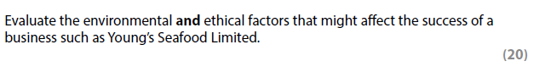

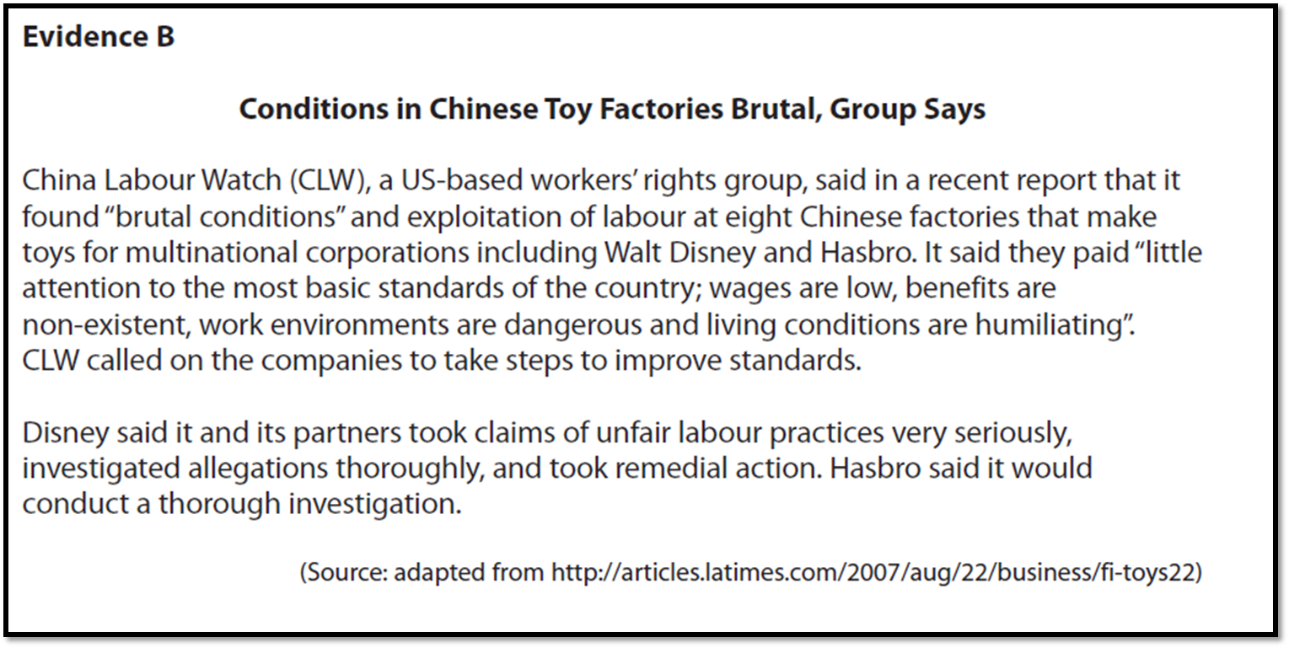

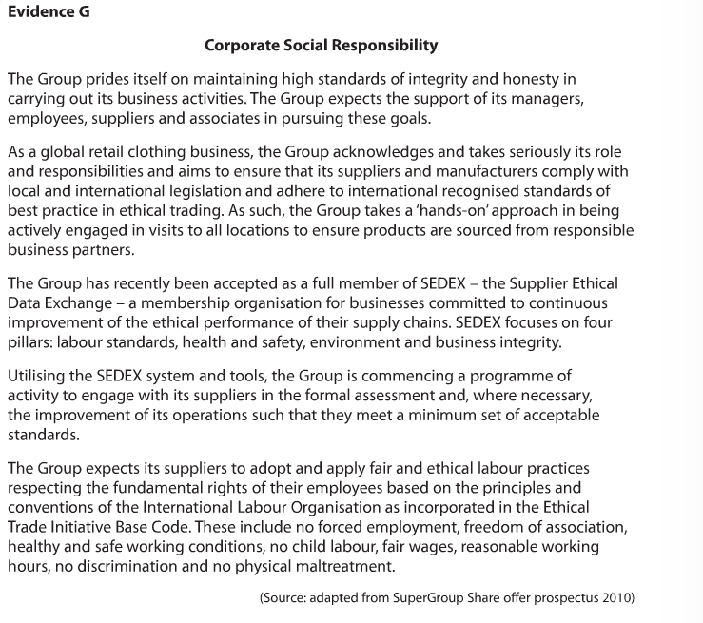
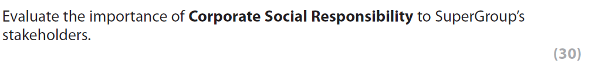
[20]

