Economic Thinkers - NOTES

Adam Smith, Friedrich Hayek and Karl Marx
This resource sheet is designed to support the new AS and A level Economics A specification Topic 1.1.6: Free market economies, mixed economy and command economy:
a) The distinction between free market, mixed and command economies: reference to Adam Smith, Friedrich Hayek and Karl Marx.

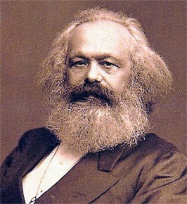
Karl Marx (1818–1883)
Karl Marx was an extremely influential thinker whose ideas ignited the movement by a third of the world’s countries towards communism in the 20th century.

Marx provided a criticism of capitalism. Capitalism is a system where the small minority – the ‘bourgeoisie’ (the owners of capital such as machines and factories) – are the ruling class, and the masses – the ‘proletariat’ (the labourers) – provide the labour to produce goods and services. Marx essentially believed that economic systems progress through different stages – capitalism is just one stage in this development process and, due to its weaknesses and flaws, will eventually self-destruct, leading to the final stage of communism.

Marx believed that capitalists (the owners of capital), whose objective is to make a profit, must end up exploiting workers to achieve this objective. This means that workers will earn wages lower than their true value. Capitalists will also have an incentive to replace labour with machines, creating both more monotonous jobs as well as unemployment. The combined effect will be to create an exploited and alienated workforce, leading to social unrest.

He also believed that competition would cause many firms to go bust, leading to a few firms holding monopoly power which would allow them to further exploit both workers and consumers. This would also lead to owners of the bust firms joining the ever-increasing proletariat majority, causing social tensions to further increase.

The capitalist economic system is also weak, Marx said, since it is an unplanned system which causes one crisis after another. This impacts most negatively on the proletariat (the labourers). Marx believed that revolution among the proletariat was inevitable. Revolution would enable workers to seize the capital (so that ownership would be among the majority). Economic planning would direct economic activity. As the economic system moves towards communism, there would be abolition of private property replaced by common ownership of resources.

However, although Marx wrote a lot criticising capitalism, he wrote relatively little on how communism would work. Marxism has had a resurgence lately. Many global problems, such as the Global Financial Crisis and growing inequalities observed in many economies, may have their root cause in the free market system.

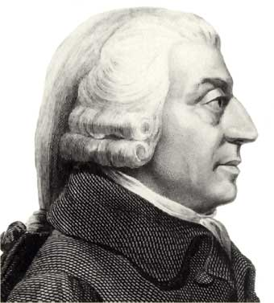
Adam Smith (1723–1790)
Adam Smith is viewed to be the founder of classical economics and was a key advocate of the market economy. The Wealth of Nations, which Smith wrote in 1776, remains a classic book in economics. His key conclusion is that, by pursuing their own self-interest, individuals would be led ‘as by an invisible hand’, with resources allocated in such a way that is in the best interests of society:

“It is not from the benevolence (kindness) of the butcher, the brewer, or the baker that we expect our dinner, but from their regard to their own interest.”

He was writing at a time when most firms were owned and run by single individual capitalists who had an active, hands-on approach to running their businesses. Like today, most capitalists ran their businesses with the self-interested aim of maximising profit. Consumers also had their own self-interest at heart when making decisions about what to buy.

Smith argued that these self-interest objectives, via the operation of the price mechanism, leads to the optimum resource allocation and therefore the best outcome for society.

The ‘invisible hand’ enables consumers and producers to interact in the market so that both can achieve their objectives. For example, if consumers suddenly want more robot vacuum cleaners, then this will push up the price in the market: consumers are competing with each other for the existing number of robot vacuum cleaners. Firms currently in the market will react by wanting to supply more of the product since there is greater scope to make higher profits, while new suppliers will be enticed into the market to take advantage of the profit opportunity. (Smith said low barriers to entry were essential to make this happen.) More resources are then being allocated to the production of robot vacuum cleaners, which is precisely what consumers wanted. Therefore everyone is happy. This whole process is known as the price mechanism.

Smith believed that competition in markets ensures that firms, whose main objective is to maximise profits, produce their goods at the lowest possible cost (productive efficiency). This benefits society and ensures markets will use resources efficiently. Smith recognised the dangers of monopoly power but at the time of his writing this was not viewed as being too significant. He also believed prices would end up being ‘fair’ but that competition was essential in achieving this (low barriers to entry [firms being able to enter and set-up in the market] are necessary to prevent firms from gaining monopoly power).

Smith also wrote about the process of specialisation and the division of labour, and how this production method could increase production and create wealth. By breaking down the production process into smaller, specialised parts, productivity rises. This is because this process helps incorporate some automation into the production process, which speeds up production. Workers also spend less time switching between tasks and the repetition of tasks makes their efficiency increase.

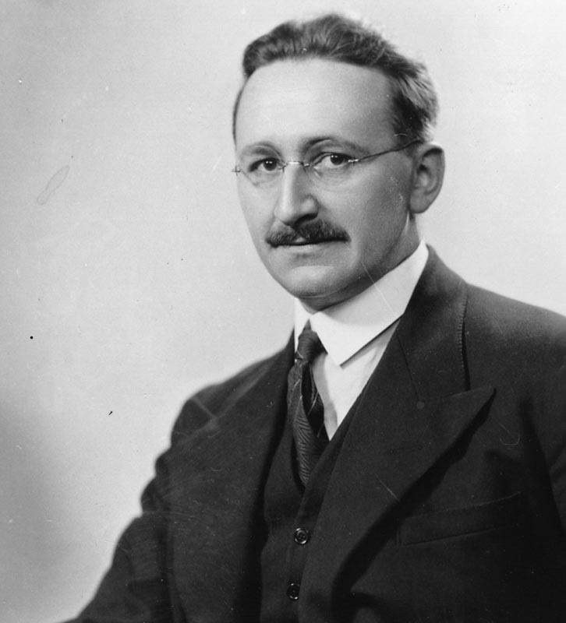
Friedrich Hayek (1899–1992)
Friedrich Hayek was a key supporter of the free market and deeply critical of socialism (state planning). He believed that the resource allocation brought about by individuals, by the operation of market forces, would be far superior to any state planning system. He believed that governments should not intervene in resource allocation decisions, except in the provision or protection of public goods (goods which the free market will not supply – such as street lamps and lighthouses, as consumers cannot be excluded from using them, even if they do not pay to do so).

While Hayek did not think that individuals make decisions about what to demand or supply based on perfect information, he did believe that they have the best knowledge of their own situation. For example, a consumer will have the most accurate knowledge of his/her particular tastes, and a manager will know what raw materials he needs to make his product.

Price movements will occur as individuals and firms participate in the market. These price movements will be observed, and individuals and firms can choose how they wish to act in terms of their demand or supply decisions, with the information they each have. The price mechanism acts as a communication network – providing signals in terms of price – consumers and producers respond accordingly to these signals.

The market will aggregate all these individual decisions, so ultimately the market will reflect all the information available to society as a whole. This means the outcome in terms of resource allocation will be the best that it can be. Hayek expressed the view that if government officials made decisions on how resources should be allocated, this would not be successful since these officials lack sufficient information about markets to be able to make informed decisions. A good example can be found in the Soviet Union, this planned economy was the world’s largest producer of shoes at the time, but the government had huge difficulties setting the price and creating a product that would be demanded. The problem with shoes that the government produced was that the comfort, the fit, the design, and the size mix of Soviet shoes were so out of sync with what people needed and wanted that they were willing to stand in line for hours to buy the occasional pair, usually imported, that they liked. Prices were also set incorrectly

With the real-world failings of communism and the questioning of the effectiveness of Keynesian demand-side management, free market advocates such as Hayek have had more prominence again since the late 20th century.

Background Knowledge: Socialism or Communism?

Note: Communism and socialism are not the same concept. Marx believes that an economy goes through stages, with the end-point being full communism.

Socialism: A stage before communism and involves all factors of production being owned by the government. As in communism, equality is the main focus. Instead of the workers owning the factors of production, workers are paid and allowed to spend their wages as they choose, while the governing body owns and operates the means of production for the benefit of the working class.

Communism: The next step on from socialism. In a full, theoretical communist society everything is owned by the working class and everyone works toward the same communal goal. There are no wealthy and poor classes. Instead, all are equal. Production from the community is distributed based upon need, not by effort or amount of work. It is expected that no more than basic needs for each worker are produced by the community; advancement and production are limited because there is no incentive to produce and/or achieve any more than this amount.

The theories of Marxism are the foundations of socialism and communism. Leninism built upon Marxism and is a political theory regarding the practical implementation of socialism (and eventually communism) within an economy. Marxism-Leninism (combination of the two) remains the official ideology of ruling parties in China, Cuba and Vietnam.

Marxism–Leninism first became a distinct movement in the Soviet Union during the 1920s, when Joseph Stalin and his supporters gained control of the Russian Communist Party; however critics of Stalinism (as it became known) point out that many aspects of Marxism-Leninism have little to do with Stalinism, which includes an extensive use of propaganda to establish a personality cult around an absolute dictator, as well as extensive use of the secret police to maintain social submission and silence political dissent. It also includes the view that self-reliance and limited/no foreign trade. A modern-day example is North Korea, which removed all mentions of communism, Marxism-Leninism in 2009; their official political ideology is now called Juche.

Capitalism: All factors of production are owned by society and prices/quantities are established by the price mechanism. Where in a communist system only the basic need is produced by the community, under a capitalist society more than this can be produced (a surplus); this surplus can then be sold by the supplier in order to pursue profit. Capitalism operates on the basis that the self-interest of workers and businesses, in their pursuit of profit, means that society is supplied with the necessary goods and services.

In reality, most economies are a combination of capitalism and socialism; the extent of the mix is what separates different economies. The USA tends to be the most capitalist in the world, whereas the UK tends to have more aspects of socialism in that we have the NHS for example.

Which System is Best?
These notes look at the advantages and disadvantages of free market systems. As you will see, the advantages of free market economies can be easily turned around to become disadvantages of command economies. Equally, the disadvantages of free market systems often highlight advantages of command economies.
In a pure free market economy, all resources are allocated via the price mechanism (Adam Smith’s invisible hand suggests that prices and quantities are established in a decentralised way through human behaviour).
In a pure free market economy, there would be no government and all resources (factors of production) are privately owned. Such an economy is a theoretical extreme and not likely in practice as a government is needed to correct market failure.
In a command economy, all resources (factors of production) are owned and distributed by the state.

The advantages of a free market economy (and the disadvantages of command economies)
- Efficiency. It makes sense that free market economies allocate their resources more efficiently. Decisions about what is being produced are in response to consumer demand. Planners (governments) are less likely to make the correct decisions across the whole economy – the price and quantity supplied is set by the government.
- Choice. Firms will produce whatever consumers are prepared to buy. Due to the free enterprise factor, there are no restrictions on what the firms can produce. It is of no surprise, therefore, that there will be a much larger choice of goods and services in a free market economy compared with a command economy. The planner (government) will be more concerned with making sure there are enough essential goods to go around rather than allocating resources efficiently between all goods.
- Innovation. Firms will always be looking to produce something new to get ahead of their competitors. We said earlier that, even though the government's role is limited, one of its jobs is to protect property rights. This will include intellectual property rights through patents. Hence, there are incentives in the free market system for firms to be innovative and produce better quality products. Obviously there is no incentive for the planner (government) to be innovative, as they have no competitors. As long as they produce the essentials the planners will be happy.
- Higher economic growth rates. One does not have to be an expert economic historian to see that countries whose economic system has been nearer to the free market model have grown much faster than those with a command economy since the second world war. The most successful economy in the world (in terms of size) has been the USA, and they have been one of the freest economies in the world. Given the factors above, it is not surprising that this is the case. It should be noted that many mixed economies have grown quite well, but certainly the post-war command economies had the worst record.

The disadvantages of a free market economy (and the advantages of a command economy)
- Public, merit and demerit goods.
Public goods cannot be provided privately because of their two characteristics, non-rivalrous and non-excludability. These goods have to be provided publicly. Even in a very free market, one of the government's few roles will be to provide defence, for example. But there may be a problem with merit goods and demerit goods. Merit goods, like health and education, tend to reach an equilibrium price that prices some people out of the market – therefore the state steps in and provides them. The UK has the NHS and although the US has no such system, the recent ‘Obamacare’ helps provide people with state-funded health insurance so that they can access healthcare.

Demerit goods are bad for you. Government should ban class A drugs, and tax cigarettes and alcohol heavily. A government with a limited role might not take enough action in this area, causing health problems for the economy.
Of course, the advantage of a command economy is that the strong government will make sure that public and merit goods are consumed at the right levels and that demerit goods are banned or taxed heavily – though be careful, a pure command economy would have no private firms to tax..
- Unequal distribution of income.
For many, this is the big disadvantage of a free market economy. In a free market with very limited government, benefits will be low, the health service poor and schools under funded. If you start life with very little, and do not even get a good education, then there will be very little protection from destitution. A command economy might not have the efficiency and enterprise for the successful to make millions, but at least the strong government will try to make sure that nobody falls through the safety net. It will be a fairer economy, even though it is likely to be less successful overall.
- The environment.
Free market economies are likely to produce more pollution, which is bad for the environment. Command economies can make sure that the production processes that they chose are as environmentally friendly as possible. They should be able to make sure that the level of output is the socially optimal level of output. Governments can try to force firms into producing the socially optimal level of output through the use of taxes, but governments with a limited role will not be keen to use taxes. Although the tax on petrol is high in the UK, it still doesn't cover the problems caused by the exhaust emissions (in health as well as the environment). Petrol prices have risen, but in real terms, the rise has not been as high as for bus and rail fares.

