Scenario Planning

Revision activities

Data Response

JCB: one of the UK's most successful manufacturers

In 2015, JCB hopes to break the £3 billion turnover mark for the first time in its history. One of the country's biggest and most important engineering companies, JCB's yellow and black construction vehicles are among the top three bestsellers globally. In its UK heartland of
Staffordshire and Derbyshire, JCB employs over 5,000 people in highly skilled, secure jobs.

One of JCB's secrets has been its willingness to invest. Its 1979 decision to start up in India has led to the achievement of a 50 per cent market share in this huge, fast-developing country. India's new government is embarking on a huge programme of investment in roads and other infrastructure which should be great for JCB.

Just in 2014, the company announced:
- a £25 million programme to double production in Germany
- a £45 million investment in a six-cylinder engine to slot into its fuel-efficient Dieselmax range
- a £150 million plan to expand production in the UK, with the expectation of creating 2,500 more jobs by 2018.

As Figure 24.3 shows, not long ago - in the 2009 recession - the company's plans were thrown into turmoil by a collapse in sales. That year the company was saved by sales growth in India and China. Even so, with an estimated total capacity of 72,000 units in 2009, the rate of utilisation was very poor.

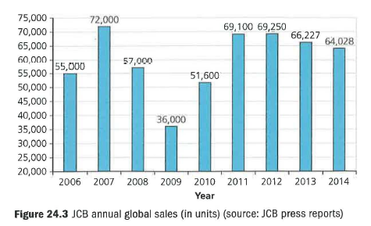

To their credit, senior managers kept their heads and kept investing in the firm's future. From a struggle to break even in 2009, the company bounced back to make £365 million profit in 2012.

In 2014, JCB has been holding to its long-term plan for significant increases in its global capacity. Its factories in India and Brazil are getting greater investment and new factories are being built in Uttoxeter and Cheadle in Britain. JCB believes that developing countries will continue to plough funds into construction investment, and that JCB should be at the heart of this business. It shows no fear of its two huge global rivals: Caterpillar of America and Komatsu of Japan.

Another plan for the future is to improve the productivity of the JCB factories worldwide. In 2014, the 12,000-strong workforce produced 64,000 units. By 2018, the hope is to get annual productivity up to eight units per worker.

Questions (40 marks; 45 minutes)

1
a) Calculate JCB's capacity utilisation in 2009. (3)
b) Explain how JCB might have set about (4)

2 Assess the problems JCB might face in implementing a new strategy that matches output to demand. (10)

3
a) Calculate JCB's labour productivity in 2014. (3)

b) JCB's directors have asked managers to devise a new strategy to meet a productivity objective of eight units per worker by 2018. Evaluate how detailed scenario planning might help the business achieve this objective. (20)

