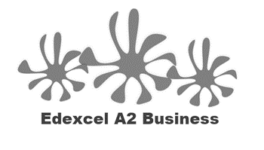
1.5.3 Business Objectives

- Do you have any of these aims?
  - To get a better phone for your birthday
  - To pass your A Level business
  - To get a part time job
  - To become a YouTube sensation
  - To get through the year without a detention / penalty / phone call home
  - To learn to play the guitar

Tick all that apply

Do you have a different aim? _______________________________________

Write a definition of business objectives here:
____________________________________________________________________________________________________________________________________________________________________

Write what SMART stands for here:
____________________________________________________________________________________________________________________________________________________________________
Business survival as an objective

_______________________________________________________________________________________________________________________________________________________________________________________________________________________________________________________________________________________________________________________________________
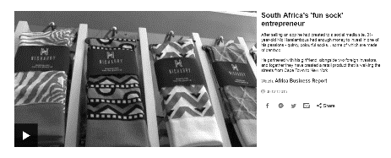
Survival
________________________________________________________________________________________________________________________________________________________________________________________________________________________________________________________________________________________________________________________________________
Profit maximisation

________________________________________________________________________________________________________________________________________________________________________________________________________________________________________________________________________________________________________________________________________
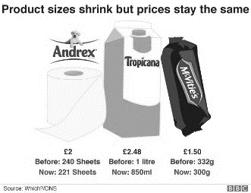
Profit maximisation - shrinkflation

________________________________________________________________________________________________________________________________________________________________________________________________________________________________________________________________________________________________________________________________________

Other business objectives

Other sales objectives

#1 Sales maximisation
#2 Market share
#3 Cost efficiency
#4 Employee Welfare
#5 Customer Satisfaction
#6 Social Objectives

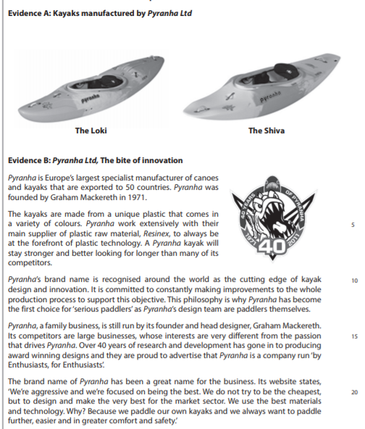

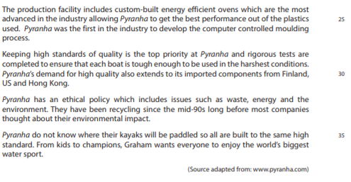

[12]

