Demand
Introduction
Managers and owners seek control over the day-to-day events affecting their business. Ice cream entrepreneurs hate the fact that - however great their ice cream - the weather is the single biggest determinant of daily demand. Many factors affect the demand for different products and services. Business people try, as much as possible, to bring the factors within their influence and ideally control. Even if the weather cannot be controlled, businesses try to combat its effects. In central London, Italian ice cream parlour Amorino also specialises in 15 different flavours of hot chocolate – to keep customers coming even when the weather is poor.

Main factors affecting demand for a product or service

Price
Price affects demand in three ways.

1 You may want an £80,000 Mercedes convertible, but you cannot afford it; the price puts it beyond your income level. The higher the price, the more people there are who cannot afford to buy.

2 The higher the price, the less good value the item will seem compared with other ways of spending the money. For example, a Chelsea home ticket costing£48 is the equivalent of going to the movies six times. Is it worth it? The higher the price of an item, the more there will be people who say no.

3 It should be remembered that the price tag put on an item gives a message about its 'value'. A ring priced at 99p will inevitably be seen as 'cheap', whether it is value for money; so although lower prices should boost sales, firms must beware of ruining their image for quality.
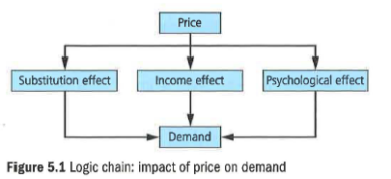

Prices of other goods

The demand for PS4s is affected by not only the price Sony sets for its console, but also prices set by others. In May 2014, Microsoft cut the price of its 'One' console by $100, boosting its demand at the (temporary) expense of the PS4. This shows that the two products are substitutes for each other. In other words, they are competitors, where the success of one is at the expense of the other.

Another factor affecting sales of the PS4 is the price set by software producers for PS4 games. If these rose from £40 each to £50, this would have an effect on sales of Sony PS4 hardware. Some potential customers would stick with their PS3 and others might look towards the Microsoft product. So PS4 software and PS4 hardware are complementary goods, where sales of one have a positive effect on sales of the other. See

Table 5.1 for more detail on this.

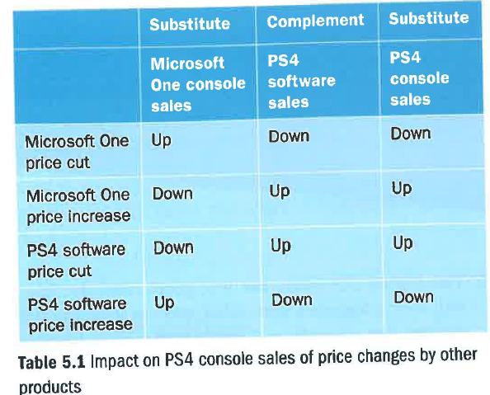

Changes in consumer incomes

The British economy usually grows at a rate of about 2.25 per cent a year. This means that average income levels double every 30 years. Broadly, when your children are aged about 1.6-18, you are> likely to be twice as well off as your parents are today. Economic growth means we all get richer over time (and spend more time in traffic jams).

The demand for most products and services grows as the economy grows. Goods like cars and cinema tickets are normal goods, for which demand rises broadly in line with incomes. In some cases, it grows even faster; for example, if the economy grows by 3 per cent 'in a year, the amount spent on foreign holidays can easily rise by 6 per cent. This type of product IS known as a luxury good.

Other goods behave differently, with sales falling when people are better off. These products are known as inferior goods. In their case, rising incomes mean falling sales. For example, the richer we get the more Tropicana we buy and the less Tesco orange squash. As orange squash is an inferior good, a couple of year of economic struggle (and perhaps more people out of work) would mean sales would increase as people switch from expensive Tropicana to cheap squash.

Fashion, tastes and preferences
This category contains some quite different influences upon demand. Fashion is difficult to manage because, by definition, the term implies that what goes up must come down. Very few brands stay in fashion for ever. It was the huge height of the fashion for FCUK that made the logo unbearable once consumer taste had moved on; French Connection suffered seven lean years after that happened.

Yet some brands do seem to be eternally fashionable, such as Chanel, Jack Daniels and Nike. This adds value to the brand and therefore allows higher prices to be charged, and higher profits to be made.

'The customer is never wrong.'
Cezar Ritz, hotelier

Seasonal factors

Most firms experience significant variations in sales through the year. Some markets, such as ice cream, soft drinks, lager and seaside hotels, boom in the summer and slump in the winter. Other markets, such as sales of perfume, liqueurs, greetings cards and toys, boom at Christmas. Other products with less obvious seasonal variations in demand include cars, cat food, carpets, furniture, TVs and newspapers. The variation is caused by patterns of customer behaviour and nothing can be done about that. A well-run business makes sure that it understands and can predict the seasonal variations in demand; and then has a plan for coping.

Demand risks

There are two situations that every manager should beware of: undiversified demand and overtrading.

Undiversified demand

When Andrew and Debbie Keeble won a £5 million order from Tesco for their Heck sausages, they were thrilled. But it meant that Tesco accounted for 75 per cent of all the brand's sales. This put the small business in a very vulnerable position. It had to create the production capacity to meet the orders, but that might leave them with impossibly high costs if Tesco decided to cancel.

Similar problems of undiversified demand occur when a business is dependent on just one product (think 'loom bands' as a craze that came and went). The answer is to try to diversify - that is, to spread risk by finding new sources of demand and therefore being less reliant upon any single source.

Overtrading
Sometimes small businesses grow so fast that they struggle to generate enough cash to meet rising bills due to rising production levels. The problem is that meeting next month's higher demand levels requires extra cash spent today (more materials and components, more staff and so on). Overtrading means running so fast that the cash position is on a knife edge, probably at the overdraft limit. That is risky.

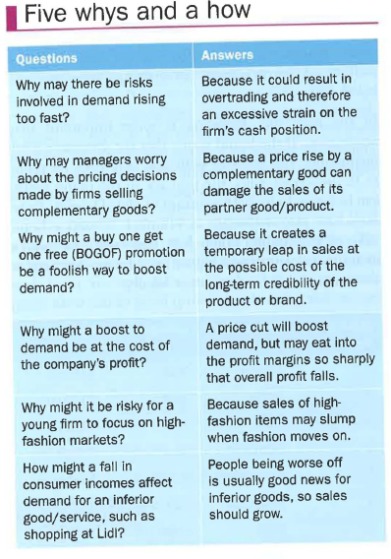
Demand – evaluation

The cleverest judgements to be made in business come from the ability to separate what is from what could be. For 20 years, Britain's Financial Times (business) newspaper was priced at £1 - a small premium to the other 'quality' papers, The Times and The Guardian. Then, between 2007 and 2010, the price of the Financial Times was increased until - at £2.50 - it became treble the price of its rivals. Astonishingly, sales were virtually unaffected. Those who wanted an economics and business-focused paper had nowhere else to go. A clever executive had spotted the opportunity to make considerably more profit from the paper. Such good judgement is based upon sound understanding of market demand; that is, a really fine understanding of what customers think, feel and want.

Key terms

Complementary goods: these are bought in conjunction with each other, such as eggs and bacon or cars and petrol.

Inferior goods: ones for which sales fall when people are better off, but rise when consumers are struggling financially.

Luxury goods: ones for which sales rise rapidly when people are better off, but may fall rapidly in hard times.

Normal goods: ones for which sales move in line with changes in consumer incomes, e.g. sales at dry cleaning outlets.

Seasonal variation: change in .the value of a variable (for example, sales) that is related to the seasons.

Substitutes: products or services in competition with each other, so customers will substitute one for the other (e.g. Dairy Milk and Galaxy).

