The Competitive Environment
Review Questions

- Chinese phone maker Xiaomi is known for producing Apple-like phones at much lower prices. Explain how Apple might respond to the threat from Xiaomi’s growth. (4)

- Figure 6.1 shows Apple to be the global smartphone number two `by volume`. What might be the impact on the figures if the data had been provided `by value`? (3)

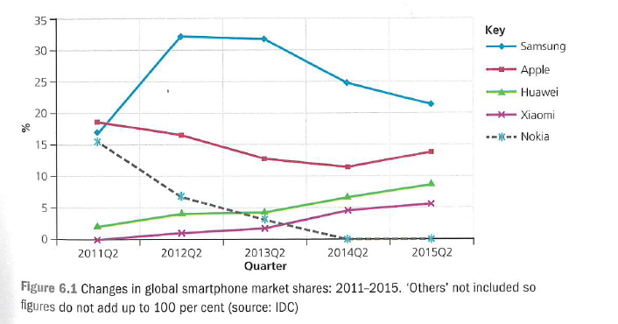

- Heinz has a stable, long-lived brand in Heinz Baked Beans. Explain briefly whether you think the following products are in dynamic/new or static/older markets.
  - Cadbury’s Crème Egg. (4)
  - Netflix. (4)

- Use Porter’s Five Forces (fig 6.2) to assess the completive position of one of the following:
  - Sainsbury’s
  - Primark
  - Greggs (10)
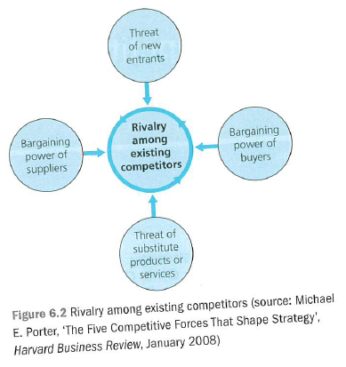

- Explain how a business might be affected by an increase in the buying power of its customers. (4)

- Outline two reasons why a supermarket might be concerned if the world’s top two breweries plan to merge into one business. (6)

