Hypothesis – The rate of diffusion depends on the concentration of the substance that is diffusing
Apparatus
- Agar cubes containing Universal indicator
- 100 cm³ glass beaker
- 0.2M Hydrochloric acid
- 0.4M Hydrochloric acid
- 0.6M Hydrochloric acid
- 0.8M Hydrochloric acid
- 1.0M Hydrochloric acid
- 50 ml measuring cylinder
- Stop clock
- Goggles
- Spatula
- Tweezers
Sequence
- Using the tweezers or spatula, put one of the agar cubes into a beaker
- Measure out 25 cm³ of 0.2M Hydrochloric acid solution – note down the concentration of the acid
- Add the acid to the beaker, starting the stop clock at the same time
- Time how long it takes for the agar jelly to change colour to red
- Record the time in your results table
- Repeat steps 1-5 using new agar cubes and the following concentrations of hydrochloric acid 0.4M, 0.6M, 0.8M and 1.0M
The Variables
Independent Variable =
Dependent Variable =

Control variables =
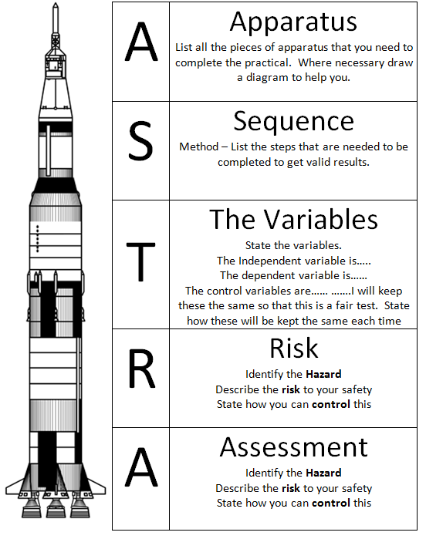
Risk
Assessment
Hazard –
Risk –
Control –

Hazard –
Risk –
Control –

