Revision questions (40 marks; 40 minutes)

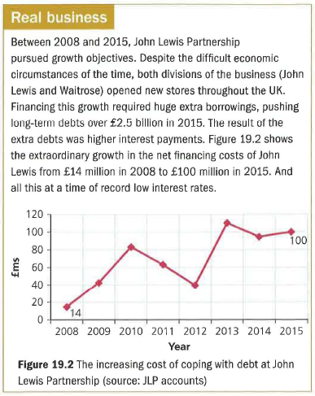
- Outline two possible reasons why a bank would want to see a company's statement of comprehensive income. (4)

a) Calculate the per cent increase in the annual net financing costs for John Lewis between 2008 and 2015. (3)

b) Explain one possible effect of this increase on the business. (4)

- Outline two ways in which employees may benefit from looking at their employer's balance sheet. (6)

- Distinguish between gross and operating profit (3)

- Explain why even a charity such as Oxfam may want to make a profit. (4)

- State two items that may be listed as current liabilities. (2)

- Distinguish between non-current and current assets. (3)

- Explain what may be included under the heading 'financing costs'. (4)
